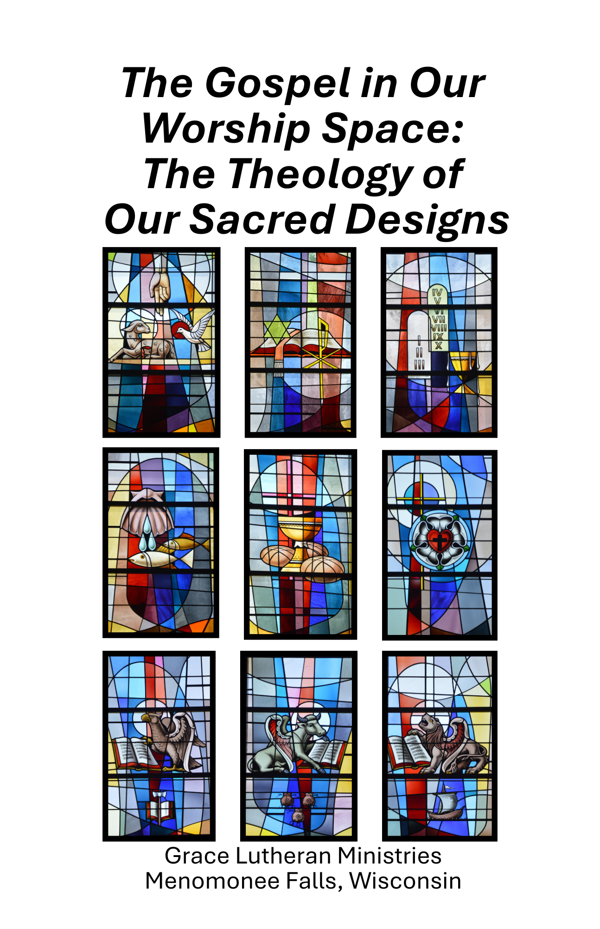
Forward

The stained-glass windows which enhance the Sanctuary and Narthex at Grace’s Cross View Way Campus were formally dedicated on May 13th, 1990, in Grace’s Kenwood Campus Sanctuary.

Each of these windows is rich in Christian symbolism and was thematically chosen to be a visual reminder of our deeply-rooted Christian heritage.

The ten windows in the Sanctuary form the foundation for our faith. They depict our Triune God, the Means of Grace (Word and Sacrament), Luther, and the four Gospels.

The twelve windows in the Narthex depict eight significant people whose legacy of faith and life have influenced God’s Church throughout the centuries.

This booklet has been prepared so that all who wish may use it to better understand and appreciate the significance and meaning of each window.

It is our hope that as you worship at Grace the beauty of the windows and the meaning behind each symbol will remind you of the important teachings of the Christian Church that they portray.

—Soli Deo Gloria—

East Side of Sanctuary: Back to Front
HOLY TRINITY
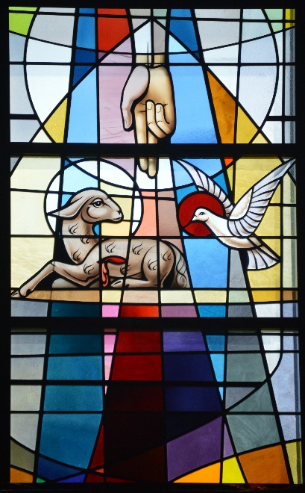

Depicted in this window are the Father (hand), Son (lamb who was slain), and Holy Spirit (dove). The Holy Trinity is one God, yet three persons.

The right hand is the symbol of the Father as creator,
all-powerful, and one who offers us blessings. The Son is
depicted as the Lamb who was slain for our salvation
(Revelation 5). The Holy Spirit is represented as a dove, a symbol dating back to the early sixth century and found in Scripture at Jesus’ baptism (Matthew 3:13-17).

Grace regularly confesses our faith in our triune God through the Church’s Creeds: Apostles, Nicene, and Athanasian.

THE WORD
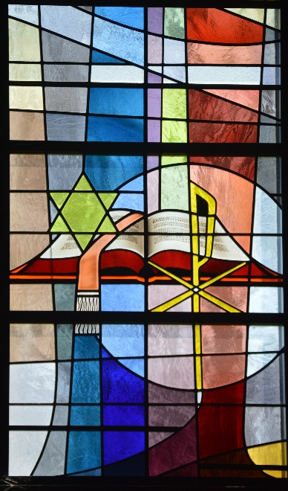

This window focuses on the centrality of the Word of God written for His people to know who our God is and His
amazing love for us in Jesus. We confess that the Scriptures are inspired and inerrant. This is God’s Word written through different authors to share with us His work to save us from sin, death, and the devil.

The Star of David shows that we embrace the Old Testament as God’s Word through Patriarchs, Kings, and Prophets,
focusing on the promise of the Messiah who would come to save His people.

The Chi-Rho (the first two letters of the Greek word for Christ) shows that the New Testament is also the Word
(written and the Word made flesh in Jesus) as we see the
fulfillment of the promised Messiah who came to save us.
LAW AND GOSPEL
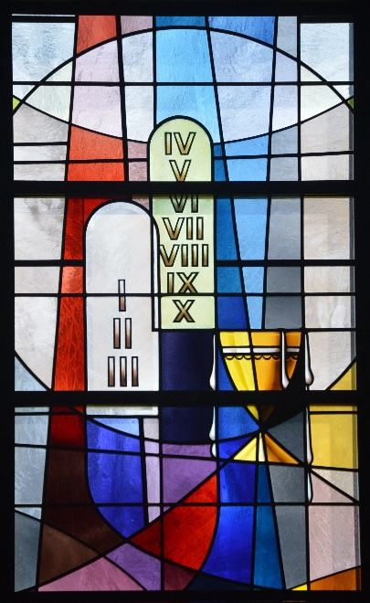

This window represents the Law of God depicted by the two tablets of stone – the 10 Commandments. The law functions as a curb to our sinful nature – reminding us of the
punishment for sin – death. It serves as a mirror to show us our sins and bring us to the cross. Finally, it serves as a guide for the Christian life that we might serve Him faithfully.

Next to the tablets is an overflowing chalice representing the love of God in Christ poured out through the Gospel – the proclamation of salvation found in Christ alone. As Moses gave the Old Covenant at Sinai – so Jesus brings in the New Covenant at the Last Supper (Luke 22:14-23).

BAPTISM
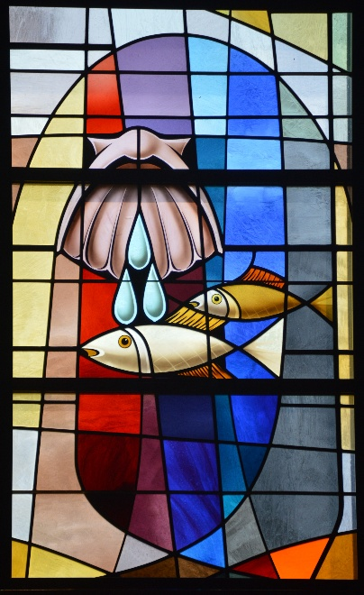

“Therefore, go and make disciples of all nations, baptizing them in the name of the Father and of the Son and of the Holy Spirit.” (Matthew 28:19-20)

The scallop shell symbolizes the act of Baptism, and the three drops of water represent not only the visible element of water but also the Triune name in whose name all
Christians are baptized.

The fish was one of the first symbols used in the early Christian Church. The Greek word for fish, IXOYC yields the initial letters to the words in Greek: ‘Jesus Christ, God’s Son, Savior.’ In baptism we have put on Christ (Galatians 3:27).

HOLY COMMUNION
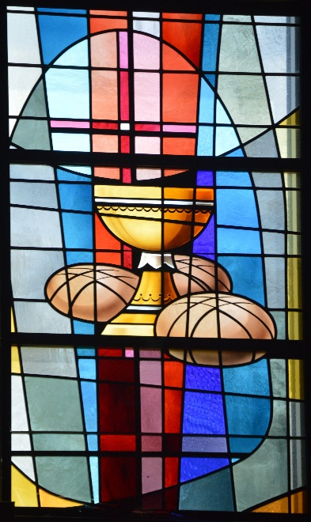
On the night that He was betrayed, during the celebration of the Passover, Jesus took bread and wine and instituted the Lord’s Supper. He gave the disciples these simple physical
elements, but with His words, “This IS my body” and “This IS my blood” – Jesus gave them exactly what He said He was giving them – His flesh and blood. In this supper, we receive the Real Presence of Jesus – His very Body and Blood in, with, and under the Bread and the Wine.

By faith in the Words and promises of Jesus, we receive this meal for the forgiveness of sins and the strengthening of our faith. It is because of this that we practice communion at Grace as often as possible. (Matthew 26:17-25; Luke 22:14-23)

West Side of Sanctuary: Front to Back
ST. MATTHEW
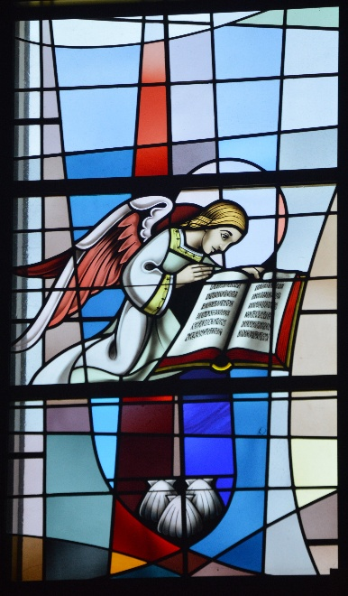
Matthew is frequently depicted as a winged man because his Gospel opens with the genealogy of our Savior – one
descended from the lineage of David and born of the virgin Mary. Because Matthew’s Gospel stresses the incarnation it points to our Savior being True God and True Man in Jesus!

Matthew was one of the twelve disciples, called by Jesus to leave his tax collector’s booth and follow Him.

Bottom Center – James
James, the brother of the Gospel writer, John, is represented here by scallop shells. These shells represent his missionary journeys.

ST. MARK
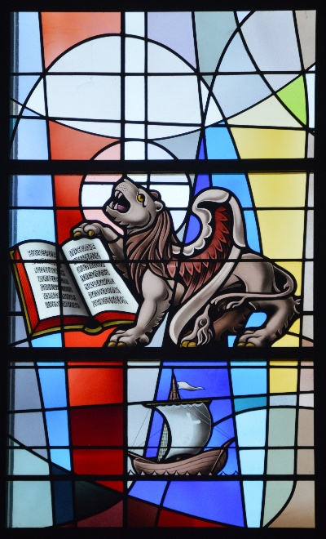

Although at times Mark is associated with a winged man, he is depicted here as a lion because he writes of John the
Baptist, “the voice of one crying in the wilderness” (Mark 1:3). The lion also represents a symbol of strength of
character.

Mark’s Gospel is significantly shorter than the rest of the Gospels. There is no birth narrative and if one uses the shorter ending of Mark – there is no physical appearing of the resurrected Jesus. Instead, the Gospel ends with women trembling, astonished, and afraid.

Bottom Center – Jude
The boat is used for Jude because he frequently traveled
using this mode of transportation.
ST. LUKE
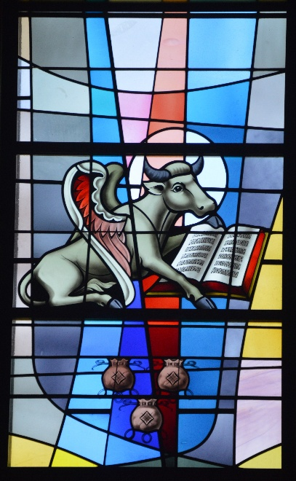

The symbol here used for Luke is the winged ox (or bull), the sacrificial animal. This figure is used because Luke gives a full account of the sacrificial death of Jesus Christ in his Gospel.

Luke was not one of the twelve disciples but wrote his
Gospel to Theophilus and did so to give an orderly account (Luke 1). This continued in his historical book – Acts of the Apostles.

Bottom Center – Matthew
This alternate symbol for Matthew, the money bag,
represents his pre-discipleship occupation as a tax collector.

ST. JOHN
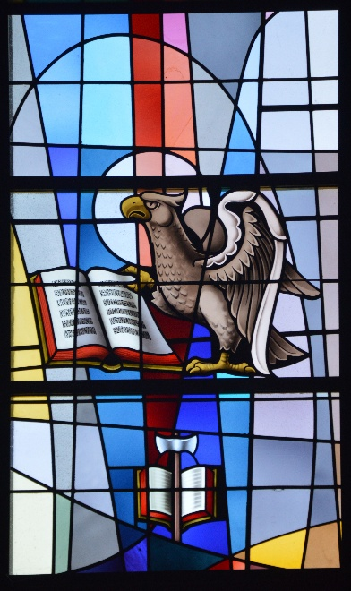

John is most often depicted as an eagle, an image used at times as a symbol for the Holy Spirit, which John talks about more than any other Gospel writer.

John was one of the twelve disciples who wrote a Gospel, three epistles, and the book of Revelation. John wrote in more picture language to show us who Jesus is so that we might believe and have salvation (John 20:30-31).

Bottom Center - Matthias
Matthias is the disciple who replaced Judas. His symbol is a battle-axe on an open book. Tradition states that, standing on the Word of God, he suffered a martyr’s death and was then hacked into pieces.

LUTHER’S ROSE or COAT OF ARMS
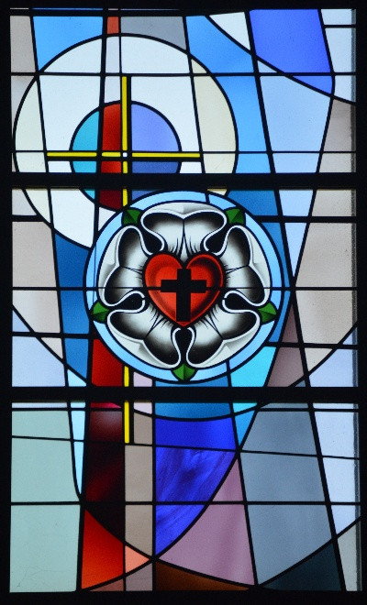

At the center is a black cross set inside a red heart which
Luther designed to remind himself that it is faith in the
crucified Lord that saves us. The heart is placed inside of a white rose to symbolize that faith gives joy, comfort, and peace. Luther chose a white rose to show that faith gives joy and peace that is greater than anything this world could ever give. The color of white is for the angels, set inside a sky-blue circle symbolizing that such joy is found in the promise of
future heavenly joy! The black ring shows that the joy of heaven has no end. In Luther’s original design the ring was gold to signify the joys of heaven are beyond any earthly joy or value.

East Side of Narthex

ANDREW
Known as St. Andrew’s cross, this X-shaped cross is used as a symbol for Andrew because he was martyred by crucifixion on such a cross.

SIMON
‘Come and follow me and I will make you fishers of men.” With those words our Lord called Simon away from his
fishing net and into discipleship. The symbol of the fish on a hook is commonly used for Simon and his brother, Andrew, who were fishermen.

BARTHOLOMEW
The three “Flaying Knives” are symbolic of Bartholomew’s manner of death – flaying and crucifixion followed by
decapitation.

JOHN
This symbol for John is derived from a legend which tells of an attempt on John’s life by a priest of Diana using a cup of poisoned wine. Tradition says that John made the sign of the cross over the cup, and the poison left in the form of a
serpent.

West Side of Narthex

PETER
The “two keys” are used as the symbol for Peter because it was to him that Christ spoke of giving the “keys of the
kingdom of heaven” (Matthew 16:19) –the binding or loosing (forgiving) of their sins.

JAMES THE LESSER
The “Saw” is used as a symbol for James the Lesser because, after a prolonged martyr’s death and mutilation, he was then sawed into pieces.

PHILLIP
The “Tan Cross” and basket form the symbol for Phillip, the disciple who participated in the feeding of the 5,000.

THOMAS
The symbols for Thomas, the spear and carpenter’s square, are by tradition, representative of the form of his martyrdom and his pre-discipleship occupation.

AN EXPLANATION OF GRACE’S CROSS

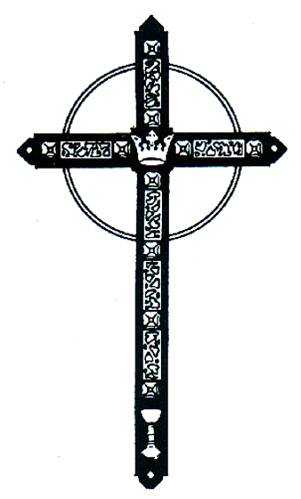

The cross that hangs above our altar was designed by the late Rev. Edwin P. Fahl, who had served his Lord and the members of Grace for 45 years.

This cross is made of rajah wood, which is a very fine-grained wood from India. It is painted black to remind us of the blackness of our sins for which our Savior died. At the center of the cross-beams is a crown which tells us that it was the eternal Christ, the King of kings and Lord of lords, who gave His life on the cross.
The filigreed panels of thorns remind us of the discomfort and agony which our Savior endured. Between the filigreed panels is the rose of Sharon mentioned in the Song of Solomon, chapter 2, verse 1: “I am the rose of Sharon” where Solomon speaks of the mutual love of Christ and His church.

At the end of each cross-beam is a triangle which tells us that the God who made our redemption possible through the sacrifice on the cross is the Triune God, Father, Son and Holy Spirit. At the end of the horizontal cross-beam and at the end of the vertical beam are three nails which affixed the hands and feet of our Lord on the cross.

At the base of the vertical beam is a chalice which puts us in remembrance of the Sacrament of Holy Communion in which we are recipients of the true body and blood of our Lord.

The gold ring which encircles the junction of the cross-beam and the crown signify that through the Christ of the cross God has made possible the crown of everlasting life which is enunciated in John 3:16: “Whosoever believeth in Him shall not perish but have everlasting life.”

THE BAPTISMAL FONT AND ALTAR
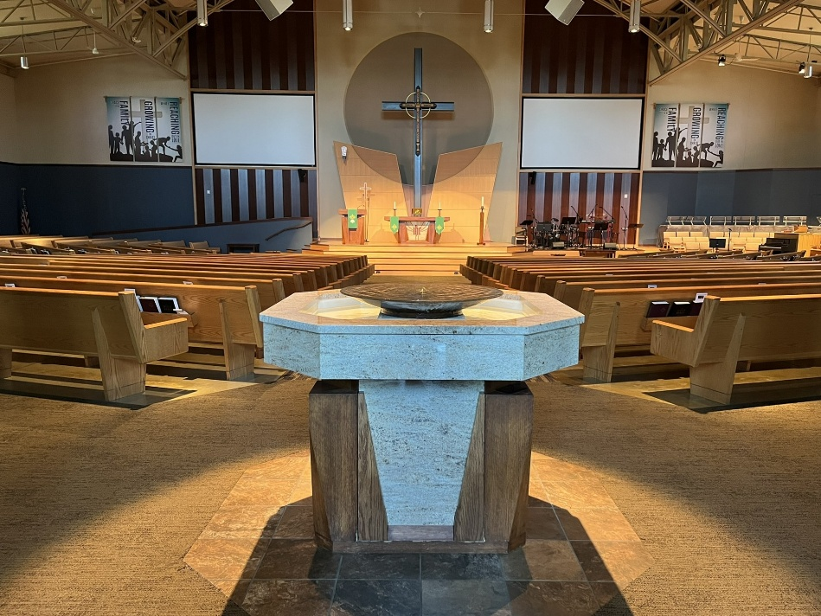

THE BAPTISMAL FONT
As you enter into the sanctuary, the baptismal font prominently stands at the back of the center aisle. The font is placed in the back of the church to remind all who come for worship that it is through Holy Baptism into Christ that one is able to come before God to worship and to receive His gifts of forgiveness, life and salvation that come to us through His Word and Sacrament.

The water in the font is continually flowing, symbolizing that the water in Holy Baptism is a life-giving water when connected with the Word of God. The stone font is eight-sided, representing the 8th day of the week (language used to refer to Easter Sunday) when Jesus Christ brought new life and salvation through His Resurrection from the grave.
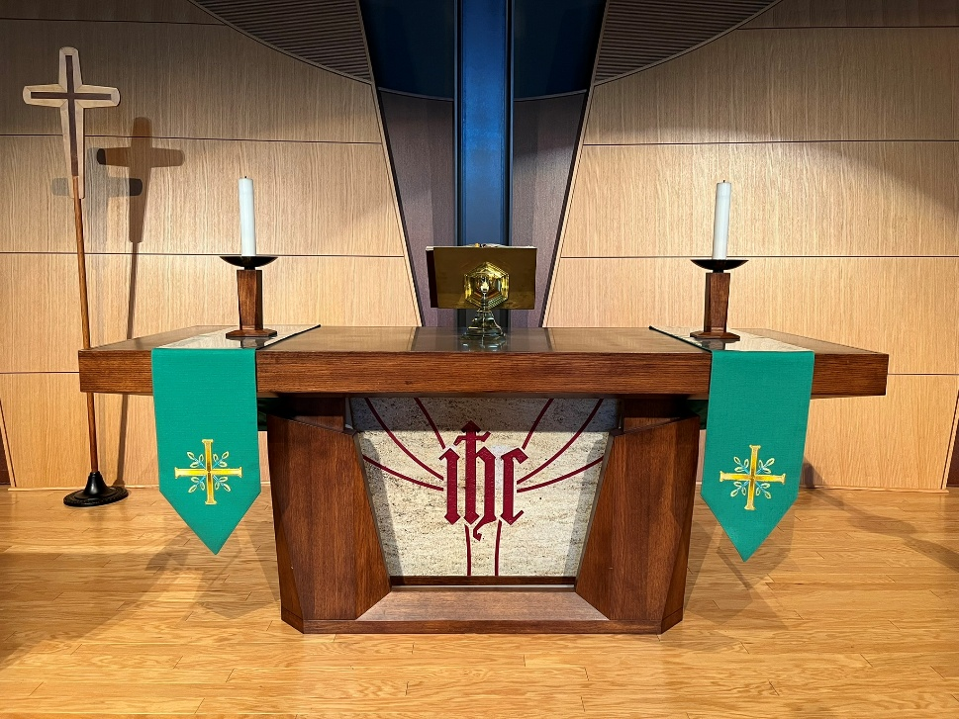
THE ALTAR
In the center of the sanctuary stands the altar. The altar is the focal point of our worship, representing the sacrifice that Christ made on our behalf to pay the cost for our sin and bring us forgiveness. It is from the altar that the sacrament of the Lord’s Supper is also received. In the Lord’s Supper the Body and Blood of Christ is given and received by faith in, with and under the bread and wine. Inscribed in the stonework on the front of the altar are the letters IHS. These three letters have been used by the Christian church for hundreds of years to represent the name of Jesus, originally spelled in Greek as IHSOUS. The first three letters of Jesus’ name in Greek are IHS. These three letters were also used as an acronym for the Latin phrase Iesus Hominum Salvator, which means “Jesus, Savior of Mankind.”
SOURCES

Van Treek, Carl. Symbols. Bruce Publishing Co., 1936.

Lueker, Ervin. The Lutheran Cyclopedia. Concordia Publishing House, 1975.

** This booklet was modified based on the original booklet put together when Grace gathered to worship in the
Kenwood Campus.

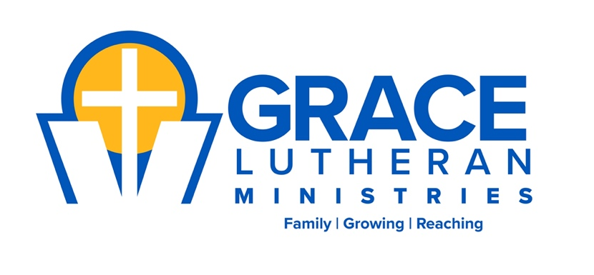

W196N9525 Cross View Way
Menomonee Falls, WI 53051
262-251-0670

www.grace-connect.org

