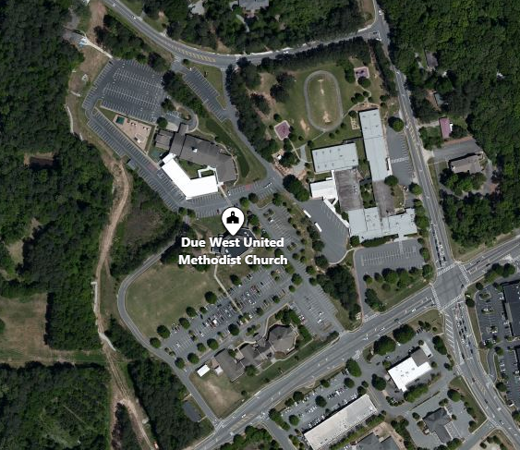
Preschool Carline Map
4’s

1’s, 2’s, K Drop Off

3’s

Due West Road
Acworth Due West Road
Burnt Hickory Road
Due West Methodist Church

