January 10, 2021 Sermon Listening Guide



“Partying Together”

**Ezra 3:10 – 13**  New International Version

**10**When the builders laid the foundation of the temple of the Lord, the priests in their vestments and with trumpets, and the Levites (the sons of Asaph) with cymbals, took their places to praise the Lord, as prescribed by David king of Israel. **11**With praise and thanksgiving they sang to the Lord:

“He is good;  
    his love toward Israel endures forever.”

And all the people gave a great shout of praise to the Lord, because the foundation of the house of the Lord was laid. **12**But many of the older priests a**nd** Levites and family heads, who had seen the former temple, wept aloud when they saw the foundation of this temple being laid, while many others shouted for joy. 13No one could distinguish the sound of the shouts of joy from the sound of weeping, because the people made so much noise. And the sound was heard far away.

**Main Ideas:**

1. The ____________________ of God is worth celebrating.

2. The ____________________of God is worth sharing.

3. The ____________________ of God is worth pursuing.

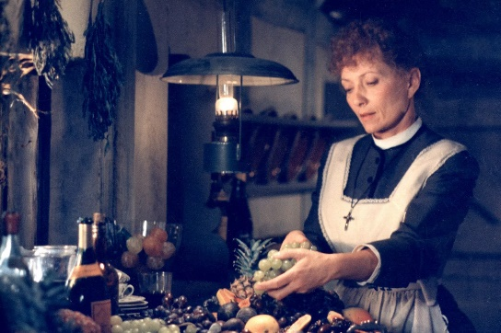

***Babette’s Feast***

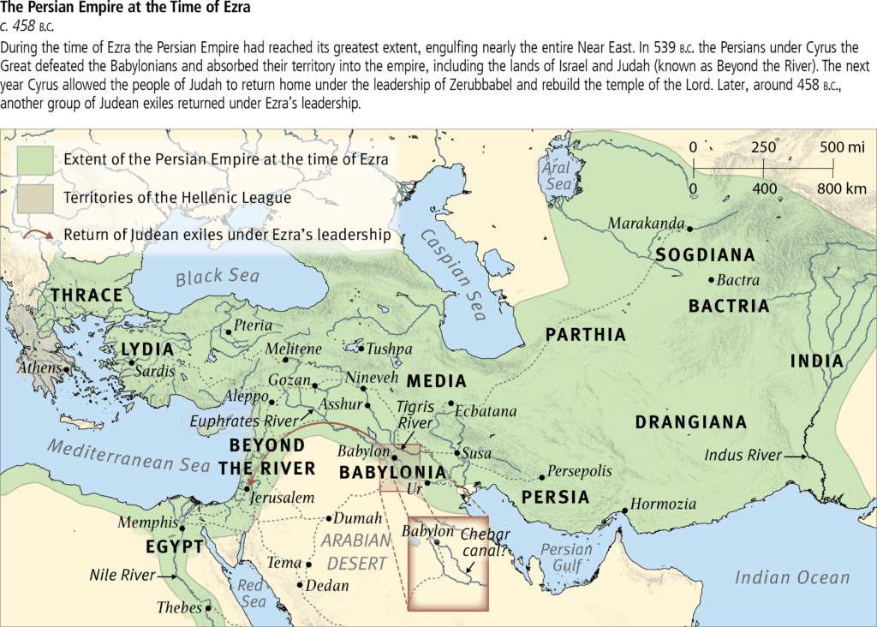

Notes on Ezra 3: 10 – 13

__________________________________________

__________________________________________

__________________________________________

__________________________________________

__________________________________________

__________________________________________

__________________________________________

__________________________________________

__________________________________________

__________________________________________

__________________________________________

__________________________________________

__________________________________________

APPLICATION QUESTIONS:

1.What would the best party ever look like for you?

______________________________________________________________________________________________________________________________

2. Why is God’s goodness the key to our joy?

______________________________________________________________________________________________________________________________

3. Name three ways God has been so good to you.

______________________________________________________________________________________________________________________________

