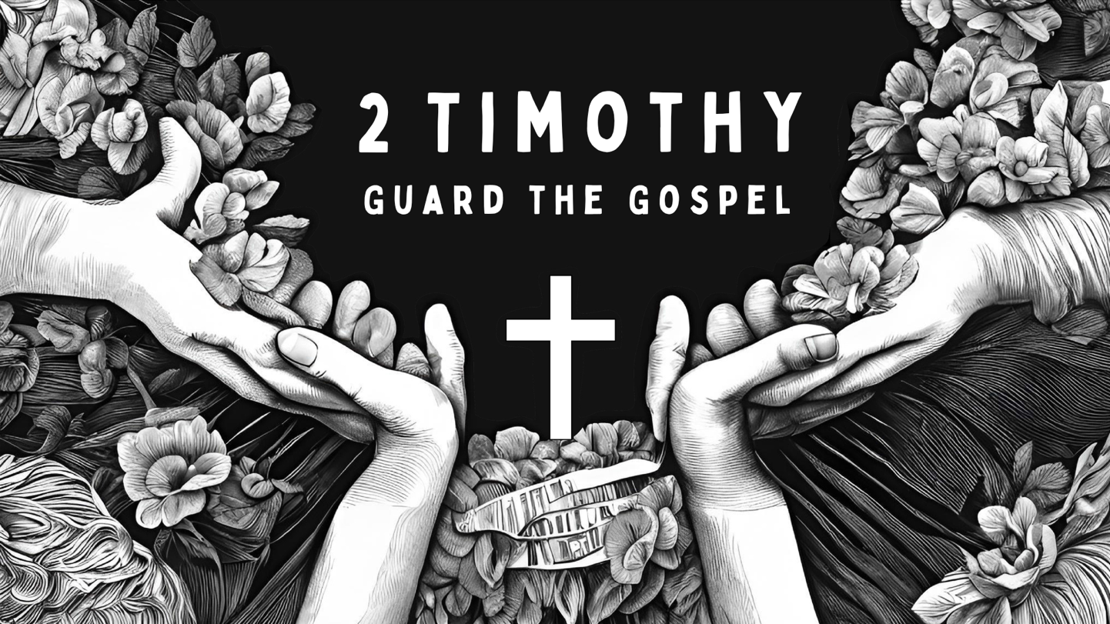

Growth Groups Material
(5 studies on 2 Timothy)
Feb-Mar 2025



Teaching Schedule
In our gatherings we will work through a 5-part series: | 30 Jan – 2 Feb  6-9 Feb  13-16 Feb  20-23 Feb  27 Feb-2 Mar  6-9 Mar | 2 Timothy 1:1-2:2  2 Timothy 2:1-13  Thu Church: 2 Timothy 2:14-3:9  Sat/Sun: Overhall Deputation (CMS)  Thu Church: Overhall Deputation (CMS)  Sat/Sun: 2 Timothy 2:14-3:9  2 Timothy 3:10-4:8  2 Timothy 4:9-22

Booklet Contents
Introduction | p.3
Study 1 (2 Timothy 1:1-2:2) | p.6
Study 2 (2 Timothy 2:1-13) | p.9
Study 3 (2 Timothy 2:14-3:9) | p.13
Study 4 (2 Timothy 3:10-4:8) | p.16
Study 5 (2 Timothy 4:9-22) | p.20

Additional Resources
We’ve put together some additional resources that might help you as you make your way through this series:

https://jannalianglican.org.au/2timothy/



Introduction

If you knew you didn’t have long, what would be your final words? What’s so important that you’d just have to say it while you still could? Paul writes to Timothy at what he senses is the very end of his life. He’s in prison in Rome for sharing the news that Jesus is King and Saviour of the world (see Acts 20-28). History tells us that Paul was probably executed during the reign of Emperor Nero (AD64-68). This letter is therefore Paul’s way of passing the baton to Timothy, before he loses his chance. At the time of the letter, Timothy is the leader of the churches in Ephesus, and is facing challenges including opposition from ungodly, influential false teachers. Paul urges Timothy to guard the true gospel that had been handed down to him by Paul. He must stand firm and continue declaring the truth. This task is not without reward, however: Paul often lifts Timothy’s vision to the wonderful future hope Christians have because of Jesus.

Although the letter is written to a church leader, it’s relevant for all of us. The things Timothy is encouraged in are the same aims for all believers: to be godly; to stand firm in sound doctrine; the pass on the gospel to others. As such, it’s best not to think of the letter as ‘one pastor writing to another pastor about how to be a pastor’, but rather as ‘one Christian writing to another Christian about how to be a Christian’. As we adopt this mindset will see that we share the same gospel as Paul and Timothy, the same eternal hope, similar challenges. And, of course, the same call to emulate the Lord Jesus in his cross-shaped life: suffering then glory. It goes without saying there’s a lot at stake if the true gospel isn’t guarded from error and handed down to others.

We’re praying for God to use this letter to grow each of us in Christ-like character so that His gospel would be guarded and promoted.

Page left intentionally blank (use for notes, prayer points etc)

Page left intentionally blank (use for notes, prayer points etc)

Study 1 | 2 Timothy 1:1-2:2

Introduction
- 2 Timothy is considered to be Paul’s last letter, written to his dear friend and Christian brother Timothy. Look up the following verses to get acquainted with Timothy. What can we know about Timothy and his role? (Acts 16:1-3, Rom 16:21, 1 Cor 16:8-11, Phil 2:19, 1 Thess 3:1-2, 1 Tim 1:3)

- If you were given an opportunity to share your final words in life, what would you say?

Read and Discuss
- Read 2 Timothy 1:1-2:2. What appears to be Paul’s main concern in this section? What repeated concept alerts us to this issue?

  - How does Paul’s own example relate to this issue (verses 11-12)?

  - How does Paul’s reference to other people relate to this issue (verses 15-18)?

- Verses 9-10 are a summary of the gospel. What does Paul emphasize? Given Paul’s circumstances, why do you think he chooses this emphasis?

- List all the instructions Paul gives to Timothy. How would you summarize them in one idea?

- The ‘good deposit’ in verse 14 is a reference to the gospel truth. In what sense does the gospel need guarding and protection? What are the dangers?

Reflect and Apply
- In all likelihood, we’re going to look foolish at some point if we’re determined to pass Jesus on to others. When has shame held you back from sharing the good news that Jesus is King? How has this passage addressed that feeling of shame?

- One key part of guarding the gospel is passing it on to others (like Paul did to Timothy, v13; and like Timothy is instructed, v 2:2). What would have been the consequences for you and me if Timothy and his generation hadn’t taken up Paul’s baton and passed on the gospel that was handed on to them? Is our generation any different in this respect?

- Draw up your own “family tree of faith” as far back as you know it. Who passed the gospel on to you? Who have you made it your task to pass the gospel on to, just as someone passed it on to you? Include these people too. Thank God for the people who have shared and taught the gospel to you, and pray for your own efforts to pass on the gospel to others.

Study 2 | 2 Timothy 2:1-13

Introduction
- Can you recall a difficult task or project you’ve been involved in that has required perseverance? Tell the group about it? What kept you going?

Read and Discuss
- Read 2 Timothy 2:1-7. Paul uses three metaphors (verses 3-6) to describe what Timothy is to be like in his task. Identify each metaphor, then consider the following questions:

  - What attribute or attitude is Paul encouraging Timothy to adopt?

  - What is the aim, reward or intended outcome in the case of each metaphor?

  - What common idea is Paul trying to get across? That is, what kind of life is Paul encouraging Timothy towards?

- In verses 8-10, Paul shifts from the three metaphors, to giving Paul encouragement as he approaches his difficult task. What three encouragements does Paul put forward? How might these things help us persevere when living as a Christian is hard?

- Verses 11-13 contain a poetic hymn (perhaps known to early Christians, or otherwise adapted by Paul from another source). What is the comfort in verses 11-12a. What is the warning in verses 12b-13?

Reflect and Apply
- Are you prepared to endure suffering and/or work hard for the cause of the gospel? How does suffering give us the opportunity to imitate Jesus more and more?

- This passage points Christians to our eternal hope several times. How does a joyful anticipation of our eternal future help us to endure suffering or hard work in the present?

- Is there a costly decision or behaviour that you need to re-commit to if you are to apply this passage to yourself? What is it? What is stopping you? (Some possibilities might include: being public about your faith in certain contexts, helping regularly in a ministry, giving financially to gospel causes).

- Of the three metaphors that Paul uses in the passage, which one do you most associate with? And which attribute is missing from your life as a follower of Jesus (the single-mindedness of a soldier; the integrity of an athlete; or the work ethic of a farmer)?

Page left intentionally blank (use for notes, prayer points etc)

Study 3 | 2 Timothy 2:14-3:9

Introduction
- Have you ever been scammed (or know of someone who has been scammed)? Why are scams often effective? What are the consequences of being scammed?

Read and Discuss
- Read 2 Timothy 2:14-26. Attempt to build up a picture of the problem facing the Ephesian churches where Timothy was a leader? What can we learn?

- What kind of leader does Paul want Timothy to be?

- Verses 20-21 seem a bit odd. How does Paul’s imagery teach us about the connection between godliness and effective ministry leadership?

- Read 2 Timothy 3:1-9. What stands out to you from this list of different types of ungodliness? Are you in danger of falling into any of these behaviours?

- According to verses 6-9, why is ungodliness such a grave concern when it comes to leaders?

Reflect and Apply
- Today’s world is filled with all sorts of mixed-messages, hype, and straight-out lies. What issues do we need to talk to the next generation about so that they’ll be following Jesus firmly for years to come?

- Imagine one of the other members of your growth group has developed some false and unhelpful ideas about a particular Christian doctrine. How are we to interact with such a person? What is our manner? What is our aim?

- Imagine you’re tasked with choosing and appointing a ministry leader (maybe a staff person, or a voluntary growth group leader). From this passage, what kinds of things would you be looking for?

Study 4 | 2 Timothy 3:10-4:8

Introduction
- Throughout this letter, Paul urges Timothy to make the Bible the centre of his ministry. Have you ever felt that our church does too much ‘Bible stuff’ and should focus more on other things? What examples of ‘other things’ come to mind?

Read and Discuss
- Read 2 Timothy 3:10-17. How is Timothy to be different to the people we read about last time (in 3:1-9)?

- What hurdles face the Christian person who seeks to be faithful to God’s word?

- In verses 14 to 17, where can Timothy find confidence to continue in gospel mission despite the promised opposition?

- Read 2 Timothy 4:1-8. What is Paul’s charge to Timothy 4:1-5? What warning does Paul issue?

- Why do you think Paul uses himself as an example for Timothy. What elements of his work and attitude does he emphasize and why?

- What future realities does Paul include in his charge, to inspire Timothy to keep sharing the gospel? How should those realities impact us?

Reflect and Apply
- Re-visit question 1. What reasons do we have for making the Bible central in all of our ministry at JAC?

- Re-consider 2 Timothy 4:3-4. How do we see that same pattern playing out in our day and age?

- Most of us aren’t full-time Christian workers like Paul and Timothy. Nevertheless, what priorities from this section apply to all of us and why? (Hint: Read Ephesians 4:11-16).

Page left intentionally blank (use for notes, prayer points etc)

Study 5 | 2 Timothy 4:9-22

Introduction
- Can you think of any tasks or jobs that are impossible to complete as an individual? Why might gospel ministry be similar to this?

Read and Discuss
- Read 2 Timothy 4:9-22. Make a list of all the people who Paul refers to in this section. What can we know about them from these verses. Which people were friends/allies? Which were unhelpful?

- What do you think verses 16 and 17 describe? What is Paul’s reflection on God’s help to him during this difficult time?

- What is Paul confident about in verse 18?

Reflect and Apply
- Many of the people mentioned by Paul, we are told, or can infer, were helpful to Paul in his ministry. If you are not directly involved in word ministry (e.g. teaching or reading the Bible with others) are you supporting this work in some way? Tell the group about your role. Could you support word ministry in an additional or new way in 2025?

- Sometimes people from our church (e.g. link missionaries, student ministers, ex-staff) end up far away from our church and it’s easy to lose touch. Why is it important that we don’t? What would it look like to keep up a supportive partnership with them like that which existed between Paul and others mentioned in this passage?

- Paul has his eyes fixed on his eternal future (see verse 18). What will help you shift your hopes from this present life to our place in God’s eternal ‘heavenly kingdom’?

- Skim through this booklet, and/or the letter of 2 Timothy. What is one thing that you will take away and remember? Describe to the group how this one thing has impacted you and what you will do with it.

Page left intentionally blank (use for notes, prayer points etc)



