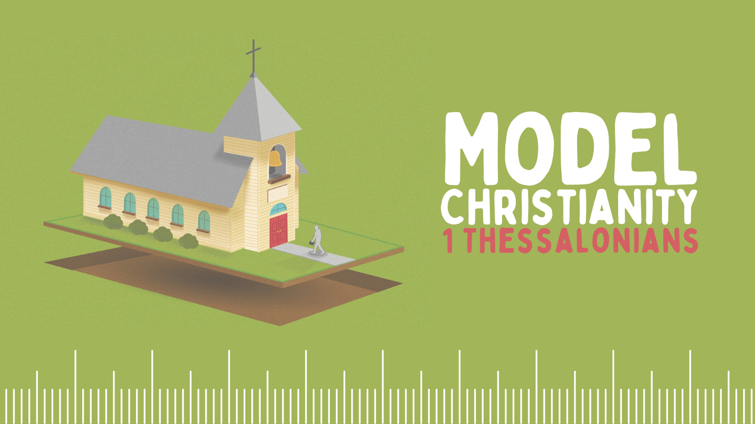

Growth Groups Material
(Studies on 1 Thessalonians)
Jan-Feb 2023



Booklet Contents
Introducing 1 Thessalonians |  | p.3
The format of these studies |  | p.5
TEACHING SERIES
Sermon | Passage
26-29 January | 1 Thessalonians 1:1-10 | Model Conversion | p.6
2-5 February | 1 Thessalonians 2:1-3:10 | Model Ministry | p.7
9-12 February | 1 Thessalonians 3:11-4:12 | Model Holiness | p.8
16-19 February | 1 Thessalonians 4:13-5:11 | Model Hope | p.9
23-26 February | 1 Thessalonians 5:12-28 | Model Christian Living | p.10

Additional Resources
 | Generic Question Worksheet (with more space for notes) | p.11
 | Map of Paul’s Second Missionary Journey  © Mark Barry 2008, visualunit.me | p.13
 | Introduction to 1 Thessalonians (link to website only)  https://www.thegospelcoalition.org/course/1-thessalonians/ | n/a
 | Commentary on 1 Thessalonians, authored by David Chapman, published online by The Gospel Coalition (link to website only)  https://www.thegospelcoalition.org/commentary/1-thessalonians/ | n/a

Introducing 1 Thessalonians
The story so far…
After the resurrection and ascension of Jesus in around AD33, the message of salvation in Him began its worldwide spread in the years that followed. One of the most important missionaries was the Apostle Paul. Paul travelled to Thessalonica in around AD50, with his co-workers, Silas and Timothy. There, they shared the gospel message about Jesus and a number of people responded in faith and were converted. However, these events also aroused significant opposition for the local Jews and Paul was forced out of town
- Read Acts 17:1-10 for an account of Paul’s visit to Thessalonica

The city of Thessalonica during Paul’s time was a major city in the region of Ancient Macedonia (now modern Greece). It was an important location for economic and political reasons, being situated on both an active port, and also the major East-West Roman road, known as the Via Egnatia. Archaeological evidence indicates that Thessalonian culture was steeped in Roman pagan religion, including the worship of the Roman emperor himself.
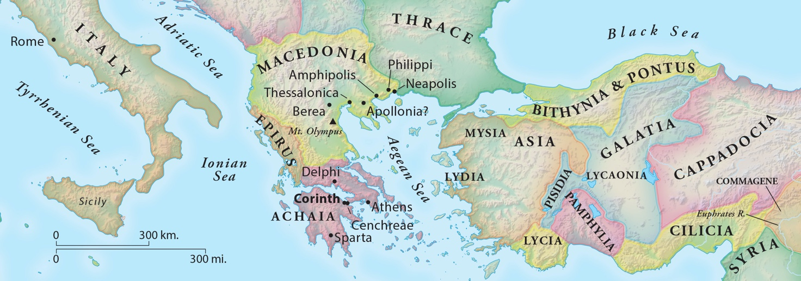

When and why did Paul write 1 Thessalonians?
After Paul had been forced away from Thessalonica, he was keen to stay in contact with the new believers, especially in light of the opposition that had been experienced. In his subsequent travels, Paul and Silas commissioned Timothy to return from Athens, to check on the Thessalonians (1 Thess 3:1-2). When Timothy returned to them, Paul was elated to hear of their enduring faith. He wrote to encourage them in this, and to continue to trust God’s promises to them in Jesus, and practice godliness.

Among the issues addressed in the letter, are the nature and sincerity of Paul’s ministry, the meaning of persecution, and question about what happens to believers after they die. In many respects, the Thessalonian church was the model church. Hence the title of this series. No doubt they had their flaws. But Paul is glowing in his praise of their continuing allegiance to Christ. The letter does not concern itself with threats of false teaching or problems with the church as is often the case with Paul’s other letters.

The format of these studies
The studies for this term are different to what we’re used to. We have reproduced the same 8 general, open questions. Broadly speaking, the questions take you through a process of bible observation (“What is said in this passage”), bible interpretation (“What is meant by what is said”) and bible application (“How should we respond”). You may recall that we trialled this with John’s gospel early in 2022. The letter of 1 Thessalonians affords us a good opportunity to revisit this approach, with a different genre of biblical literature. By way of reminder, here are some reasons why we think this approach is valuable:
- To grow confidence in God’s word: We’re convinced that by the power of the Holy Spirit, anyone can read the biblical text carefully and arrive at many helpful insights that can encourage, challenge and grow us. Sometimes a long list of questions over-complicates things and distracts us from this task. Or worse, we can become more interested in interpreting the questions and trying to answer them, than being led by the text itself.
- To develop Bible reading skills: In God’s kindness, our aim is that as we do this, we will develop in our ability to read the Bible well for ourselves. That is, to learn to look for the types of things that will help us understand a passage well.
- Flexibility: This format can be used by any individual or group, in whatever setting they find themselves in. You might like to use these questions with a friend or family member
- Simplicity: This approach will allow you, and your Growth Group leaders to approach the biblical text in the same way each week.
We recognize that this approach might not ‘gel’ with your style of thinking. Please have a go! And don’t worry if there are questions about the passage which remain unanswered. The aim is to discern the main thrust of a passage and be changed by what we learn. To help you out, we’ve added a couple of bonus application questions for each passage to help stimulate discussion.
1 Thessalonians 1:1-10 | Model Conversion

- What can you learn from this section about the person or situation to which the letter is written?
- Are there any important words which help us get to the heart of the author’s message? How do these words help us? (Hint: Are there repeated words, connecting words like ‘therefore’, ‘so’, ‘rather’).
- Do we learn something particular about God, Jesus, ourselves?
- Is there any past or future event(s), circumstances, or other person(s) described? Why has the author included this?
- Are any instructions or commands issued which we ought to follow? What are they?
- Are there any promises or assurances to be comforted by? What are they?
- Can you sum up the main point of the section (or subsections) in your own words?
- Does this passage call you to change something in your life? If so, how might you go about this? (Hint: This might be something we understand/believe or something we do or don’t do)

Bonus Application Questions
    - This passage speaks about the ‘conversion’ of the Thessalonians – from pagan idolatry to sincere Christian trust in Jesus. How is your own experience similar, or different to that of the Thessalonian church? Should there be similarities?
    - We are all creatures of hope, being shaped by our expectation of what the future holds For the Thessalonians, verse 10 says it all. What events in your future (actual or possible) is having the most impact on your current lifestyle?

1 Thessalonians 2:1-3:10 | Model Ministry

- What can you learn from this section about the person or situation to which the letter is written?
- Are there any important words which help us get to the heart of the author’s message? How do these words help us? (Hint: Are there repeated words, connecting words like ‘therefore’, ‘so’, ‘rather’).
- Do we learn something particular about God, Jesus, ourselves?
- Is there any past or future event(s), circumstances, or other person(s) described? Why has the author included this?
- Are any instructions or commands issued which we ought to follow? What are they?
- Are there any promises or assurances to be comforted by? What are they?
- Can you sum up the main point of the section (or subsections) in your own words?
- Does this passage call you to change something in your life? If so, how might you go about this? (Hint: This might be something we understand/believe or something we do or don’t do)

Bonus Application Questions
    - In this passage we see Paul reveal how his deepest emotions are connected to the spiritual welfare of his Christian friends? What do your deepest emotions indicate is most important to you? Should we be like Paul, ‘stressing’ about the spiritual welfare of others?
    - If you are engaged in leadership or ministry of any kind, what aspects of Paul’s character (described especially in 2:1-12) would you like to emulate?

1 Thessalonians 3.11-4.12 | Model Holiness

- What can you learn from this section about the person or situation to which the letter is written?
- Are there any important words which help us get to the heart of the author’s message? How do these words help us? (Hint: Are there repeated words, connecting words like ‘therefore’, ‘so’, ‘rather’).
- Do we learn something particular about God, Jesus, ourselves?
- Is there any past or future event(s), circumstances, or other person(s) described? Why has the author included this?
- Are any instructions or commands issued which we ought to follow? What are they?
- Are there any promises or assurances to be comforted by? What are they?
- Can you sum up the main point of the section (or subsections) in your own words?
- Does this passage call you to change something in your life? If so, how might you go about this? (Hint: This might be something we understand/believe or something we do or don’t do)

Bonus Application Questions
    - Is it God’s responsibility, or our responsibility to ensure we grow in holiness?
    - God’s will is for our sanctification (1 Thess 4:3). That is, to live differently to the world around us. What worldly, sinful ways are you currently trying to put to death? What godly patterns of behaviour would you like to grow in?

1 Thessalonians 4:13-5:11 | Model Hope

- What can you learn from this section about the person or situation to which the letter is written?
- Are there any important words which help us get to the heart of the author’s message? How do these words help us? (Hint: Are there repeated words, connecting words like ‘therefore’, ‘so’, ‘rather’).
- Do we learn something particular about God, Jesus, ourselves?
- Is there any past or future event(s), circumstances, or other person(s) described? Why has the author included this?
- Are any instructions or commands issued which we ought to follow? What are they?
- Are there any promises or assurances to be comforted by? What are they?
- Can you sum up the main point of the section (or subsections) in your own words?
- Does this passage call you to change something in your life? If so, how might you go about this? (Hint: This might be something we understand/believe or something we do or don’t do)

Bonus Application Questions
    - Do you fear death? Why or why not?
    - Twice, Paul urges the Thessalonians to encourage one another with the truths they are being taught (1 Thess 4:18, 5:11). How can we actively encourage one another about the hope we have?

1 Thessalonians 5:12-28 | Model Christian Living

- What can you learn from this section about the person or situation to which the letter is written?
- Are there any important words which help us get to the heart of the author’s message? How do these words help us? (Hint: Are there repeated words, connecting words like ‘therefore’, ‘so’, ‘rather’).
- Do we learn something particular about God, Jesus, ourselves?
- Is there any past or future event(s), circumstances, or other person(s) described? Why has the author included this?
- Are any instructions or commands issued which we ought to follow? What are they?
- Are there any promises or assurances to be comforted by? What are they?
- Can you sum up the main point of the section (or subsections) in your own words?
- Does this passage call you to change something in your life? If so, how might you go about this? (Hint: This might be something we understand/believe or something we do or don’t do)

Bonus Application Questions
    - This section contains a number of different exhortations. Which of them do you especially need to hear today? Why?
    - Paul reminds us of God’s faithfulness in verse 24. How are you comforted by the promise that God will work to sanctify you, if you belong to Jesus (verse 23)?

Passage: Date: (Page 1 of 2)
- What can you learn from this section about the person or situation to which the letter is written?

- Are there any important words which help us get to the heart of the author’s message? How do these words help us? (Hint: Are there repeated words, connecting words like ‘therefore’, ‘so’, ‘rather’).

- Do we learn something particular about God, Jesus, ourselves?

- Is there any past or future event(s), circumstances, or other person(s) described? Why has the author included this?

Passage: Date: (Page 2 of 2)
- Are any instructions or commands issued which we ought to follow? What are they?

- Are there any promises or assurances to be comforted by? What are they?

- Can you sum up the main point of the section (or subsections) in your own words?

- Does this passage call you to change something in your life? If so, how might you go about this? (Hint: This might be something we understand/believe or something we do or don’t do)

