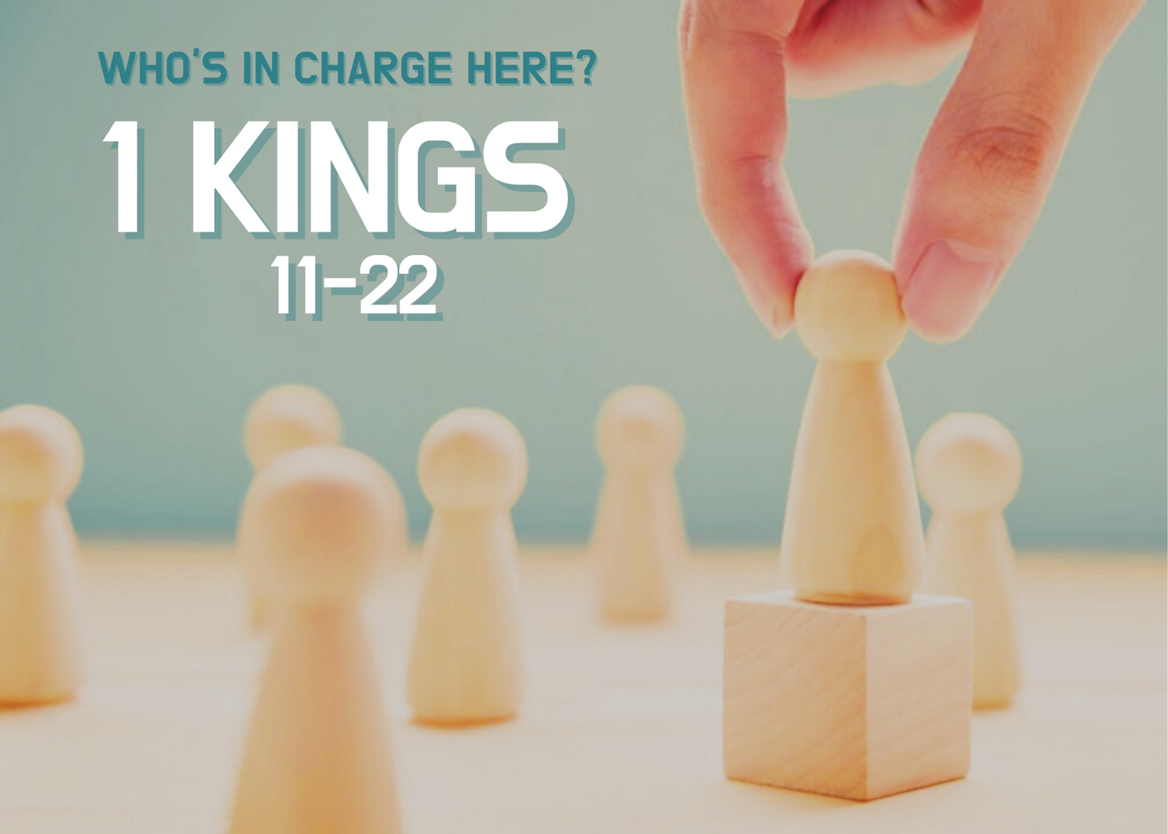
Growth Groups Material
(Studies on 1 Kings 11-22)
Apr-Jun 2022


Booklet Contents
Introducing 1 Kings 11-22 |  | p.3
TEACHING SERIES
Sermon | Passage
28 Apr-1 May | 1 Kings 11:14-12:24 | p.5
5-8 May | 1 Kings 12:25-14:20 | p.6
12-15 May | 1 Kings 14:21-16:28 | p.7
19-22 May | 1 Kings 17 | p.8
26-29 May | 1 Kings 18 | p.9
2-5 Jun | 1 Kings 19 | p.10
9-12 Jun | 1 Kings 20 | p.11
16-19 Jun | 1 Kings 21 | p.12
23-26 Jun | 1 Kings 22 | p.13

Additional Resources
 | Map: The Divided Monarchy  Holman Bible Publishers, 1992 | p.14
 | Infographic: The Kings of Judah and Israel  https://visualunit.me/2010/03/27/kings-of-judah-israel/ | p.15
 | Bible Timeline  https://visualunit.me/2010/03/18/bible-timeline/ | p.16
 | Chart: The trajectory of God’s Kingdom  Vaughan Roberts, God’s Big Picture: Tracing the Storyline of the Bible, InterVarsity Press, 2012. | p.17
 | Introduction to 1 & 2 Kings (link to website only)  https://www.thegospelcoalition.org/course/1-2-kings | n/a

Introducing 1 Kings 12-22

The story so far…
After creation and the fall, God set about putting things right again through Abraham and his family. He promised Abraham a multitude of descendants who would inherit land and would be blessed by God. In fact, the whole world would be blessed through this nation (Genesis 12:1-3). However, Abraham’s family, and the fulfillment of these promises, faced a setback when they found themselves enslaved in Egypt. God showed his great power and love for his people by rescuing them from Egypt and entering into a covenant with them - a covenant full of promises, warnings and all kinds of regulations governing the relationship between God and his chosen people (Exodus-Deuteronomy). God eventually led them into the promised land of Canaan (Joshua). After a rough start (Judges), the people asked God to give them an earthly king like the other nations. So He did. First Saul, and then David (1-2 Samuel). 1 Kings picks up the story towards the end of David’s life and initially focuses on the reign of Solomon, David’s son. This is a great high point in Israel’s history. Solomon builds God’s temple and the people enjoy peace and prosperity. But things turn sour because Solomon disobeyed God, married foreign wives, and worshipped false Gods. This would be the beginning of the end for the Kingdom of Israel.

What’s the purpose of 1 & 2 Kings?
1 & 2 Kings was written for God’s people in exile in Babylon. They’d lost God’s land, king, city and temple. It seemed like the forces of this world had overwhelmed God and his promises. If the God of their fathers did exist, and was good and all-powerful, how was it that his chosen city and temple had been destroyed. Why has God’s chosen royal family all but come to its end? The answers in 1 & 2 Kings are simple, but profound. God’s people were being judged by God for their ongoing sin – led by their kings.

However, there is still hope, because 1 & 2 Kings reveals that history is not determined by human forces, but by God keeping his promises. In these books we see a partial fulfilment of God’s promises to David (to establish the kingdom of his son), but the ultimate fulfillment was still to come. 1 & 2 Kings is also written for us! God has now appointed Jesus – descended from David, raised from the dead- to rule His kingdom forever. In 1 & 2 Kings God has given us wisdom for salvation through faith in Christ Jesus (2 Timothy 3:15).

What about 1 Kings 11-22.
1 Kings 11-22 begins the account of the downfall of the Kingdom of Israel. First, the people divide, into a Southern Kingdom, known as ‘Judah’, and a Northern Kingdom, known as ‘Israel’ (yes, this is confusing). Then, we get successive accounts of the kings in each of these two kingdoms. Some are given more attention. Others less. A few are faithful and serve God. The majority don’t! Instead, they rebel against God and worship false idols. Amidst this rebellion, the theme of God’s powerful word keeps bobbing up. Numerous prophets, speaking God’s word engage with, and judge the kings. The most well-known of these prophets is Elijah – who gets plenty of airtime from chapter 17 onwards, along with his nemesis King Ahab.

What about us?
As events unfold, readers must ask the question – “Who’s in charge here?” Who is calling the shots? Who rules history? Is it the kings with their earthly power? Will they get away with rebellion? Is it Baal and the so called ‘gods’ of the other nations who are in charge? Time and again we will be reminded that God’s will, expressed through His word is utterly supreme. If only there was a faithful King who would obey God’s word completely. Then God’s people would be blessed! Reading 1 Kings brings into sharp relief the character of the perfect, faithful leader that God’s people need - King Jesus. The promised Son of David, upon whom we can truly pin our hopes and serve with confidence.

1 Kings 11:14-12:24

- We’re beginning a new teaching term looking at the second half of 1 Kings. Skim through chapters 1-11, which we looked at in 2021. What key events took place in these chapters?

- Read 1 Kings 11:9-13. Why was God angry with Solomon? What is God going to do about this? Is there any hope offered to Solomon?

- Read 1 Kings 11:14-25. In these verses Hadad the Edomite and Rezon son of Eliada are described. What do they have in common with each other?

- Read 1 Kings 11:26-43. Jeroboam is introduced. What plans does God have for him?

- Read 1 Kings 12:1-24. These verses describe Rehoboam and his early leadership. What words would you use to evaluate Rehoboam’s leadership?

- How does this chapter represent a major contrast with the trajectory of chapters 1-11?

- What evidence do we see of God’s faithfulness to his word in this section?

- We’ve called our teaching series for this term: “Who’s in charge here?” Based on this chapter, why do you think this is an appropriate title?

- Perhaps you know of people, or churches that have drifted away from God and his word? How does this chapter help us understand why this happens?

- According to this chapter, God is sovereign over the worst moments in history, even amongst his own people. Can you think of sad moments, or even times of stupidity (like Rehoboam) in your own life? How are you comforted knowing that God remains in control over these things?

- J.I. Packer writes: “In the Bible, divine sovereignty and human responsibility are not enemies. They are not uneasy neighbors…They are friends, and they work together.” Do you find it easy to accept, or even understand how God’s control and human choice work together?

1 Kings 12:25-14:20

- Can you think of famous historical figures who have left an awful legacy on history?

- Read 1 Kings 15:33-34, 2 Kings 13:1-2, 17:21-23. How would you sum up the role Jeroboam plays in the history of Israel (the Northern Kingdom)? In this passage we’re going to see why Jeroboam is such a notorious figure.

- Read 1 Kings 12:25-33. What is motivating Jeroboam in his decisions? What other OT events does this section remind you off?

- In modern Australia, we’re less likely to worship golden calves or other statues. What might our idols be? And how would we know?

- In our day, where do we see people redefining God according to their own ideas, like Jeroboam did?

- Read 1 Kings 13:1-10. What is God’s response to Jeroboam leading God’s people astray into idol worship?

- Read 1 Kings 13:11-34. This is an odd little interruption to the account of Jeroboam. What big point is being made by these events and how do they relate to Jeroboam?

- Read 1 Kings 14:1-20. What attitude towards Ahijah, the prophet, does Jeroboam have? What word of God do we see fulfilled in this section? What is promised, but yet to be fulfilled?

- Whilst the events of the Old Testament can’t always be applied to us directly, what warning should we take from the story of Jeroboam?

- How does this chapter grow our confidence in God’s word of promise to Christian believers?

- What would it look like to take the Word of God as seriously as it deserves?

1 Kings 14:21-16:34

- In the Bible, which category do you consider more important – kings or prophets? Why?

- Can you complete the following table summarising the kings of Judah (the southern kingdom):

Verses | Name | Relationship to previous King | Key info/events | God’s assessment of their reign | How did they die?

- Can you complete the following table summarising the kings of Israel (the northern kingdom):

Verses | Name | Relationship to previous King | Key info/events | God’s assessment of their reign | How did they die?

- How many times in these chapters do we see a reference to the Word of the Lord being fulfilled? Why do you think the author emphasizes this so often?

- If the Word of the Lord never fails, as we see in this chapter, in what sense is this good news. In what sense is this bad news?

- What hope for God’s people appears in these chapters?

- “Our fate depends on the character of our King?” Do you agree with this statement?

- Read Luke 4:1-13. How is Jesus different to the kings we read about in this section of 1 Kings?

- What elements of Jesus’ godly leadership of his people are you thankful for?

1 Kings 17

- From chapter 17 onwards the pace of the narrative slows down. Whereas chapters 14-16 covered several kings, the focus now is on the reign of King Ahab of Israel, and his contemporary, the prophet Elijah. Re-read 1 Kings 16:29-34. What was so bad about Ahab?

- Read 1 Kings 17:1. What is God’s response to the idolatrous behaviour of Ahab and the nation of Israel?

- The false God Baal was associated with weather and fertility. Baal-worshippers believed that if they appeased him, he would send good weather and their crops would flourish. How does this background shed light on God’s purposes in withholding rain?

- Read 1 Kings 17:2-24. Despite the lack of rain and the famine which ensued (18:2), God provided for the physical needs of his prophet, Elijah. How does he do that?

- Do you see any significance in the location of the events which begin in verse 8?

- Where in the chapter do we see references to God’s word? What point is being made in those instances? How does this add to our understanding of God’s word which has been developing throughout this series?

- Elijah’s ministry was accompanied by some incredible miracles? What were the two miracles he performed? What was the point of these miracles, do you think?

- How does the ministry of Elijah in this chapter remind us of Jesus? What response is God looking for when we encounter men such as this? How is the widow’s response to Elijah in verse 24 a good model to follow?

- Read James 5:17. Do you think we have much in common with Elijah. What is similar about our situation, compared to his? What is different?

- How is Elijah an example of faith for us to follow?

- Have difficult circumstances ever led you to doubt God’s faithfulness and goodness towards you? What helps you trust God during these times?

1 Kings 18

- When have you seen a sporting team utterly defeated?

- Read 1 Kings 18. If you can, split into smaller groups and have each group read different sections and summarise what happens? (Verses 1-15, 16-29, 30-46).

- Describe the situation in Israel at the time of 1 Kings 18?

- What is God going to do about the problem of severe famine? How is this related to Elijah showing himself to Ahab? (v.1)

- Why does Elijah summon all the prophets to meet him at Mt Carmel in v.20?

- Compare the accounts of the offering to Baal and the offering to Yahweh? How is God’s supremacy demonstrated in these events?

Offering to Baal (verses 25-29) | Offering to Yahweh (verses 30-38)

- What is the connection between Elijah proving that YHWH is God, and the problem in the story, the famine?

- Read 1 Thessalonians 1:6-10. Paul talks about how the Thessalonians have repented and turned to Christ. In what ways are their repentance similar or different to the way the people of Israel recognised Yahweh as God in 1 Kings 18?

- What convinces you that Jesus is the only true and living God?

- The God of the Bible, who took on flesh in Jesus, is the only true and living God worthy of our trust and worship.
  - What false gods are you tempted to trust in instead of Him?
  - What practical steps can you take in your life to turn away from these gods?

1 Kings 19

- Can you think of a time in your life when a high point was followed by a low point? How did it affect you?

- Read 1 Kings 19:1-9. What threat to Elijah unfolds after the ‘God contest’ of chapter 18? Do you think he responds rightly?

- What do we learn about God’s care for his people? Is God interested in our spiritual welfare only, or other elements of our experience?

- What is significant about the location that Elijah ends up at?

- Read 1 Kings 19:9-18. What is it that is causing Elijah’s despair?

- The author seems to focus on the manner in which God communicates with Elijah? What point about God is being conveyed in verses 11-13?

- How do you think we should feel about Elijah’s despair in this chapter? Has he stopped trusting God? Can you identify with his struggles?

- Read 1 Kings 19:19-21. Here we are introduced to Elijah’s successor Elisha. He will feature prominently in 2 Kings. For now, Elijah and Elisha are together. How is the presence of Elisha part of God’s kindness towards Elijah amidst his despair?

- Jesus went through a similar ordeal to Elijah in the Garden of Gethsemene, the night before he died (read Luke 22:39-46). What kept him focused on his mission?

- Have you ever felt like God’s purposes are a lost cause? What has made you feel like this? What do we learn about God’s character in this chapter that can encourage us when we feel like that?

- What can we learn from God’s treatment of Elijah, about how to deal sensitively with fellow believers who are feeling down, exhausted, or otherwise under great stress?

1 Kings 20

- Do you think the rulers of our world will one day bring justice and peace to all people? Why or why not?

- Read 1 Kings 20:1-12. A powerful menacing enemy threatened the northern kingdom of Israel. How would you describe the way Ahab deals with Ben-hadad?

- Read 1 Kings 20:13-25. How does victory come to Ahab and the people of Israel? How is the word of the prophet in verse 22, different to the word in verses 13-14? What does this imply about the object of Ahab’s faith?

- Read 1 Kings 20:26-34. Why did Ahab have mercy on Ben-hadad? On what grounds might you think this was a good thing?

- Read 1 Kings 20:35-43
- What light do the two ‘failures’ in v 35-36 and v 37-40 cast on Ahab’s failure? Why should Ahab have killed the enemy of God’s people? (See v 42 and also v 28)?

- In what situations might we be tempted to think that our view of being kind/expedient is better than obeying God’s word?

- From this chapter, in summary, how does Ahab fail to be the king God’s people need?

- As God’s ultimate king, Jesus has defeated the great enemies of humanity – sin, death and Satan. One day he will destroy them all completely. He is the hope of the world! (Hebrews 2:14-15, Colossians 2:13-15 & 1 Corinthians 15:20-28).

  - How does knowing this help us to trust in Jesus?

  - What implications does this have for how we relate to the enemies of God today? (See Matthew 5:44, Romans 12:19-21) What is wrong with saying that 1 Kings 20 tells us to destroy the enemies of God?

- Reflecting back to the opening question, who or what is the only hope for lasting and universal justice and peace? What implications might flow from this for us?

- What would be good to ask in prayer, or to thank God for, as a result of hearing His word in this chapter?

1 Kings 21

- In what ways do we see leaders (of all kinds) using power for selfish ends? In what ways might we also do this – exercising whatever (perhaps small scale) power we might have for selfish ends?

- Read 1 Kings 21:1-16.
  - From this section, what kind of leader was king Ahab?
  - How would you describe the leadership style of Jezebel?
  - To what extent was Ahab complicit in the killing of Naboth? What do you think he should have done?
  - What other parts of the Bible does this bring to your mind?

- Read 1 Kings 21:17-26.
  - What was God’s perspective on Ahab and what he did? (And didn’t do!)
  - God’s words of judgment on Ahab and Jezebel were fulfilled in history. See 1 Kings 22:37-38, 2 Kings 9:30-37 & 2 Kings 10:1-17 (if you can stomach it!). What does this teach us about God and his word?
  - Was Ahab really that bad? What does the narrator tell us in v 25-26? What was at the heart of his sin?

- Read 1 Kings 21:25-29.
  - Upon hearing of the coming judgment, what impact did God’s word have on Ahab? (Even if only temporarily!)
  - Although were not told that Ahab cried cry out to God for mercy, nor took steps to rectify what he had done, or even commit himself to change his ways, God showed mercy by delaying his punishment. What aspect of God’s nature does this illustrate?
  - How might this encourage/ instruct us when we consider our own sin, or the sin of others?

- How might 1 Kings 21 help us to more deeply appreciate Jesus - his character as a ruler, his death and his eventual return? (If you’re stuck for ideas, you might be helped by considering: Isaiah 9:6-7, Mark 10:42-45, John 10:14-15, Romans 3:21-26, Acts 17:30-31, 2 Peter 3:13)

- It’s not easy for sinful people to take responsibility in leadership and consistently do what is right.
- Give thanks for Jesus - for the kind of ruler he is, for his death, and that he will return to put all thing right.
- Give thanks for those willing to serve by leading our nation, institutions and churches.
- Pray for leaders to be humble, wise and just - concerned for the wellbeing of those they serve. (1 Tim 2:1-4)
- Pray that you will be submissive to all governing authorities (Romans 13:1-7, 1 Peter 2:13-17)
- Pray that you yourself will act justly and love mercy (Micah 6:8) in situations where you have power (eg. as parents, at work, in clubs, with people relatively more vulnerable than ourselves, etc).
1 Kings 22

- Have you ever responded to a message from someone, only to find out that it wasn’t who you thought it was?

- Ahab has been king in Israel since Chapter 16. What do you remember so far about the reign of Ahab?

- Read 1 King 22:1-12. What do the two kings (of Judah, and of Israel) want to do? How would you describe the relationship between the two kings?

- Judah and Israel seem to be working together to restore the kingdom! Do you think this is a good thing or a bad thing? How do you expect the story to go?

- Amidst the 400 prophets blessing the kings plans for war, we’re introduced to another prophet: Micaiah, son of Imlah. Read 1 Kings 22:13-28. What does Micaiah say regarding this situation? How does it compare to the word of the other ‘prophets’?

- We have a dilemma. There are prophets, who all claim to have the word of God, saying different things. How can we know what is from God and what is from a ‘lying spirit’ (v22)? What does this event teach us about listening to the word of God?

- Read 1 Kings 22:29-39. What is the outcome of the battle? Which prophets were correct about God’s word?

- Ahab had 400 prophets who told him what he wanted to hear and ignored the one prophet who told him the actual word of God. In what way are we tempted to do the same?

- Read 2 Timothy 3:14-4:4. How does this passage help us think about discerning what is truly God’s word? How can we help each other to guard against our itching ears?

- Sometimes people share with us that God has spoken to them, encouraging a certain course of action (e.g. to enter or break a relationship, to take a certain job, to leave church, etc). How should this chapter shape our response to situations like that? What distinguishes us from the likes of Ahab and Jehoshaphat who were tasked with discerning which prophets were legitimate?

- Pray for diligence to test the messages we hear and for discernment as we examine their consistency with God’s full and reliable revelation in the Bible.

