

Growth Groups Material
(6 Studies on 1 Corinthians 8-11)
Nov-Dec 2022


Introducing 1 Corinthians
The story so far…
After the resurrection and ascension of Jesus in around AD33, the message of salvation in Him began its worldwide spread in the years that followed. One of the most important missionaries was the Apostle Paul. He planted a church in Corinth in around AD51 and stayed there for around 18 months. The church members were likely from a range of backgrounds – rich and poor, Jew and Gentile.
Fun fact: Historians use Paul’s time in Corinth to piece together the chronology of his life. In Acts 18:12ff, during Paul’s time in Corinth, we read of Gallio, the ‘proconsul of Achaia’ (the region Corinth was situated it). 20th century archaeological discoveries in Greece refer to Gallio’s time in office being around AD51-52. Hence, we can date Paul’s time in Corinth to around the same time.

The city of Corinth during Paul’s time was a melting pot of ethnic people groups, pagan religion and Greek philosophy. Located by the narrow strip of land connecting Achaia to mainland Greece, it also controlled a vital sea-trade route, and as such become a prosperous, wealthy city. The moral corruption that often trickles down from wealth, was rife in Corinth, especially sexual immorality. 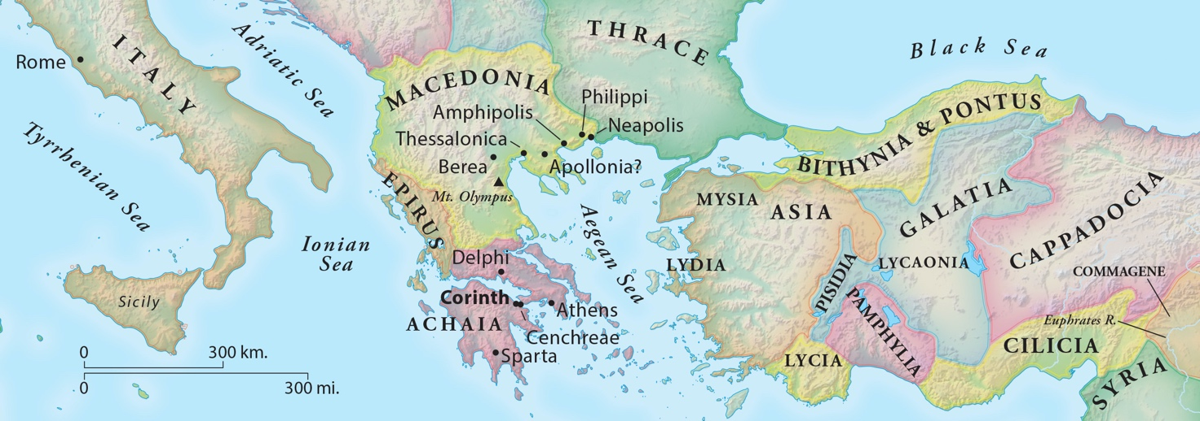
When and why did Paul write 1 Corinthians?
After leaving Corinth, Paul continued in his missionary journeys. A few years later, when he was in Ephesus (around AD54) Paul began hearing of problems emerging in the Corinthian church: from Chloe’s household (1:11); a letter he had received (7:1); and/or the visit of three men from the church, Stephanas, Fortunatus and Achaicus (16:17). 1 Corinthians is the second of (perhaps) four letters Paul wrote to the church:
- A ‘previous’ letter not preserved (referred to in 1 Cor 5:9)
- 1 Corinthians (written in Ephesus in around AD54-55, c.f. 1 Cor 16:8)
- A ‘severe’ letter not preserved (referred to in 2 Cor 2:4, 7:8)
- 2 Corinthians

Paul wrote 1 Corinthians, to address the many moral compromises being made by the church, and their confusion surrounding a range of matters – especially as they relate to the unity, holiness and the orderly ministry of the church.
In chapters 8-11, Paul transitions out of his teaching on sex, marriage, divorce and singleness and addresses other issues which have been drawn to his attention. In particular, chapters 8-10 all revolve around the question of whether Christians could eat food sacrificed to idols.
Note: In the ancient world animal sacrifices were a regular part of pagan worship. The temple served not only as a place of worship but also the local butchers shop. People served and sold meat that originated as a pagan sacrifice.
Differences in the congregation over ‘idol-food’ afforded Paul an opportunity to teach important principles about how we relate to others in our church family, especially if we disagree with them. Paul even uses himself and his ministry as a detailed example of the mindset to adopt. After, this Paul gets into some more niche issues including what men and women ought to wear in church, and how to share the Lords Supper together. A consistent theme throughout this section will be whether we insist on our freedom in Christ to do as we think, or will we be shaped by other-person centredness and love. There is lots of helpful teaching on how we ought to relate to one another within God’s family!

Teaching Series and Booklet Contents
Sermon | Passage/Title
3-6 November | 1 Corinthians 8
 | Study 1 ………………………………………………………………………………. | p.5
10-13 November | 1 Corinthians 9:1-23
 | Study 2 ………………………………………………………………………………. | p.6
17-20 November | 1 Corinthians 9:24-10:22
 | Study 3 ………………………………………………………………………………. | p.7
24-27 November | 1 Corinthians 10:23-11:1
 | Study 4 ………………………………………………………………………………. | p.8
1-4 December | 1 Corinthians 11:2-16
 | Study 5 | p.9
8-11 December | 1 Corinthians 11:17-34
 | Study 6 | p.10

Additional Resources
 | Map of Paul’s Second Missionary Journey  © Mark Barry 2008, visualunit.me | p.11
 | Introduction to 1 Corinthians (link to website only)  https://www.thegospelcoalition.org/course/1-corinthians-courses/ | n/a

Study 1 | 1 Corinthians 8
- Have you ever eaten at a restaurant (maybe Thai or Indian) and seen a shrine to a divine figure? How does it make you feel?
- Read 1 Corinthians 8:1-13. What is the situation in Corinth that Paul is addressing here? Which different groups of people within the church are being discussed?
- What do Christians know about God? How would this shape our understanding of idols, and of food sacrificed to idols?
- What is Paul’s direction to those who feel free to eat food sacrificed to idols?
- Do you think there may be things you do as a Christian that make other Christians uncomfortable? Or which may be unhelpful for their faith?
- Are there things that other people do which make you uncomfortable but aren’t technically ‘wrong’? How should you go about handling that?
- Eating food sacrificed to idols might not be the hot button issue for us today? Are there other issues that Christians might disagree about, and which the principles we’ve learn would be applicable?
- How does this passage challenge our view of Christian maturity?
- Pray for loving hearts that are sensitive to other people and willing to forego our rights for the sake of others

Study 2 | 1 Corinthians 9:1-23
- What are your most important rights? Would you ever give them up, or allow them to be taken from you?
- Read 1 Corinthians 9:1-19. What rights does Paul claim to have by virtue of being an apostle?
- What is Paul’s main message about his own approach that he’s trying to encourage in the Corinthians?
- Read 1 Corinthians 9:20-23. What is Paul’s pattern of life, and why?
- Is there anything you think ought to change in order to win more people to Christ:
  - in your personal life;
  - in your family life;
  - in our church life.
- Paul’s philosophy seems very open ended: “all things to all people”. Thinking about our efforts to connect people to Christ (whether personally, or through church), what are the non-negotiables? What can we be flexible about?
- These days, it seems that in many cases that “if you don’t stand up for your rights, who will?”. Other paraphrases of this sentiment might be “lookout for number one, because no one else will”. What is it about the gospel that helps us deny ourselves voluntarily?
- Pray that we’d have the attitude of Paul: completely consumed by Christ and his mission that we are willing to sacrifice many things to serve him more!

Study 3 | 1 Corinthians 9:24-10:22
- Is absolute freedom a good or a bad thing?
- Read 1 Corinthians 9:24-27. These verses relate to what follows in chapter 10. What is Paul concerned about for the Corinthians?
- Read 1 Corinthians 10:1-13.
  - Who does Paul use an example to the Corinthians?
  - What do the Corinthians have in common with them?
  - What is the warning Paul is issuing?
- Which do you think you are in more need of at the moment: warnings or assurance? Why?
- Read 1 Corinthians 10:14-22. What is the command Paul issues and why?
- What are our idols?
Note: an idol is something that we serve, or put first in our lives, rather than God. Imagine the part of your life that you couldn’t live without. Or finish the sentence: “I’ll really be happy when _______”. This is an idol.
- How might we try to hold onto our idols, even as we follow Jesus as Lord?
- Pray for a cautious and sober-minded approach to our freedom in Christ. Pray that we learn from the examples from the Old Testament, not to flirt with sin

Study 4 | 1 Corinthians 10:23-11:1
- Read 1 Corinthians 10:23-11:1 Paul returns to the issue of eating ‘idol food’. It seems as though eating ‘idol food’ from the meat market might be acceptable, depending on the context. When would eating the meat be acceptable? What is the rationale of for this?
- When would eating the meat be discouraged? What is the rationale for this?
- Can you think of other examples where acting in love towards others might require you to give up your liberty?
- Verse 31 is well-known and oft-quoted. How is it a good summary of what Paul has been teaching in the last few chapters. Are you mindful of living to glorify God in all areas of your life?
- Paul calls us to imitate himself, as he imitates Christ. How is Christ the best example of the principles Paul has taught over the last few chapters.
- Pray for that we’d have the same selfless mindset that Christ exhibited, and which Paul imitated.

Study 5 | 1 Corinthians 11:2-16
- Why is it easier for us to follow the culture of our day than the Bible? What are the advantages of following the cultural norms we are familiar with? What are the dangers?
- Read 1 Corinthians 11:2-16. What (in a nutshell) are the men and women in Corinth told to do?
- A range of reasons are given for this instruction. Can you summarise the reasons given in verses:
  - 3-6
  - 7-9
  - 10
  - 13-15
  - 16
- To what extent are these reasons tied only to first century Corinthian culture? Or should they apply to all cultures, in all places at all times? How might you tell the difference?
- In passages such as this, and others (like 1 Timothy 2:8-15, Ephesians 5:22-33) the Bible acknowledges differences of roles between men and women (in church, and in homes). What is your reaction to this element of biblical teaching? What is good about recognizing different roles for men and women? What are some of the dangers?
- Why are verses 11 and 12 so important in ensuring we don’t misunderstand what Paul is saying?
- In our culture what demeanour, dress codes or symbols or might express or suppress the gender distinctions God has built into creation?
- Pray for wisdom to understand what God teaches us here, and discernment about how to express our God-given ‘male-ness’ and ‘female-ness’ in suitable ways.

Study 6 | 1 Corinthians 11:17-34
- In what way is celebrating the Lord’s Supper meaningful to you? What do you think are the most important aspects of the Lord’s Supper?
- Read 1 Corinthians 11:17-34. What is happening in Corinth that Paul is concerned about?
- In verses 23-26 Paul recounts the tradition about the Lord’s Supper that he passed on to the Corinthians.
  - What happens when we share the Lord’s Supper?
  - Why do you think Paul recounts the meaning of the Lord’s Supper as he does here?
- From verse 27 onwards, Paul explores the implications of what he has said.
  - What is eating or drinking in ‘an unworthy way’?
  - What is the big warning Paul issues?
  - What does Paul encourage?
- Do you take the Lord’s Supper seriously when you partake of it?
- Are there other practices we have at church, or ways of doing things, that express division rather than unity?
- In what ways might we fail to think of others when we meet together as the church?
- Pray that we would reflect the seriousness of Jesus’ death in our attitudes towards the rest of the church body. If necessary, ask for forgiveness and for God’s help to regard and act differently towards others.

