

Growth Groups Material
(7 studies on Romans 5-8)
Oct-Dec 2024
LEADERS GUIDE



Teaching Schedule
In our gatherings we will work through a 7-part series: | 17-20 Oct  24-27 Oct  31 Oct-3 Nov  7-10 Nov  14-17 Nov  21-24 Nov  28 Nov-1 Dec | 1: Romans 5:1-11  2: Romans 5:12-21  3. Romans 6:1-23  4. Romans 7:1-25  5. Romans 8:1-17  6. Romans 8:16-27  7. Romans 8:28-39

Booklet Contents
Introduction | p.3
Study 1 (Romans 5:1-11) | p.8
Study 2 (Romans 5:12-21) | p.11
Study 3 (Romans 6:1-23) | p.15
Study 4 (Romans 7:1-25) | p.18
Study 5 (Romans 8:1-17) | p.22
Study 6 (Romans 8:16-27) | p.25
Study 7 (Romans 8:28-39) | p.29

Additional Resources
We’ve put together some additional resources that might help you as you make your way through this series:

https://jannalianglican.org.au/livingundergrace/ | 

Introduction
The book of Romans is one of the most well-known and influential of Paul’s New Testament letters. A church in Rome had likely developed very soon after the ascension of Jesus. There were people from Rome present in Jerusalem, on the Day of Pentecost, when Peter delivered his famous speech (Acts 2:10). Paul, though, had never been to Rome. After many years of missionary journeys around other parts of the ancient Mediterranean, Paul had plans to travel west, via Rome, towards Spain (Rom 15:22-24). So, he writes this letter to the church, most likely from Corinth, around 57AD, to pave the way. In it, he sets out his mature, comprehensive understanding of the Christian gospel, sharpened over many years of study and proclamation.
Earlier in the year, we saw that the main message of Romans 1-4 was that we’re saved by faith not works. It’s not our moral or religious performance that saves us, but God’s gift through faith in Christ. In chapters 5-8 Paul unpacks how our life and future is changed by this gift of salvation. His arguments will provide us with deep assurance of our new status before God, as well as convict us about the new life that God both gives us, and calls us to live by. We’ve termed the series ‘Living under grace’.
As we learn how to ‘live under grace’ we’ll reckon with our new identity, our wonderful certain hope, our present experience of battling with sin (even as we’re being transformed by God) and lots more. Yes, there’s a few paradoxes. But if you’re finding that odd, be assured, others have felt this as well: famous 16th century German reformer, Martin Luther, said Christians are “simul justus et peccator”, meaning Christians, are at the same time, both righteous and sinners. There is much rich but complex truth packed into these 4 chapters. But it’s worth the effort to get our heads into it, so that our hearts and hands will be transformed. We pray you will benefit greatly from examining this wonderful letter with each other.

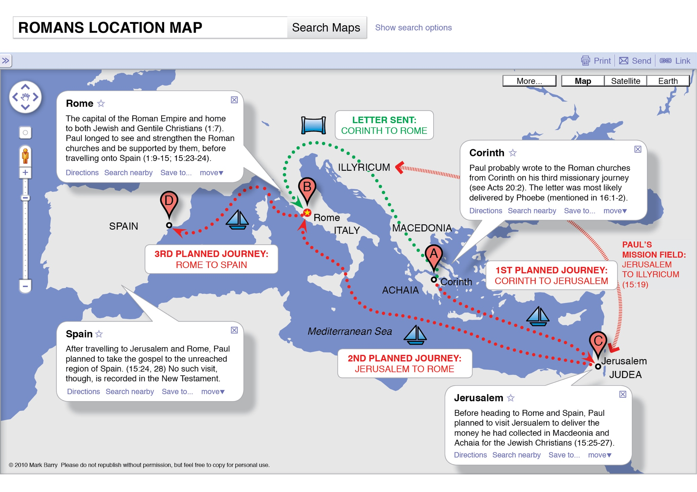
*Graphics produced by Mark Barry (Visual Unit): https://visualunit.me/tag/romans/
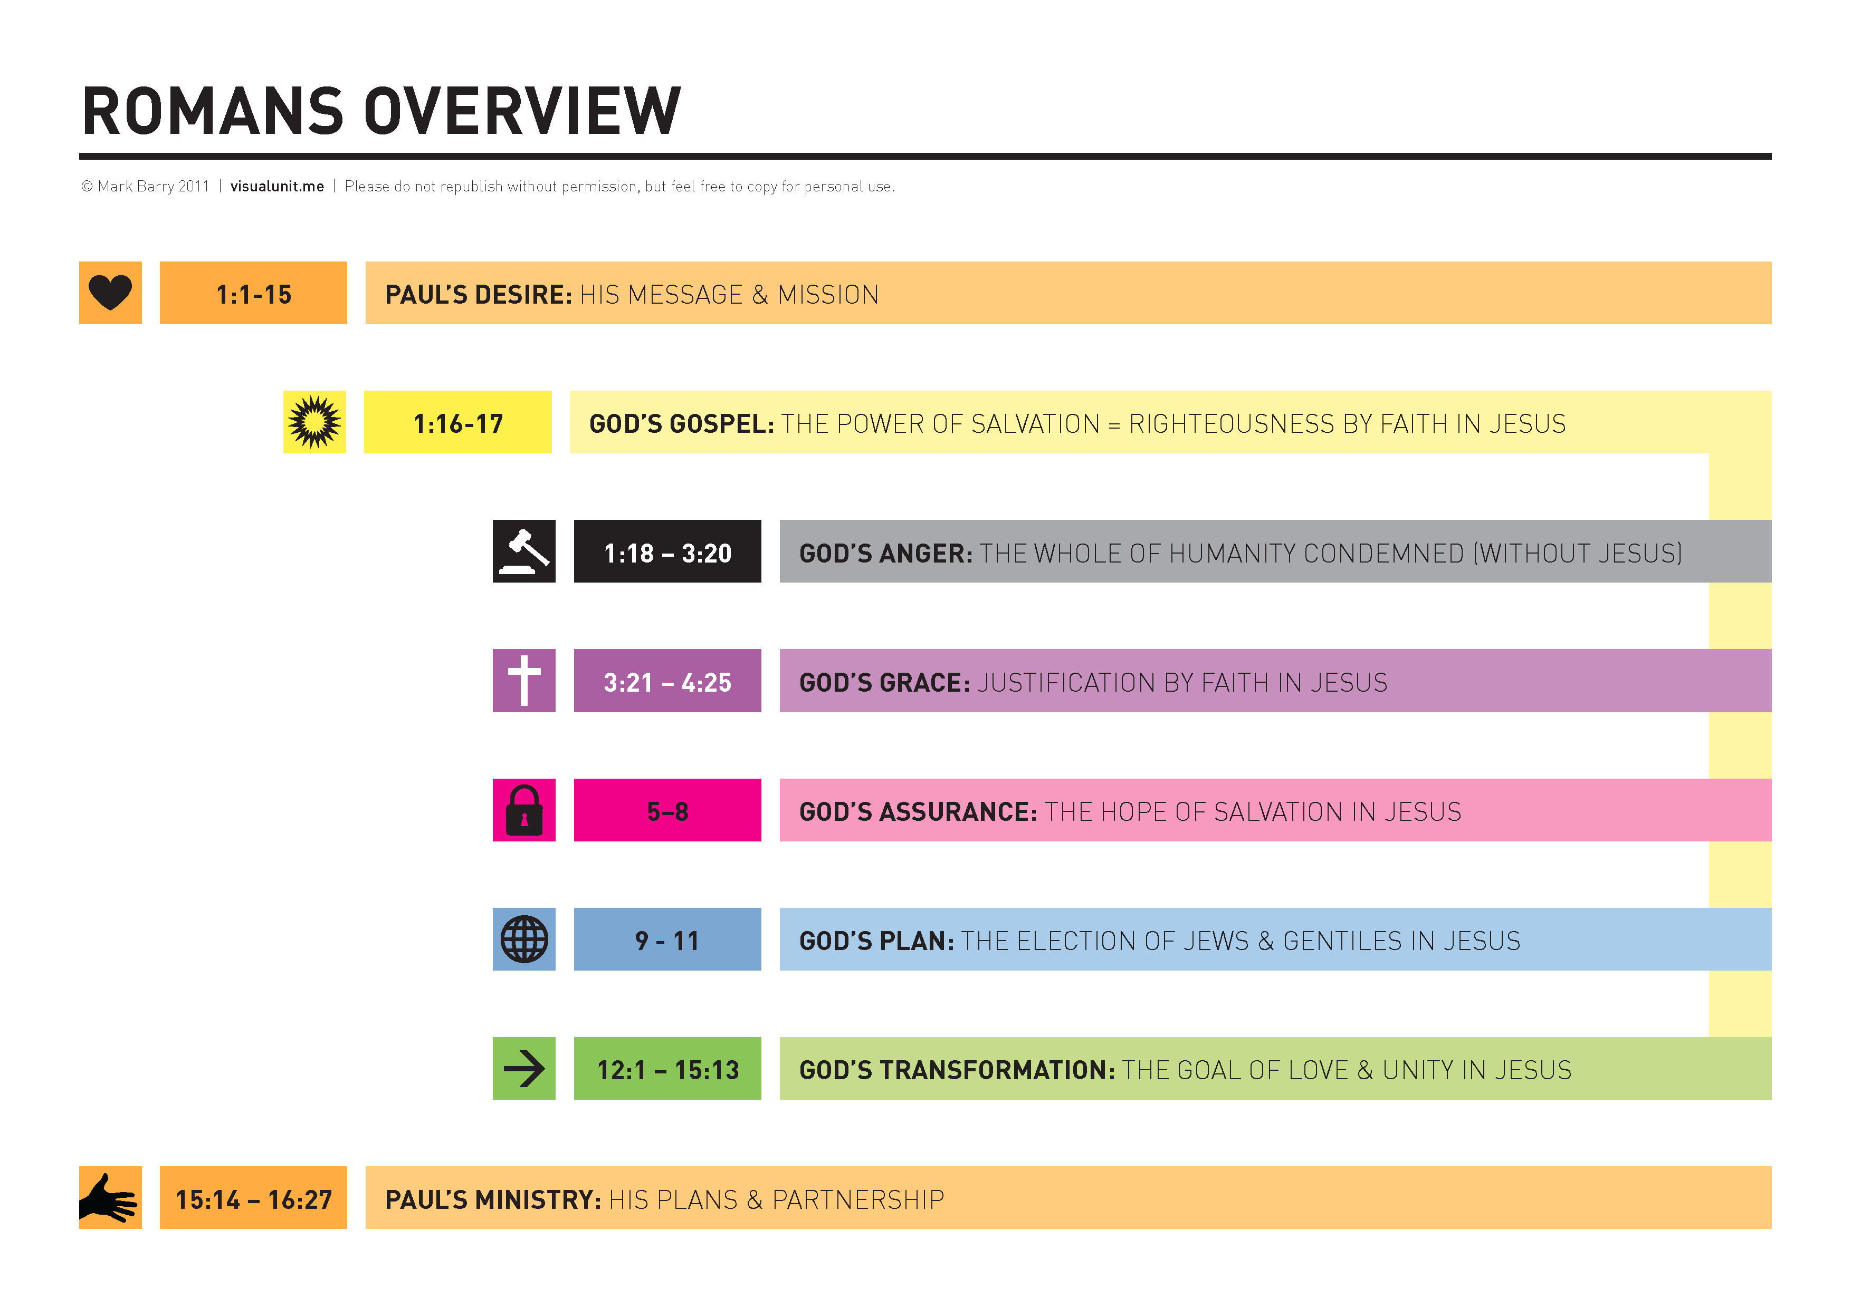
*Graphics produced by Mark Barry (Visual Unit): https://visualunit.me/tag/romans/
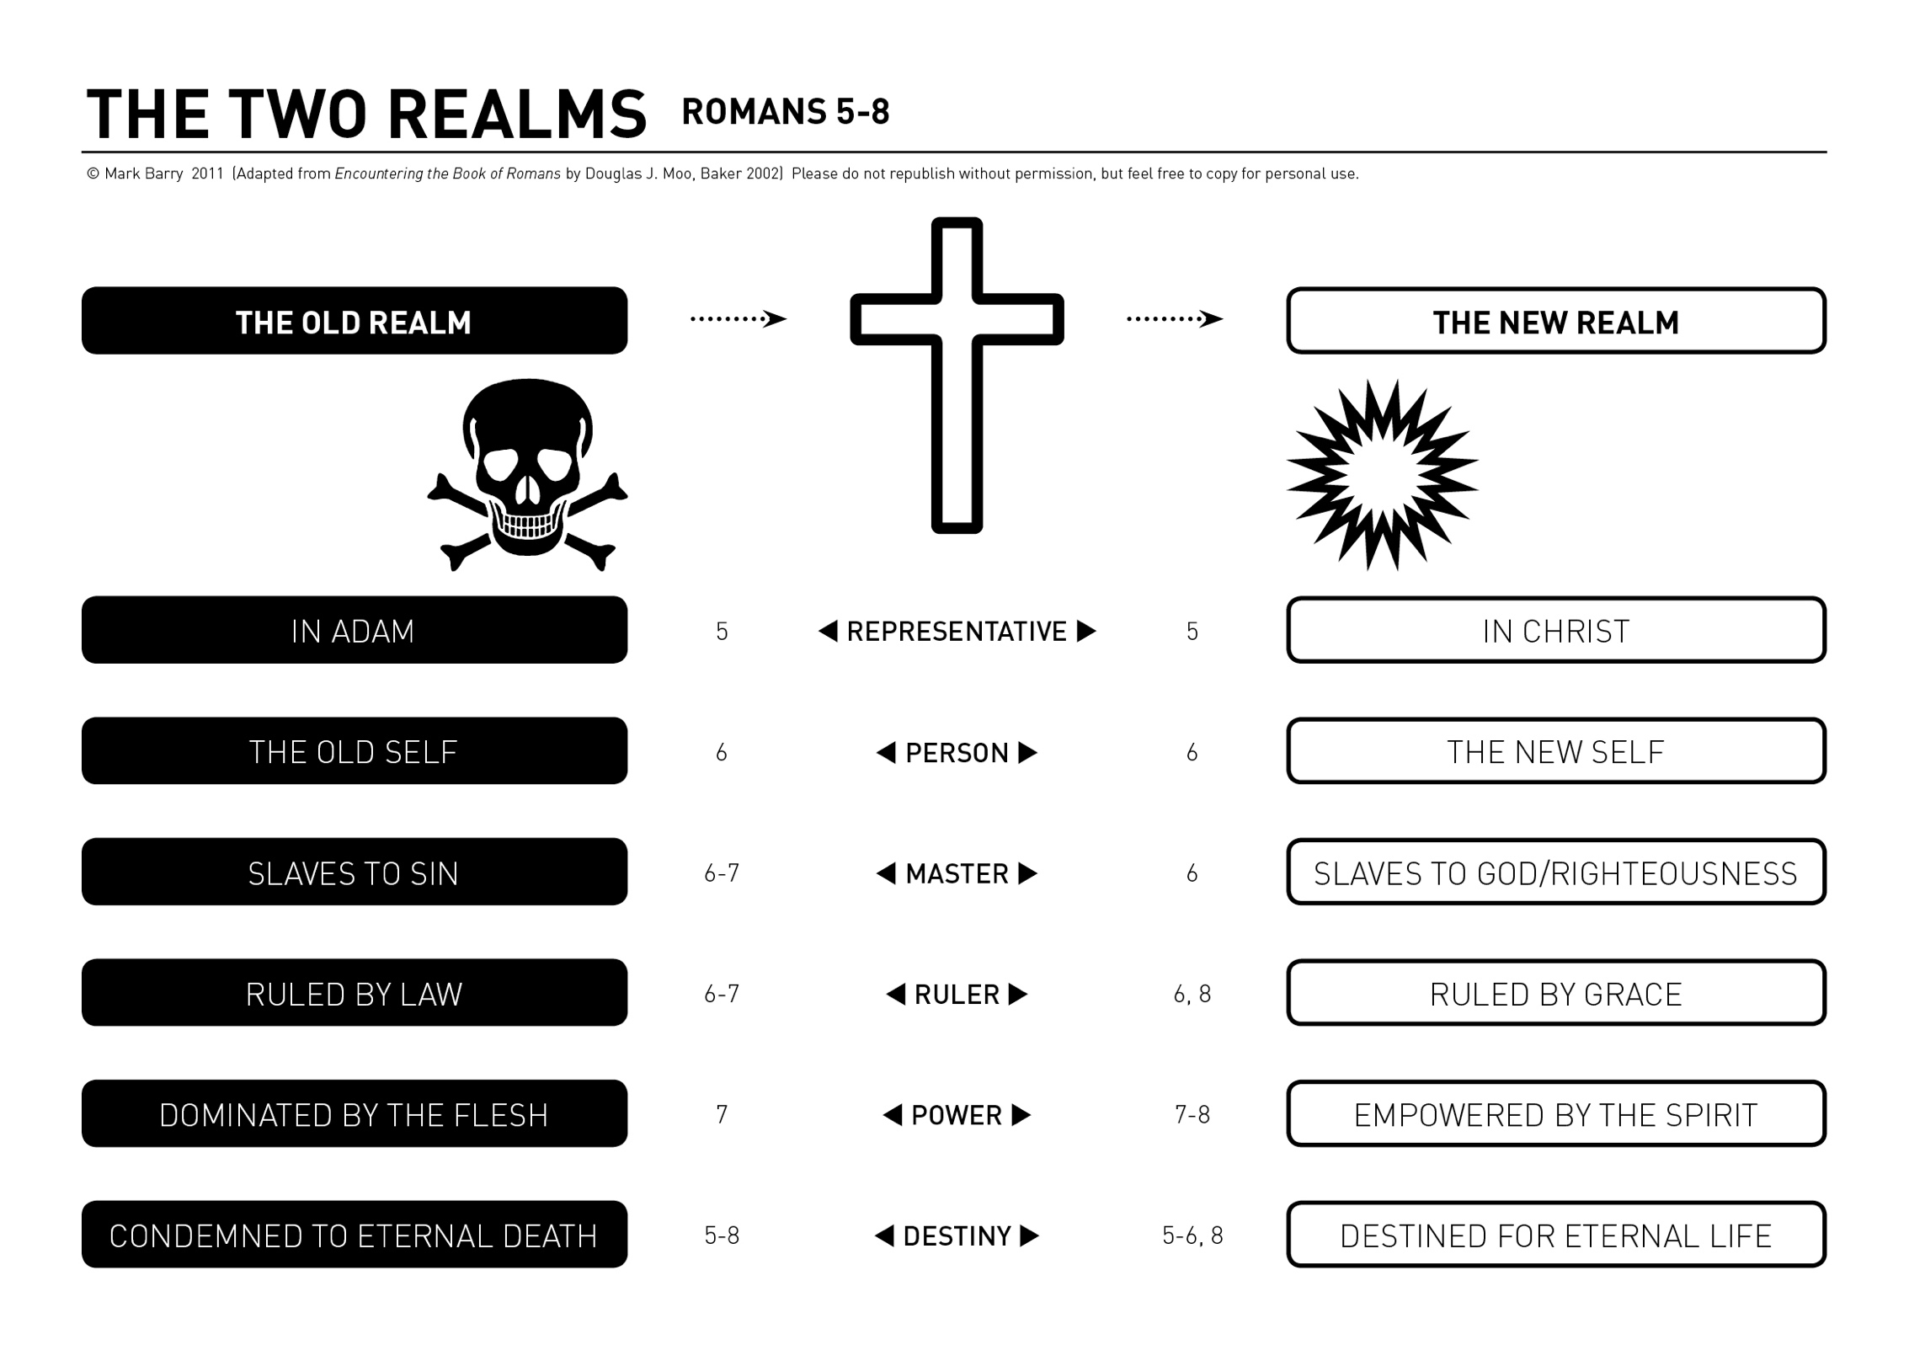
*Graphics produced by Mark Barry (Visual Unit): https://visualunit.me/tag/romans/
Page left intentionally blank (use for notes, prayer points etc)

Note for leaders:
- Leaders’ notes look like this (dot point, grey shading)
- Please refer group members to the QR code on page 2, if they would like to explore further resources.
- As usual, please don’t feel compelled to do every question. I encourage you to tailor the study to suit your group.
Study 1 | Romans 5:1-11
Introduction
- What are your recollections from our earlier series - Romans 1-4: Faith Not Works? How would you summarize Paul’s main message from those chapters? (hint read Romans 3:21-26)
- The letter of Romans is an integrated argument, which builds, section by section. It’s important to refresh our memories of chapters 1-4 before diving into chapters 5-8. The main thing to remember comes from the series title – we’re saved by faith not works. Paul’s big aim is to assure his readers that our salvation depends entirely on, and is secure in, Christ.

- For you, what is the best thing about being a Christian? What brings you the most joy, or are you most enthusiastic about?
- This is more of a reflective question. You will see in the first few verses of chapter 5 Paul takes stock and sums up what he’s established in chapters 1-4, namely, the benefits that belong to those who are saved.

Read and Discuss
- Read Romans 5:1-11. What does Paul say are the benefits of being a Christian?
- This is a straightforward comprehension question. Ask your group to read the text closely and identify the answers. Some answers include: justified (v1), peace with God (v1), access to God (v2), the hope of the glory of God (v2), the ability to handle afflictions (v3).

- In verse 5 Paul says that our hope in Jesus won’t disappoint us (i.e. it won’t let us down). What reasons are given in verses 6-11 to back up this claim?
- In true Pauline style, the logic in verses 6-11 is tightly argued. Paul makes a number of points aiming to give his readers full assurance that God’s gift of salvation is certain. In verses 6-8 Paul speaks to the fact that Jesus died for us while we were still sinners. In other words, Jesus death happened before God’s people (like you and I) responded to God or had a chance to demonstrate godly living. In verses 9-11

- At various points in verses 6-11 Paul describes us as sinners, or as God’s enemies. How and why does Paul emphasize this truth? How is this meant to assure us about our salvation?
- This question essentially covers the same territory as question 4, but with different wording. The point is that God has saved is in Christ while we were his enemies. There is no sense whatsover that God saved us because of our godly living or moral performance. In reality, the opposite is the case. God saved us at our worst!

- Read verses 9-10 carefully. What important spiritual events have happened in the past? What important spiritual events are still to happen? How does God’s work in the past, assure us of our future enjoyment of salvation blessings?
- This question essentially covers the same territory as question 4, but with different wording. Again, these verses need careful unpacking. Twice, Paul uses what is called an a fortiori argument, meaning from the stronger to the lesser. Or think from the harder thing to do to the easier.
- Verse 9: God has already done the really hard thing (the stronger), by justifying us, even though we were sinners. Therefore, if he’s already done that, it will be a relatively simpler thing for him to do shield us from his wrath on the final day, and confer on us our full salvation (the lesser).
- Verse 10: says the same thing to verse 9 in a different way. We’ve already been reconciled through Jesus death (the stronger/harder). Now that that has happened, and Jesus is alive, our salvation is connected to Jesus ongoing eternal life (the lesser/easier).
- Note: in both verses the term being ‘saved’ refers to our final salvation when Jesus returns and we come to experience our salvation in it’s fullness.

Reflect and Apply
- Verses 3-5 draw a connection between afflictions and hope. How do hard times tend to sharpen our hope in our eternal future with Jesus?
- This question is less about comprehension, more about reflection. One avenue to explore is how suffering in this life takes our attention off temporary, wordly things, and forces us to put our hope in eternal things (which aren’t being threatened by our suffering)

- Think back to your answers to question 2. Would you change your response based on what we’ve learnt from this passage?
- For reflection. This may be a good point to challenge the group about what they really consider to be the benefits of being a Christian. I’ve they’ve said things like ‘belonging to a community’, or a ‘sense of peace’, without being specific, perhaps they need reminding of the immense spiritual and eternal benefits.

- A friend when asked “Will you be accepted by God on the last day?”, responds: “I hope so, but it would be arrogant to think that it’s certain.” How does this passage correct them?
- It’s not arrogant to have assurance about salvation when that is precisely what Paul is arguing for here. That is one of the chief aims and outcomes of God’s gift in Christ – that we would be sure of our salvation, and therefore motivated to live out our new life.

- What might it look like to ‘boast in God through our Lord Jesus Christ’ (v11)?
- Not sure. See what the group says.
- The word ‘boast’ can have negative connotations for us, but probably not for Paul. At a minimum, Paul is contemplating that Christians will speak publicly and positively about their salvation in Christ.

Study 2 | Romans 5:12-21 (members book page 10)
Introduction
- In what ways do we feel the pain of a world under death?
- This should be straight-forward to answer. We see illness, disease, natural disasters, and ofcourse death. Different people might wish to share about their own experiences of pain of different types. Allow them to do that, as it will bring the hope of these verses into clear focus.

- The Bible is clear that in God’s sight there are only two groups of people in the world (those who have peace with God through Jesus, and those who don’t). Do you find this truth easy or hard to accept? Why?
- We will see that one of the clear messages of Romans 5:12-21 is that there are only two groups of people in the world. Those ‘in Adam’ and those ‘in Christ’. It’s natural to feel a bit confronted by this, and ‘bend the rules’. Particularly when we think of loved ones, or decent people, who aren’t Christians.
- Take care the way you interact with group members over this question as it can bring heartache to the surface for people with non-Christian family members.

Read and Discuss
- Read Romans 5:12-14. How did sin and death enter the world? Who do they affect?
- The key verse here is verse 12. Sin entered the world through the sin of Adam (and Eve). This is referring to the doctrine of original sin – namely, that all humanity have all inherited a sinful nature by virtue of being descended from Adam and Eve.
- Death also entered the world at the same time, but notice we don’t die because of Adam’s guilt. We die because we too, like Adam, sin.
- Verses 13-14 are notoriously difficult. In short, because Paul is addressing a Jew-heavy audience who associated sin and death with law – Paul is making it clear that both sin and death was still there before the law came.

- Read Romans 5:15-21. What is the gift? What is the trespass? What are the results of each?
- The gift refers to God’s gift of justification/salvation because of Christ. The outcome of the gift is self-explanatory – many people receive forgivness and life.
- The gift is elaborated further in verses 18-21 as being connected to the one righteous act (v18) or one man’s obedience (v19). This is reference to Jesus and his perfect obedience to God the Father. Both Jesus’ perfect life of obedience and his moment of obedience in submitting himself to death, together comprise the obedience referred to in verse 19.
- The trespass refers to Adam’s first sin (e.g. Genesis 3). The outcome of the trespass is that many people died (e.g. all humanity after Adam) (v15).

- How is the gift different to the trespass?
- The crucial verse here is verse 16. There was one trespass (one sin) led to judgment and condemnation. But it was after many trespasses (sins) that God extended grace. The many trespasses and sins refers not just to Adam’s sin, but all of the sin which happened between Adam and Jesus.

- According to Paul, which action (the gift or the trespass) was greater, and why?
- See notes to question 5 above.

Reflect and Apply
- It’s common to think that children are born innocent and good, and only become corrupt as they are influenced by the world around them. What does this passage teach us about our spiritual condition at birth?
- This is hard to digest, but an inevitable consequence of the doctrine of original sin.
- See also Ps 51:5 and Eph 2:1-3 for verses that refer to our inherent sinful nature.
- See article by Tim Challies, for further reading: Original Sin & the Death of Infants

- Theologians sometimes describe Jesus as the ‘new’ or ‘second’ Adam. What makes that a helpful description? What do Adam and Jesus have in common?
- This is very helpful language. Paul even makes the connection in verse 14: Adam is a type (or pattern) of the Coming One, Jesus.
- The big point Paul is making is that God deals with humanity according to representatives. In Adam, we were all made sinners and therefore die. In Christ, Christian believers are made righteous (by justification) and will live. The pattern of the one affecting the many is the same in both.

- Why is it such good news that God deals with us through a representative?
- It means our saved status doesn’t ultimately depend on us and our moral or religious credentials. It’s all about Jesus, and what he’s already accomplished.

- It really is the case that there are two types of people who have ever lived: those ‘in Adam’ and those ‘in Christ’. How does that make you feel?
- Invite group reflection. As noted with introductory questions, this can be a sensitive topic for some people.
- Some implications for this truth include (1) our assurance – if we’re in Christ our status before God and eternal hope are absolutely certain, and (2) our need to evangelize. Apart from Christ all people remain condemned.
- C.f. John 3:36.

Page left intentionally blank (use for notes, prayer points etc)

Study 3 | Romans 6:1-23 (members book page 13)
Introduction
- Have you ever encountered something that seems too good to be true? (Or can you imagine something that would be?) What was it?
- The aim here is to re-introduce the scandal of grace that is an inevitable implication of the gospel.
- In a sense, yes it is true, according the gospel that we’re guaranteed salvation. That is really good! But, one of the challenges to wrestle with in this part of Romans is that we don’t fall into one of two traps when it comes to applying the gospel to our lives. The first extreme is to say that because we’re already saved by grace, the way we live is irrelevant. The other extreme is to say that now we’re saved, we must earn our salvation by demonstrating a sufficiently changed life. The words irrelevant and earn are problematic, as we’ll see. It’s better to say that now we’re saved and united to Christ, the only appropriate life is one which gives effect to this new identity.

- Christians should aim to grow in godliness and minimize sin in their life. What motivates your efforts to do this?
- This is more of an open question. Paul, in chapter 6 is addressing our motivation to life a transformed life.

Read and Discuss
- Read Romans 6:1-14. What is the question Paul poses in verse 1? Can you explain why this question arises out of everything covered in Romans so far?
- The question Paul is asking is “Should we keep on sinning so that grace may multiply”. The letter so far has laboured to demonstrate that we can be fully assured that we’re saved by God’s grace in Christ. So, if our sin is all absorbed by God’s grace and makes him look wonderfully generous, surely the more we sin, the more gracious God is – to his glory.

- According to verses 2-10, why is it unthinkable that Christians would want to keep on sinning?
- Paul’s argument in this section all revolves around how the saved Christian has now become united to Christ. Crucially, this means that we’ve ‘died to sin’ as our master, and taken on a new master in Jesus. See the graphic on page 6.
- There is something huge, with respect to our identity, and the spiritual realm we live in when we become Christians. A transition takes place. From old-self to new-self. From serving sin to serving Jesus. This all feels abstract to us, but this is real picture of what has happened to us according to God.
- It’s important to note that we won’t always subjectively feel like this change has happened. As Romans 7 will remind us, we live with two natures at war within us (the ‘fleshy’ self, a.k.a the sinful nature, and the new spiritual, united to Christ self). This is why, in verse 11, we’re told to consider ourselves dead to sin and alive to God. We constantly need to appropriate the truth of the gospel into our minds, preaching to ourselves of our new identity and training ourselves in the ways of the new self. It won’t just come naturally.
- What are we to do instead? Why?
- Verses 11-14 are the key verses here. See third dot point under question 4 above.
- We’re to actively seek to offer ourselves to God, not to sin. The reason for this is because of what. Paul has explained in verses 2-10. We’re now alive to God. He is our new master, not sin.

- Read Romans 6:15-23. There are two slave-masters described here. Who or what are they? Which slave-master does the Christian believer now serve?
- The gist of this section is similar to the first part of the chapter. Again the idea of sin and righteousness as ruling powers comes to the fore.
- The two slave-masters are sin and righteousness. Christian’s now serve righteousness, not sin.
Reflect and Apply
- Your friend says: “I’m saved by God’s grace, so it doesn’t really matter how I live anymore!” Use the ideas from Romans 6 to address this comment
- See how the group goes, translating what they’ve learnt into a draft response.
- The foundation to such a response is the new identity as someone united to Christ, who has died to sin, and is now alive to God.

- Paul is talking a lot here about the doctrine of ‘union with Christ’. That is, everything that has happened to Christ has happened to believers and everything that is true of Christ is true of believers? Why is this doctrine so important to the way we think about ourselves?
- This is a wonderful doctrine in many respects. It shapes the way we view ourselves – so that we’re always understanding ourselves to be connected to Christ, even when we’re not at church or doing anything that feels ‘spiritual’. This should help us resist temptation to sin as we can always call on Jesus to help us. We also understand that it’s not right for us to be sinning if we belong to Jesus.
- It’s also a picture of salvation that is much bigger, and perhaps deeper than mere justification. It can be easy to consider our salvation as a one-time legal transaction that took place when we first put our faith in Christ. Our status was changed from guilty to innocent – which is true and great – but not the whole truth. That legal truth (or moment of conversion) is the foundation of a new and living relationship with Jesus.

- What ‘parts of ourselves’ can, and ought we offer to God, and how practically can we do that, both as individuals and as a church?
- For group brainstorming. The answer really is every part of ourselves and our lives. From our minds and the way we think; our bodies and the way we use them, our words and the way we speak, our wallets and the way we spend; our energy, our priorities, our time etc.

- Pray for each other in the battle not to allow sin to reign over us, and to live new lives in Christ, offering ourselves to God.

Study 4 | Romans 7:1-25 (members book page 15)
Introduction
- “I do not understand what I do. For what I want to do I do not do, but what I hate I do” (Romans 7:15). To what extent does this resonate with your experience of the Christian life?
- Romans chapter 7 is well known for Paul’s description of the inner struggle he faced, drawn on the one hand towards doing God’s will, and on the other hand, towards satisfying his own sinful desires. Invite group members to describe (or at least recognize) the inner battle they too experience.
- Whilst not being judgmental about this, it might be a concern if someone does not experience this inner struggle. This will rarely be a sign that their struggle with sin is relatively easy and they are finding it easy to be godly. On the contrary, it could be a sign that they’re not struggling with sin enough and don’t have a deep desire to put sin to death and lead a godly life.

Read and Discuss
- Read Romans 7:1-6. Paul uses an analogy from marriage to explain the relationship between the Christian and the Old Testament law. Do Christians remain subject to the Old Testament law?
- 7:1-6 are connected to 6:14, where Paul had asserted that Christians are no longer law, but under grace. Remember the Jewish background. to many of the Roman believers. It would have been unthinkable for them to do away with the OT laws, that to this point, had been at the centre of their religious identity.
- Paul’s point is because Christians have died to the law (through union with Christ) we’re no longer under the law.
- There are other debates about the place of the OT law in the life of the Christian (e.g. about the way it can offer general guidance about the kinds of things God wants for us). But the implication of this section is clear: we’re no longer bound by the OT law.
- Read Romans 7:7-25. According to verses 7-13, what effect does law have on the sinful human heart? Have you personally experienced this dynamic?
- The question emerging form 7:1-6, and especially verse 5 (which says that the law aroused the flesh to sin) is whether the law itself was actually bad, and not good. This would have been a huge question for people of Jewish background who held the law in high regard. It’s this whole issue of whether the law is good or bad that drives Paul to write this section. He’s not primarily writing in order to describe his inner struggle.
- Verses 7:7-13 elaborate on 7:5. The effect of the law is that it prompts us to sin. It’s like the classic example: tell a child not to jump on the couch, and their immediate desire is to jump on the couch. The law functioned in similar way. It brings the worst out of sinful human hearts.

- How does Paul describe the “law” in vv. 7–20? Is it a good thing? A bad thing? A mixture?
- Paul wants to make the point that the law itself is good, not bad. The problem of Paul’s sinful struggle was with his fleshly weakness and not the law itself. Verse 14 is key.

- Read v 21-25. What outcome emerges when sinful people try to be acceptable to God through keeping his law? In what way does this help us to understand and appreciate Jesus?
- Paul , throughout this section is describing his experience as a Christian, but in particular, emphasizing our inherent sinful nature (which is NOT automatically removed when we become Christian).
- The result of having a ‘fleshy’ sinful nature that is now brought under Christ and given the Holy Spirit, is that we’re engaged in an internal battle – between two parts of ourselves. This inevitably leads to weakness and failure.
- But this section should not be considered as a complete picture of the Christian life. It’s a true and real part of it, but Paul is deliberately emphasizing the negative, weak side. There is victory over sin that comes through the Spirit – more of that in chapter 8.
- When we are reminded of our weakness, we can turn our eyes to Jesus who was tempted but never gave in. We can be thankful, not only for his death for our sin, but also his perfect life of obedience, which we’re far too weak to attain.
Reflect and Apply
- How should Christians understand our ongoing struggle to put sin to death in our lives? What has brought this inner struggle about?
- We should accept this ongoing struggle as a reality of our two natures coming into conflict. Our human fleshy, sinful nature, has been overlaid with a new spiritual nature. The two are in conflict.
- The struggle is in fact a sign of new spiritual life, rather than evidence that you don’t have the Holy Spirit.

- Should Christians grieve their ongoing struggle to put sin to death, or should we carry on ‘guilt-free’?
- This question is deliberately provocative. In a sense, we can feel liberated from the guilt of sin (see Hebrews 9-10, for example). However, it is right that if we now love God and want what he wants, the ongoing presence of sin in our lives troubles and grieves us.
- Paul himself exhibits grief and frustration at his own sin in verse 24.

- How would you use this passage to:
  - challenge a Christian who is complacent about their sin?
- The point here is that a Christian ought to struggle against sin.

  - encourage a Christian who is burdened by their sin?
- The point here is that a Christian ought not be too discouraged by the presence of sin in their life. They can look to Jesus who saves us, and should also persevere in their efforts.

- A young Christian friend writes to you: “I thought I was a Christian, but I’m not sure anymore. Over the weekend I saw some of my old friends and before I knew it, I was back into my old bad habits. Someone has told me that my faith was obviously not real”. How would you respond to this person?
- See all of comments above. The existence of sin in one’s life is not a sign of illegitimate faith. Ofcourse such a statement warrants careful application – the amount and character of sin is relevant, as is one’s attitude towards sin.

Page left intentionally blank (use for notes, prayer points etc)

Study 5 | Romans 8:1-17 (members book page 18)
Introduction
- If you’re a Christian, to what extent are you conscious of the work of the Holy Spirit in your life? In what situations are you most aware of His presence and power?
- This is a broad opening question, inviting honest reflection. The role and work of the Holy Spirit can be an area for confusion. We’ll read lots about His role in this chapter.

Read and Discuss
- Read Romans 8:1-8. What do you think the Law was powerless to do (because in our sinful nature we can never keep it), that God has now done? Who benefits from this?
- What the law was meant to do was to enable sinful people to live righteous lives (thereby bringing peace between God and human beings). It couldn’t do that because sinful human beings could not obey the law perfectly
- But God has effected this plan through the saving work of Jesus.
- Jesus both perfectly fulfiilled the law on our behalf AND took the penalty for all our transgressions.
- MOREOVER, Jesus’ work enabled the Holy Spirit to be given to believers, which now empowers them to genuinely grow in righteous living.
- In other words (drawing on verse 4), the law was NOT sufficient to overcome the flesh, in its aim of producing righteous living. But the Spirit CAN overcome the flesh in producing righteous living, thereby accomplishing the law’s original aim.
- Paul is NOT saying that the new righteous living of Spirit-filled Christians earns our salvation. But Paul IS saying that the new righteous living of Spirit-filled Christians is the expected and natural result of being saved, albeit in a progressive manner.

- What do we learn about the mindset of the flesh? What about the mindset of the Spirit?
- This is relatively simple comprehension question. Read verses 5-9 and take note of each category and what is said about them.

- Read Romans 8:9-11. Who is the Holy Spirit? In whom does the Holy Spirit live? What does having the Holy Spirit in us mean for our present existence and our eternal future?
- The HS is described variously as the Spirit of God, the Spirit of Christ, the Spirt of him who raised Jesus from the dead.
- The ‘Christ’ of verse 10, also parallels the ‘Spirit of God’ in verse 9. In each instance, whether it’s Christ, or the Spirit of God, they are both ‘in you’.
- In verse 11, we’re assured that if the Spirit is in us, God will raise us from the dead, just as he did Jesus.

- Read Romans 8:12-17. What is the new obligation for Spirit-filled Christians?
- The obligation is to work at putting to death the deeds of the body (a.k.a the flesh) and to be led by the Spirit.

- What is the wonderful privilege that the Spirit gives Christian people, both now, and in the future?
- We become God’s children and get to call God Father.
- We now have a relationship with God characterized by love and family affection, rather than fear.
- As God’s children, we are co-heirs of the whole world with Christ.

Reflect and Apply
- Consider your ‘decent’ and ‘nice’ friends who aren’t Christians. What are the implications for them (and how we think of them) from the flesh/Spirit contrast we’ve read about?
- This may be confronting for group members who have close friends or family who aren’t Christians. Treat the discussion with care.
- The passage, however, indicates that people who aren’t in Christ remain ‘of the flesh’. In their mind, whether they acknowledge it or not, these people are hostile to God.
- These people are headed towards death (of the everlasting variety)

- If someone said to you – “If you’re already a good person, then becoming a Christian doesn’t make much difference to your life”, how might you answer them from this passage?
- This would be an unusual way to think. We ought to see a growing different between a life governed by the flesh, vs a life governed by the Spirit.

- What might it look like to be diligent in putting ‘to death the deeds of the body’? How can we help each other in this? Does fierce opposition to sin presently characterize your approach to life?
- This is more of an open, brainstorming question for the group to consider. How can we practically, be diligent in putting sin to death. Some answers might include, praying; reading the Bible regularly so that our heart is constantly moved by God’s kindness, so that we want to obey him; talking with one another about our struggles and establishing forms of accountability.
- The second part of the question is more searching – people may not want to answer it directly. It’s a good question to pose though.

- Using Romans 8:1-17, what encouragement do we have that the Christian life is going to turn out well?
- For open reflection.
- Verse 11 is great – the assurance of being raised to life, if the Spirit is in us.

Study 6 | Romans 8:16-27 (members book page 20)
Introduction
- As you read this sentence right now, what is the first thing which comes to mind, that you are looking forward to with eager anticipation?
- The passage for today contains a lot about our future hope. It will be interesting to consider what each of us actually looking forward to, and whether or not the eternal realities God has promised us, feature in our thinking.

Read and Discuss
- Read Romans 8:16-27. What is the content of the Christian “hope”? (i.e. What can we look forward to?). Consider this answer for both (a) creation, and then, (b) ourselves.
- For us we’re looking forward to what theologian have named glorification. In the passage we read about: the glory to be revealed in us (v18), and the adoption, which is the redemption of our bodies (v23).
- For creation, the key verses are 19-22. Like us, and our bodies, the creation is anticipating being made new and free from decay.
- Article: What is glorification

- What should we expect life to be like in the present?
- Suffering (v18). People won’t need convincing of this.

- How can having such a confident “hope” change our perspective and attitudes in the present?
- According to Paul in verse 18, a comparison between present sufferings and our future glory is a worthwhile exercise. In practice, contemplating our eternal future can bring great joy, even amidst present trouble.
- It can also have the effect of ‘loosening’ our attachment to the things of this life, and free us up to serve and be more generous. We know that in eternity we won’t lack anything good.

- What is the connection between having the Holy Spirit and having hope towards God’s planned future?
- The relevant verses here are 26 and 27. The ‘groanings’ of the Spirit are hard to identify precisely. What is probably meant here, is that our deep yearnings for sin and suffering to be gone, or our deep desire to grow in godliness; are all indicators that this world is not our home.

Reflect and Apply
- In what ways do we see creation experiencing futility and decay? How do you feel knowing that these kinds of things will one day be taken away forever?
- For group brainstorming and reflection. This won’t be hard. There are plenty of signs of our world being broken.
- Take great delight in remembering that a time is coming when all the problems of our fallen world will come to an end.

- How does this passage expand our vision of God’s plans for the world, beyond simply the salvation of individual people?
- God’s plans are for the whole of creation to be restored to perfect, not just individual people. See also Rev 21:1-4.

- In what situations might you choose to read this passage with another Christian to help them trust and obey Christ?
- For group reflection. Perhaps with someone who is going through some kind of suffering. In particular, those suffering physically from disease or illness will be reminded that their illness is a sign of a creation subject to decay, and there is hope for the redemption of our bodies.

- Think about the difference between Christian hope and the hope that non-Christians have. What is the difference (cf. 1 Thess 4:13-18)? How could this insight be useful for evangelism?
- There are obviously massive differences, which the group ought to be able to identify. For non-Christians, hope is centred on this life, and has an end-date. It cannot ultimately overcome death. For Christians, we have a sure eternal hope beyond death.
- There are all kinds of possibilities for employing these truths in evangelism. Perhaps you could start conversations with people along the lines of “what are you looking forward to in life?”. Alternatively, you could discuss the declining state of the world (and the environment), and work towards the Christian hope for creation to be restored.

Page left intentionally blank (use for notes, prayer points etc)

Study 7 | Romans 8:28-39 (members book page 22)
Introduction
- When contemplating our individual futures, or the future of our culture, or our world, what are the biggest threats that cause people to be afraid or insecure?
- For open discussion. This is a chance to enumerate all the assorted problems we face in life. There is a myriad of negative circumstances that we can find ourselves in. All of them can generate fear or insecurity.

Read and Discuss
- Read Romans 8:28-30. What comfort is found in verse 28?
- Paul says that God is at work through “all things” for the good of God’s people.

- Have a go at identifying and explaining each ‘link’ in the chain of activities God does for us in salvation.
- The chain referred to is in verses 29-30. It is God’s foreknowledge (e.g election) > predestined > called > justified > glorified (same as being conformed to the likeness of Jesus).
- See graphic here by Mark Barry

- According to the passage itself, what is the “good” that God works for those who love him? How is this different from what we often think is “good” for us?
- This is a really important question. It’s easy for us to see the word good in verse 28 and apply our own definition of what is good. Then we form the errant view that when God is at work through suffering or trials, he’s ultimately working towards our happiness, or towards better circumstances. That might not be the case
- The ‘good’ of verse 28 is understood from verses 29-30. God’s ultimate aim is to save us in eternity and conform us into the likeness of Jesus.

- Read Romans 8:31-39. Identify the 5 questions Paul asks in this section. Identify the answer given responding to each question.
- Questions 1 and 2: What do we say about these things. If God is for us, who is against us. The answer is that God is most certainly for us because he gave us his son.
- Question 3: Who can bring an accusation against us. Answer – it is only God who is eligible to bring accusations against sinners, and he has already justified us.
- Question 4: Who is the one who condemns. Answer – Only Jesus by virtue of his perfect life and appointment as judge can condemn us. But in his seat of authority he is interceding on our behalf, not condemning.
- Question 5: Who can separate us from the love of Christ. Answer – nothing. Not even all the things Paul goes through in verses 35-39.

- What is the overall impact of this question-and-answer approach?
- Paul’s aim is to ram home the point, unambiguously, that we really are secure with God. There is no imaginable threat to our standing before God, and our eternal hope, that has the ability to effect separation between us and God.

- List all the possible things which might causes us to think that God is against us. Can you think of any possible hardship that is not covered by this list?
- Again, for open reflection and brainstorming. The goal of this question is for people to realise that there is nothing that can happen to us that ought to worry us that God is against us, or which has the power to separate us from God.
- This doesn’t mean life will feel easy or that Christians ought to always have a happy disposition. But it does bring deep contentment in the face of problems.

Reflect and Apply
- Romans 5-8 begins and ends with firm assurances that being justified by God’s grace through faith in Christ will certainly result in final salvation – sharing in God’s glory. The gospel Paul preached is completely reliable. It promises and will deliver eternal life! How do you feel that your eternal destiny is so secure?
- This question invites honest response from group members.
- We should feel a measure of peace and contentment about this.

- How does a passage like this equip us to endure suffering?
- See notes on questions above.
- At a minimum, we ought not view suffering as a sign that God is against us. We can also be confident that God is at work through our suffering for good purposes. We might not be able to identify, with any specificity, what those good purposes are. But Verse 28 assures us that God is at work through all things for our good.
- You may like to recall the suffering of Joseph and his reflections to his brothers in Genesis 50:15-21. His story is an example of the theology of Romans 8:28 played out in real life.

- Flick back through this booklet. What truth, challenge or encouragement from Romans 5-8 has stood out to you most? How will you ensure you are changed by this?
- Open reflection. Encourage your group to flick back through their book, or Romans 5-8 itself and to identify one or two things that have stood out.
- The second question is a bit more direct. The aim is to move people from simply acknowledging what they’ve learnt towards reflecting on how their life ought to be different as a result.



