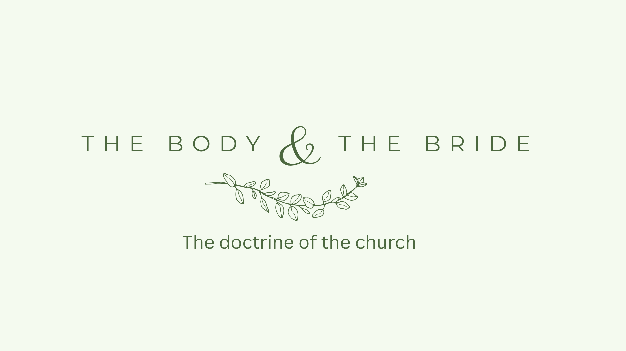

Growth Groups Material
(5 studies on biblical images of the church)
Oct-Nov 2025



Teaching Schedule
In our gatherings we will work through a 5-part series: | 16-19 Oct  23-26 Oct  30 Oct-Nov 2  6-9 Nov  13-16 Nov | What is the church?  Who builds the church?  The healthy church community  The healthy church gathering  The church in the world

Booklet Contents
Introduction | p.3
Study 1 - The Church as God’s Temple | p.5
Study 2 - The Church as Christ’s Body (Part 1) | p.8
Study 3 - The Church as Christ’s Body (Part 2) | p.11
Study 4 - The Church as Christ’s Bride | p.14
Study 5 - The Church as God’s Household | p.17

Additional Resources
We’ve put together some additional resources that might help you as you make your way through this series:

https://jannalianglican.org.au/thechurch/ | 

Introduction

The Bible uses lots of different images to refer to God’s people, the church. In these studies, designed to complement our doctrine for life teaching in our weekly gatherings, we’ll focus on just four of those images.

Studying the different pictures of the church helps us see who we really are as God’s people. Each picture reveals a different facet of the church’s identity and purpose. No single image captures its fullness. The temple shows that God’s Spirit lives among us. The body reminds us we all belong and need each other. The bride points to Jesus’ deep love for His people. The household speaks of belonging, care, and family.

No single metaphor tells the whole story, but together they give us a rich view of what the church is meant to be. When we understand these images, we learn how to love one another better, serve with joy, stay holy, and keep our eyes on Jesus, the one who leads and loves His church.

Our prayer is that as we learn more through these images, we will not only grow in knowledge, but love, service and responsibility towards this precious gathering of God’s people we call the church!

Page left intentionally blank (use for notes, prayer points etc)

Study 1 | The Church as God’s Temple

There are many ways in which the church is described in the New Testament. One prominent metaphor is that of a building – in particular, the “temple”.

A short history of God’s temple...
In the Old Testament God’s people were blessed to have God dwell among them. This happened via the ‘tabernacle’ (or ‘tent’), then via the Jerusalem temple. Both were constructed with the most precious materials and described in great detail. It is hard to capture the significance of this – but see 1 Kings 8:10-13 & 27-30.

A significant element in the tragedy of the Exile was the destruction of the temple. The prophets however, promised a new temple from which blessing would flow (e.g. Ezekiel 40-48), and to which people from all nations would come to worship and pray (Isaiah 56).

When Jesus came, he called his own body “this temple” (John 2:19-21), and he is described as having ‘tabernacled’ with us (John 1:14).
In the final vision of the new heavens and new earth in Revelation 21 & 22 there is no temple at all (see 21:21). There is no need for a dwelling place for God, because then “God’s dwelling is with humanity, and he will live with them” (Revelation 21:3).

Read and Discuss

- Read 1 Corinthians 3:16-17. How / why can Paul call the church at Corinth “God’s Sanctuary” (The sanctuary was the focal point of God’s dwelling within the temple complex).

- What implications does Paul draw from this insight? (Along with verse 17, consider also the context shown in verses 3 & 4).

- Read 2 Corinthians 6:14-7:1. How do verses 16-18 deepen our understanding of the church as God’s sanctuary?

- Read Ephesians 2:19-22. What further details are added here to our picture of the church as God’s temple?

Reflect and Apply

- How might our awareness of God’s presence among us change the way we approach our gatherings? Our own lives?

- In the Old Testament the temple was a holy, sacred place, because God dwelt there. Priests could even be killed if they entered the temple in the wrong way. Should we think of the church (the people, the gathering etc.) in the same way? Should we be more reverent and formal in our approach? Or is it ok to be relaxed and casual?

- In the Old Testament the temple was also place where the nations could come to encounter the only true God. How does the church fulfill that role today? How are we going with that calling?

Study 2 | The Church as Christ’s Body (Part 1)

Introduction

- Share your ‘One Thing’ from last weekend’s teaching

The most prominent New Testament image of the church is the body of Christ. In this discussion we will focus on what use is made of this in Ephesians. In the next study we will look at 1 Corinthians 12.

Read and Discuss

- Read Ephesians 1:20-23. What do we learn here about the relationship between Christ and the church? (Do you think “church” here refers to the church gathered in heaven, or to a local congregation?)

- Read Ephesians 4:1-16. Why should we work hard at keeping the “unity of the Spirit”? What will this involve?

- What does a mature church ‘body’ look like? (To help ‘sharpen’ your thinking, try to think of examples of immaturity in churches. What do immature churches need to grow?)

- What is God’s plan for the growth and strengthening of the body? Who is involved in this? What are their roles?

Reflect and Apply

- How might this passage challenge common assumptions about the job descriptions of ‘pastors and teachers’ and the role of church members in growing the church?

- What do you think “speaking the truth in love” might look like for you in our church?

- Are their ways this teaching might apply to the way your own group functions and grows?

- From what you have seen in this study, for what can you thank God? What would be good to pray for each other, for our whole church, and for churches everywhere?

Study 3 | The Church as Christ’s Body (Part 2)

Introduction

- What different gifts (ability/talent/strength) has God given the people of our church? Make a list of gifts and think about the ways in which you have benefited from these.

Read and Discuss

- Read 1 Corinthians 12. According to verses 1-11, what do all members of the church share in common? In what ways do we differ and why?

- Paul uses the image of the body to illustrate and apply the idea of many different gifts in one church. Focusing on verses 12-31:

  - Is the local church at Corinth a body, part of a body, or only like a body? Why?

  - What should characterize a properly functioning church?

  - How will a church become like this?

  - To what extent can/should this be applied directly to your small group?

Reflect and Apply

- From this passage it is clear that every member is a valuable member of the church and has something to contribute, but in practice people sometimes feel like they aren’t valued, or don't have something to contribute. Why do you think this happens? How could we change this?

- How/when might we communicate ‘I don’t need you‛ (v 21-21) to others? How can we avoid this?

- What needs are not being met (or opportunities not being taken) around our church? Are there ways that you could contribute? What would help you to do this?

- Who in our church do you rely on most as a fellow “part of the body”? How could you show gratitude for them this week?

- Spend time praying for each other and for our church. Give thanks for our unity and diversity. Give thanks for particular people who serve you. Ask God to help you play your part in the life of the body.

Study 4 | The Church as Christ’s Bride

Introduction

In this series of studies we are looking at the main images of the church used in the New Testament. So far, we have examined the church as God’s temple and as Christ’s body. In this study we will consider what it means for the church to be the bride of Christ.

The background to this image is found in the Old Testament, where the prophets speak of God and Israel in terms of a marriage relationship. God set his love upon Israel and delighted in her as his bride (Jeremiah 2:2), yet Israel was unfaithful, ‘prostituting’ herself to other gods (Ezekiel 16, Hosea 1-3). God however promised that once again he would rejoice over her “as a groom rejoices over his bride’ (Isaiah 62:5).

- The image of a bride is a powerful one. What features of a “bride” and her relationship with a groom immediately spring to mind for you?

Read and Discuss

- The ‘bride’ image is used in 3 places in the New Testament: 2 Corinthians 11:1-4, Ephesians 5:22-33 & Revelation 19:6-10, 21:1-2 & 9-11. Read each of these passages and try to build a picture to answer these questions...

  - What (from the text itself) does the image teach us about how to think about God and his church?

  - What do you think is the intended impact of this image on our emotions and our ‘affections’ (ie. what we love and hate)?

  - Does the New Testament picture the church as currently ‘betrothed’ (promised as a bride for Jesus), or is she already married? When is it envisaged that the wedding has or will happen?

- Is there any hint in these passages that being ‘the bride of Christ’ means that church members should not marry in this life? What would you say to someone who thinks this way?

- In what ways can we, as Jesus’ bride, prepare now for the great wedding day of Lamb?

- How does it affect you to think that Jesus doesn’t just tolerate the church, but loves her deeply as His bride?

- The image of marriage communicates exclusivity. In what ways might we be tempted to give our love or loyalty to other “suitors” instead of to Christ?

- Pray in response to what you have learned in this study. Give thanks that Jesus prepares us to be beautiful for him on the great wedding day. Ask for God’s help to live in a way consistent with this.

Study 5 | The Church as God’s Household

Introduction

In this series of studies we are looking at the main images of the church used in the New Testament. So far, we have examined the church as God’s temple, Christ’s body, Christ’s bride and in this study we will look at the church as God’s household.

- Some of us have happy experiences of being part of a ‘household’, others not so happy. What are the benefits of being part of a well-functioning ‘household’?

Read and Discuss

- Read 1 Timothy 3:14-16. What do you think it means that God’s household, the church, is the “pillar and foundation” of the truth?

- In what ways does understanding the church as God’s household make sense of the qualifications of church leaders (see especially 1 Timothy 4-5 & 8-12).

- Read Hebrews 3:1-6. What position does Jesus hold in God’s household?

- What is this knowledge meant to motivate us to do? (See also Heb 3:7-14)

- Read Romans 8:12-17. This passage doesn’t explicitly refer to the church as God’s household. However, what household type concepts do you see in this passage?

- How should Christians think of themselves according to this passage?

Reflect and Apply

- How might viewing the church as a family rather than an organisation change our expectations and priorities?

- How do you feel about calling fellow Christians brother or sister? Do you consider other Christians to be your spiritual family? How can we grow in thinking about, and treating other Christians as family?



