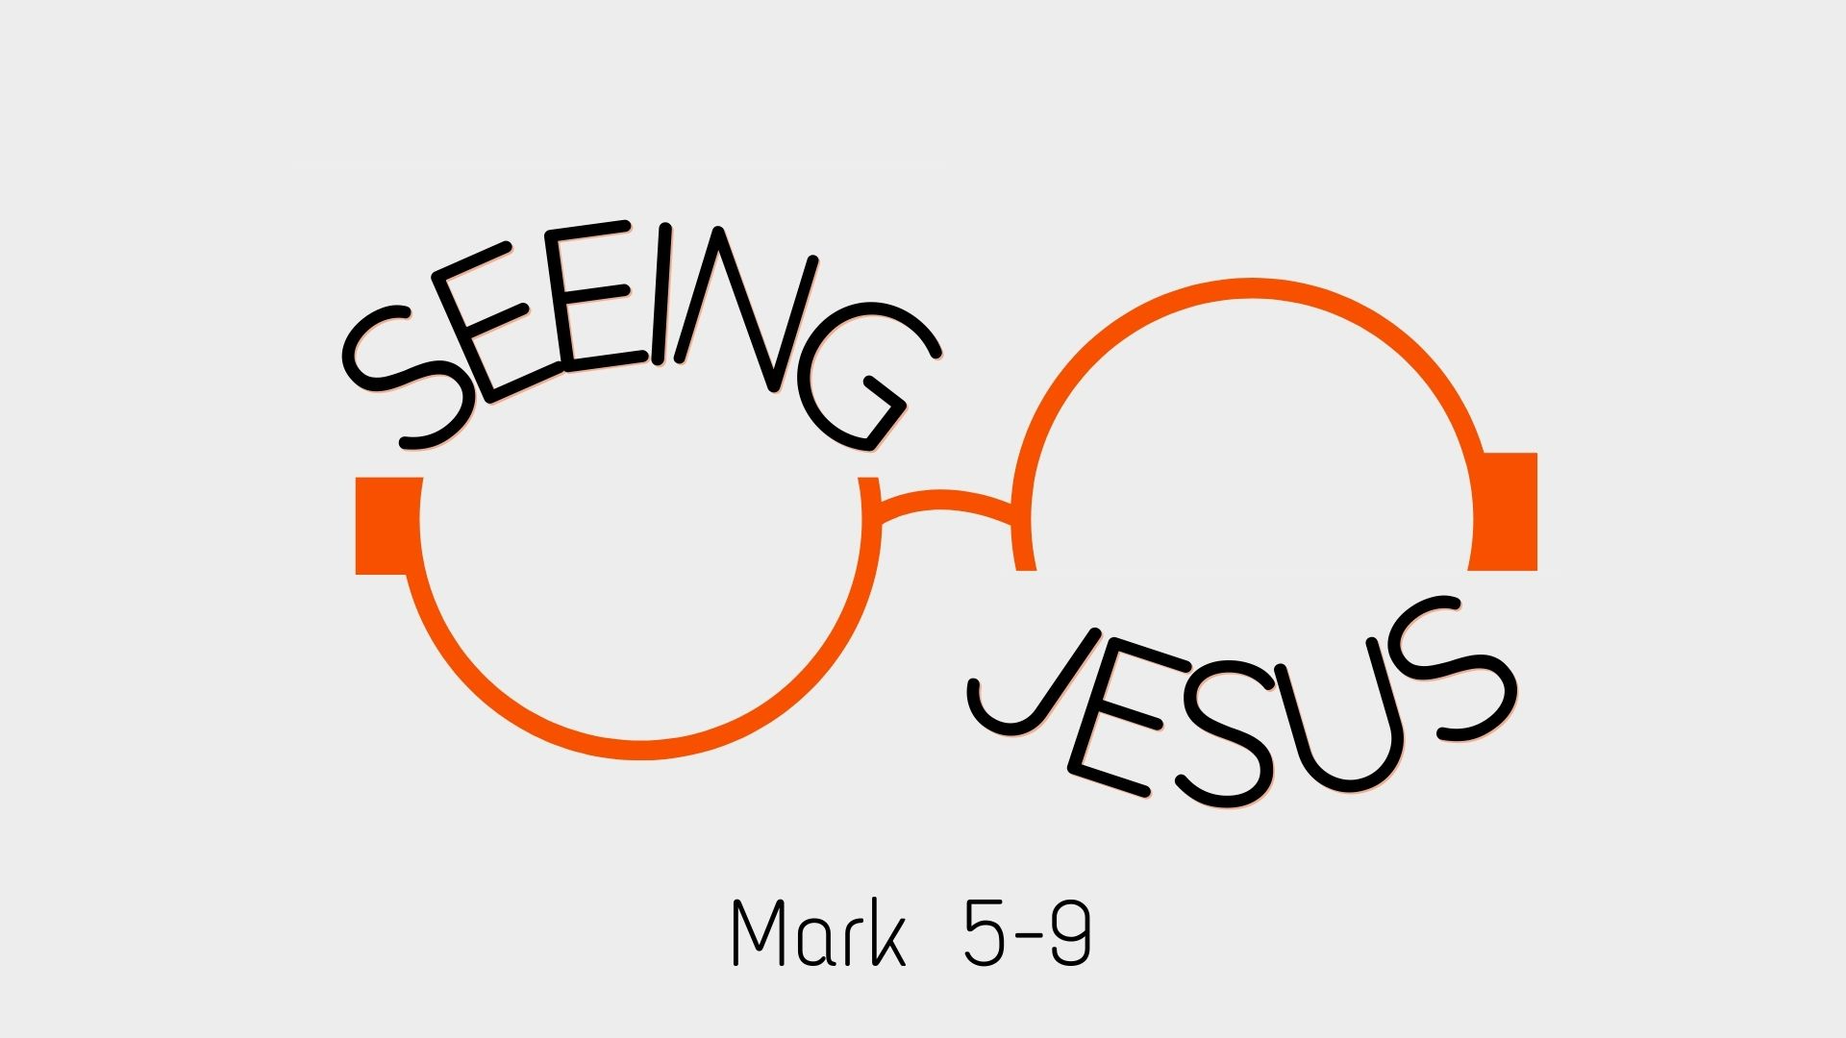

Growth Groups Material
(4 studies on Mark 5-9)
Mar-Apr 2025



Teaching Schedule
In our gatherings we will work through an 8-part series, which spans the school holidays and includes the Easter Weekend: | 13-16 Mar  20-23 Mar  27-30 Mar  3-6 Apr  10-13 Apr  18 Apr (Good Friday)  19/20 Apr (Easter Sunday)  24-27 Apr | Mark 5:1-20  Mark 5:21-6:6  Mark 6:6-52  Mark 6:53-7:23  Mark 7:24-8:26  Mark 8:27-9:1  Mark 9:2-13  Mark 9:14-29

Note: This material contains 4 studies, corresponding to the first 4 sermons in the series. These 4 weeks fall within the school term, whereas the remaining 4 weeks fall within the school holidays. We anticipate that most groups will take a break during the school holidays, hence why studies for these weeks have not been written.

Booklet Contents
Introduction | p.3
Study 1 (Mark 5:1-20) | p.4
Study 2 (Mark 5:21-6:6) | p.7
Study 3 (Mark 6:6-52) | p.12
Study 4 (Mark 6:53-7:23) | p.15
Life boat list activity | p.18

Additional Resources
We’ve put together some additional resources that might help you as you make your way through this series:

https://jannalianglican.org.au/seeingjesusmark


Introduction

Is there anything more important in life than Seeing Jesus clearly? We don’t think so. Carefully reading and reflecting on Mark’s gospel will help us do just that, whatever our background, or wherever we’re up to on our own faith journey.

The Gospel of Mark is the shortest and most action-packed of the four Gospels, offering a fast-paced account of Jesus’ life, ministry, death, and resurrection. Likely written between A.D. 50–70, Mark’s Gospel is believed to be based on the eyewitness testimony of the Apostle Peter and was recorded by Mark, who was a companion of both Peter and Paul.

Broadly speaking, the book has two halves, all aimed at the one purpose of showing that Jesus is the Christ (c.f Mark 1:1), who suffers for our sin. In the first half (1:1-8:26), Mark is intent on showing Jesus’ identity as the Christ (God’s promised King). In the second half (8:27-16:8), the book focuses on Jesus’ mission: the need for Jesus to suffer and be rejected for our sin. In these studies we pick up the story in the second part of the first half. We’ll encounter unequivocal evidence of Jesus’ divine identity, as he demonstrates his authority (over demons, nature, sickness, even death) time and time again. We’ll also see people’s mixed reactions as they come to grips with who Jesus is. Both good and bad reactions.

Will you see Jesus for who he really is? What is your answer to the disciples’ famous question after they had just seen Jesus calm the storm: “Who then is this?” (Mark 4:41). For some of us, asking this question again might feel like we’re covering old ground. But do take the opportunity to be moved afresh as you see again the power, the compassion, the beauty and the trustworthiness of our Lord in the pages of Scripture.

Study 1 | Mark 5:1-20
Introduction
- Can you describe a time when you have felt powerless or trapped (e.g. in a difficult situation that you were unable to change). How did this make you feel?

Read and Discuss
- Read Mark 5:1-20. To help you observe what’s happening, have a go at drawing a picture of one of the scenes in this passage.

- What does Mark emphasize about the man who lived amongst the tombs?

- What do we learn about Jesus and his power over evil spirits/demons?

- What was the response of the locals to what had happened? What is unusual about it?

- What is the response of the formerly demon possessed man. How does he model the right response to us?

Reflect and Apply
- At the start of this part of Mark, the disciples ask a question which should shape our response to what we read (across chapters 5-8). After Jesus calms the storm, they ask: “Who then is this? Even the wind and the sea obey him!” (Mark 4:41). What answers to that question do we get in the current passage?

- What do you have in common with the demon-possessed man? What has Jesus done for you? Who can you tell about it?

- Is it right to be afraid of Jesus? Are you afraid of him? What kind of fear of Jesus is healthy/unhealthy?

Study 2 | Mark 5:21-6:6a

Introduction
- What things in life are you most afraid of?

- How do people tend to deal with fears these days?

Read and Discuss
- Read Mark 5:21-43. What do we learn about each person and their need? Put yourself in their shoes. What words might you use to describe their state of mind?

- What response to Jesus is Mark promoting through Jesus’ own words in this section?

- Read Mark 6:1-6. This feels very different to what has happened in chapter 5. How do the people in Jesus’ hometown respond to him? Why do you think Mark includes this section?

Reflect and Apply
- At the start of this part of Mark, the disciples ask a question which should shape our response to what we read (across chapters 5-8). After Jesus calms the storm, they ask: “Who then is this? Even the wind and the sea obey him!” (Mark 4:41). What answers to that question do we get in the current passage?

- Jesus doesn’t promise that he will heal us from our assorted illnesses and health conditions. But he does promise life beyond death. Death is our great enemy that no-one can stop! How does Jesus power over death comfort us?

- This passage (along with the last few passages in Mark) frequently contrast fear and faith. One commentator describes Mark’s main point as this: “Jesus is bigger than the things you’re afraid of. Trust and fear him instead.” What do you make of this summary? When would it be helpful to remember this truth?

A helpful quote from a commentary, applying todays lesson:

Imagine you are catching the ferry back from Belgium after a weekend full of moules-frites and waffles. The name of the ship is the Herald of Free Enterprise. As the water starts to pour through the windows, you realize you might die, and you're a little nervous, to say the least. But because you're a Christian, you are spared the utter terror that grips others on board. You believe in a Saviour who can even get you through death, if it comes to that.

Imagine you are in a hospital waiting room, where the only thing to read is a pile of Country Life magazines, and you've been through all of them twice. Your daughter has been in surgery for hours. As the doctor approaches with a grave expression on her face, you're a little nervous, to say the least. But because you're a Christian, you are spared the utter terror that grips others in the waiting room. You believe in a Saviour who can even get your daughter through death, if it has to come to that.

(from Dig Deeper into the Gospels, Andrew Sach and Tim Hiorns, IVP 2025)
Page left intentionally blank (use for notes, prayer points etc)

Study 3 | Mark 6:6-52

Introduction
- What attributes make a leader worthy of following?

Read and Discuss
- Read Mark 6:6-29. What do these verses describe? Is Herod an attractive or unattractive character? What are his strengths and weaknesses?

- Read Mark 6:30-44. What elements of Jesus’ character does Mark emphasize?

- Read Mark 6:45-52. What stands out to you from this scene?

- In the feeding of the 5,000 and walking on water scenes Mark might be alluding to some parts of the Old Testament. Skim read Exodus 14-16. What events happen in these verses? What common features do you notice between those chapters and the current passage? What point might Mark be making by these allusions?

Reflect and Apply
- At the start of this part of Mark, the disciples ask a question which should shape our response to what we read (across chapters 5-8). After Jesus calms the storm, they ask: “Who then is this? Even the wind and the sea obey him!” (Mark 4:41). What answers to that question do we get in the current passage?

- Herod enjoyed listening to John the Baptist but wasn’t willing to repent of his sin (marrying his brother’s wife). How is the example of Herod a warning to us not to ‘sit on the fence’ when it comes to our response to Jesus?

- How is Jesus being contrasted with Herod? What qualities did Jesus exhibit that Herod didn’t? How might our understanding of Jesus’ character (in addition to his authority that we’ve seen in the last few weeks) help us to trust and follow him?

Study 4 | Mark 6:53-7:23

Introduction
- How would you define the concept of ‘sin’?

Read and Discuss
- Read Mark 7:1-23. What had Jesus’ disciples done that the Pharisees and Jewish leaders were concerned about?

- How does Jesus respond to the Pharisees?

- Have a go at putting Jesus’ words in verses 14-23 into your own words? What common error is Jesus correcting?

Reflect and Apply
- At the start of this part of Mark, the disciples ask a question which should shape our response to what we read (across chapters 5-8). After Jesus calms the storm, they ask: “Who then is this? Even the wind and the sea obey him!” (Mark 4:41). What answers to that question do we get in the current passage?

- Think about your own life, or the life of a potential Christian believer? What would be the signs of a ‘hypocritical’, ‘surface level’ Christianity? What would be the signs that someone has been truly changed on the inside and is genuine in their faith?

- Imagine you’re reading through Mark with an unbelieving friend and they’ve enthusiastically agreed with everything so far… e.g “There is no-one like Jesus….he has power over everything….he really must be God!”. However, they’re not convinced yet to put their trust in him. How could a chapter like this push your friend closer towards real, saving faith?

Praying for our life boat lists

We know that everyone’s greatest need in life is to be reconciled with God through Jesus so that their sins can be forgiven. We want lost people to be saved, and know the eternal hope of salvation, rather than perish under God’s judgment.

 | In our church gatherings of 27-30 March we heard more about our Connect plans at church. That is, what we’re doing together as a church to reach people and connect them to Christ. At the heart of our efforts is to be identifying unbelievers in our lives that we want to see saved and praying diligently for them, and our own efforts to share Jesus with them.
A tool we use to help us pray regularly is our life boat list. These are bookmarks upon which we can list three people that we’re deliberately praying for and actively working towards sharing Jesus with.  In our groups, it would be excellent to share with each other who is on our life boat lists, and pray together for each of these people, and our efforts to reach them.  You might like to use the next page record the name of the people you are praying for. |  | 

Praying for our life boat lists

Group Member | Life boat list



