

Growth Groups Material
(Studies on John 2-11)
Jan-Apr 2022


Booklet Contents
Introducing John’s Gospel |  | p.3
The format of these studies |  | p.4
TEACHING SERIES
Sermon | Passage
27-30 January | John 2 | p.5
3-6 February | John 3 | p.6
10-13 February | John 4 | p.7
17-20 February | John 5 | p.8
24-27 February | John 6 | p.9
3-6 March | John 7 | p.10
10-13 March | John 8 | p.11
17-20 March | John 9 | p.12
24-27 March | John 10 | p.13
31 March – 3 April | John 11 | p.14

Additional Resources
 | Quick Reference Passages  John’s Prologue (1:1-18)  John’s Purpose Statement (20:30-31) | p.15
 | Map: Palestine in the time of Jesus (produced by Visual Unit)  https://visualunit.me/2011/02/03/palestine-map/ | p.17
 | Generic Question Worksheet  (with more space for notes) | p.18
 | Introduction to John (link only)  https://www.thegospelcoalition.org/course/john-courses/ | n/a
 | Study notes on John published by St Helens, Bishopsgate, UK (link only)  https://www.st-helens.org.uk/resources/study/61/ | n/a
 | A video overview of John 1-12 produced by The Bible Project (link only)  https://youtu.be/G-2e9mMf7E8 | n/a

Introducing John’s Gospel
As the name suggests, this book was written by John, the son of Zebedee, one of Jesus’ 12 disciples. Sometimes he refers to himself as the ‘disciple whom Jesus loved’ (John 13:23, 19:23). John wrote his account of Jesus life later than most of the other New Testament documents, probably between AD 70-95. If you have read the other three gospels (known as the ‘Synoptic Gospels’) you will notice the big differences in style and content. John’s Gospel contains more large passages of Jesus teaching, deeper symbolism on the life-giving identity of Jesus (think of the famous ‘I am’ statements’) and less actual activity narrated. This gives John’s Gospel a sense of depth as the reader is presented with a rich, multi-layered, and cosmic display of the identity, works, words, and mission of Jesus.
Apart from the Prologue (1:1-18) and the Epilogue (21:1-25) Bible scholars typically see three main structural sections in the book:
- The ‘book of signs’ (chapters 1-10) in which Jesus reveals his identity
- A transition (chapters 11-12) in which Jesus’ mission to die becomes apparent
- The ‘book of glory’ (chapters 13-20) which focuses on the last week of Jesus life
Along with this big picture we also recommend that you keep returning to two things as you work your way through John. First, the Prologue (1:1-18) in which John’s major themes are foreshadowed (e.g. the divinity of Jesus, Jesus’ identity as the Messiah, Jesus as the source of life, salvation through belief in Jesus, different responses to Jesus etc.). Second, John’s explicit statement about why he wrote the book:
John 20:30 Jesus performed many other signs in the presence of His disciples that are not written in this book. ³¹ But these are written so that you may believe Jesus is the Messiah, the Son of God, and by believing you may have life in His name.
John wants his readers to come to saving faith in Jesus. But given the depth of his material, he also wants believers to grow into a rich, vibrant relationship with Jesus. Our hope and prayer is that as you read John’s gospel, that you also would find life in Jesus.

The format of these studies
The format of the studies for this term are deliberately different to past series’. For each week we have reproduced the same 8 general, open questions. Broadly speaking, the questions take you through a process of bible observation (“What happens in the passage”), bible interpretation (“What does this mean”) and bible application (“How should we respond”). There are a number of reasons we’re trying this new approach:
- To grow confidence in God’s word: We’re convinced that by the power of the Holy Spirit, anyone can read the biblical text carefully and arrive at many helpful insights that can encourage, challenge and grow us. Sometimes a long list of questions over-complicates things and distracts us from this task. Or worse, we can become more interested in interpreting the questions and trying to answer them, than being led by the text itself.
- To develop Bible reading skills: In God’s kindness, our aim is that as we do this, we will develop in our ability to read the Bible well for ourselves. That is, to learn to look for the types of things that will help us understand a passage well.
- Flexibility: This format can be used by any individual or group, in whatever setting they find themselves in. You might like to use these questions with a friend or family member
- Simplicity: This approach will allow you, and your Growth Group leaders to approach the biblical text in the same way each week.
We recognize that this approach might not ‘gel’ with your style of thinking. Please have a go! And don’t worry if there are questions about the passage which remain unanswered. The aim is to discern the main thrust of a passage and be changed by what we learn. To help you out, we’ve added a couple of bonus application questions for each chapter to help stimulate discussion after you’ve worked through the first 8 questions.

John 2
- What happens in the section you are reading? Can you summarize the key events in your own words?

- Who are the characters that appear in this section? How do they interact with Jesus? What do we learn about them?

- Is there anything in this section that seems unusual or surprising? Is there anything that seems to be particularly important? Tip: Look for things the characters say, or words that are repeated.

- Are there any connections to the Old Testament in this section (e.g quotations, Jewish customs or festivals)? Do you think these are significant? Why?

- What does this section reveal about who Jesus is, and what he came into the world to do?

- Have you read anything that reminds you of ideas in John’s Prologue or Purpose Statement (see p.14)? How does this section help to achieve John’s purpose?

- Is there anything you need to change about the way you follow Jesus as a result of this section? Tip: This might relate to what you think about Jesus, or yourself; How you approach other people, or church; or your level of confidence to keep believing in Jesus.

- Imagine a friend asks you, “Why should I bother with Jesus?” How would you persuade them to follow Jesus, using what you’ve learnt from this section?

Bonus Application Questions
    - Jesus’ coming meant that the old covenant ways of relating to God (such as ritual purification and temple sacrifices) were done away with. Are there any ‘old ways’ of relating to God that you need to do away with now that Jesus has come?
    - We see an assertive (even angry) side of Jesus in 2:13-16. How does this make you feel? Is this consistent with your existing understanding of Jesus and his character?
John 3
- What happens in the section you are reading? Can you summarize the key events in your own words?

- Who are the characters that appear in this section? How do they interact with Jesus? What do we learn about them?

- Is there anything in this section that seems unusual or surprising? Is there anything that seems to be particularly important? Tip: Look for things the characters say, or words that are repeated.

- Are there any connections to the Old Testament in this section (e.g quotations, Jewish customs or festivals)? Do you think these are significant? Why?

- What does this section reveal about who Jesus is, and what he came into the world to do?

- Have you read anything that reminds you of ideas in John’s Prologue or Purpose Statement (see p.14)? How does this section help to achieve John’s purpose?

- Is there anything you need to change about the way you follow Jesus as a result of this section? Tip: This might relate to what you think about Jesus, or yourself; How you approach other people, or church; or your level of confidence to keep believing in Jesus.

- Imagine a friend asks you, “Why should I bother with Jesus?” How would you persuade them to follow Jesus, using what you’ve learnt from this section?

Bonus Application Questions
    - How much credit can you take for your earthly birth? How much credit can you take for your spiritual birth? How does this reality help you to live the Christian life with humility, thankfulness, and assurance?
    - John the Baptist says of Jesus: “He must increase, but I must decrease.” (3:30). What will you do to implement that principle in your own life?
John 4
- What happens in the section you are reading? Can you summarize the key events in your own words?

- Who are the characters that appear in this section? How do they interact with Jesus? What do we learn about them?

- Is there anything in this section that seems unusual or surprising? Is there anything that seems to be particularly important? Tip: Look for things the characters say, or words that are repeated.

- Are there any connections to the Old Testament in this section (e.g quotations, Jewish customs or festivals)? Do you think these are significant? Why?

- What does this section reveal about who Jesus is, and what he came into the world to do?

- Have you read anything that reminds you of ideas in John’s Prologue or Purpose Statement (see p.14)? How does this section help to achieve John’s purpose?

- Is there anything you need to change about the way you follow Jesus as a result of this section? Tip: This might relate to what you think about Jesus, or yourself; How you approach other people, or church; or your level of confidence to keep believing in Jesus.

- Imagine a friend asks you, “Why should I bother with Jesus?” How would you persuade them to follow Jesus, using what you’ve learnt from this section?

Bonus Application Questions
    - What are your particular ‘thirsts’? What spiritual longings do they reveal? Are there any unhelpful ways in which you are tempted to satisfy these ‘thirsts’?
    - Jesus is the Saviour of the World (4:42) and he says that time of harvesting people for God has begun (4:35-38) How can you follow the example of the Samaritan woman and invite people to meet Jesus?
John 5
- What happens in the section you are reading? Can you summarize the key events in your own words?

- Who are the characters that appear in this section? How do they interact with Jesus? What do we learn about them?

- Is there anything in this section that seems unusual or surprising? Is there anything that seems to be particularly important? Tip: Look for things the characters say, or words that are repeated.

- Are there any connections to the Old Testament in this section (e.g quotations, Jewish customs or festivals)? Do you think these are significant? Why?

- What does this section reveal about who Jesus is, and what he came into the world to do?

- Have you read anything that reminds you of ideas in John’s Prologue or Purpose Statement (see p.14)? How does this section help to achieve John’s purpose?

- Is there anything you need to change about the way you follow Jesus as a result of this section? Tip: This might relate to what you think about Jesus, or yourself; How you approach other people, or church; or your level of confidence to keep believing in Jesus.

- Imagine a friend asks you, “Why should I bother with Jesus?” How would you persuade them to follow Jesus, using what you’ve learnt from this section?

Bonus Application Questions
    - “God’s great desire is that the world honour His Son. Someone may appear incredibly moral, or even religious, but if they fail to honour the Son, they remain under divine wrath.” Do you agree with this statement? How would society respond to this sentence?
    - Think over the last 4 chapters of John. Are you persuaded that Jesus is the Messiah? What has persuaded you?
John 6
- What happens in the section you are reading? Can you summarize the key events in your own words?

- Who are the characters that appear in this section? How do they interact with Jesus? What do we learn about them?

- Is there anything in this section that seems unusual or surprising? Is there anything that seems to be particularly important? Tip: Look for things the characters say, or words that are repeated.

- Are there any connections to the Old Testament in this section (e.g quotations, Jewish customs or festivals)? Do you think these are significant? Why?

- What does this section reveal about who Jesus is, and what he came into the world to do?

- Have you read anything that reminds you of ideas in John’s Prologue or Purpose Statement (see p.14)? How does this section help to achieve John’s purpose?

- Is there anything you need to change about the way you follow Jesus as a result of this section? Tip: This might relate to what you think about Jesus, or yourself; How you approach other people, or church; or your level of confidence to keep believing in Jesus.

- Imagine a friend asks you, “Why should I bother with Jesus?” How would you persuade them to follow Jesus, using what you’ve learnt from this section?

Bonus Application Questions
    - What is the food that lasts for eternal life (6:27) and how do we eat it?
    - What does it mean that the Father ‘gives’ people to the Son (v.37, 39, 44-45, 64-65)? How does this shape our understanding of people who reject Jesus? What should we do about this?
John 7
- What happens in the section you are reading? Can you summarize the key events in your own words?

- Who are the characters that appear in this section? How do they interact with Jesus? What do we learn about them?

- Is there anything in this section that seems unusual or surprising? Is there anything that seems to be particularly important? Tip: Look for things the characters say, or words that are repeated.

- Are there any connections to the Old Testament in this section (e.g quotations, Jewish customs or festivals)? Do you think these are significant? Why?

- What does this section reveal about who Jesus is, and what he came into the world to do?

- Have you read anything that reminds you of ideas in John’s Prologue or Purpose Statement (see p.14)? How does this section help to achieve John’s purpose?

- Is there anything you need to change about the way you follow Jesus as a result of this section? Tip: This might relate to what you think about Jesus, or yourself; How you approach other people, or church; or your level of confidence to keep believing in Jesus.

- Imagine a friend asks you, “Why should I bother with Jesus?” How would you persuade them to follow Jesus, using what you’ve learnt from this section?

Bonus Application Questions
    - Why do you think that there still exists so many conflicting ideas about Jesus’ identity?
    - Debate rages in this chapter about the true identity of Jesus? Who do you say he is?
    - Have you ever faced opposition when speaking about the exclusive claims of Jesus? What comfort is there in this section if you have experienced that?
John 8
- What happens in the section you are reading? Can you summarize the key events in your own words?

- Who are the characters that appear in this section? How do they interact with Jesus? What do we learn about them?

- Is there anything in this section that seems unusual or surprising? Is there anything that seems to be particularly important? Tip: Look for things the characters say, or words that are repeated.

- Are there any connections to the Old Testament in this section (e.g quotations, Jewish customs or festivals)? Do you think these are significant? Why?

- What does this section reveal about who Jesus is, and what he came into the world to do?

- Have you read anything that reminds you of ideas in John’s Prologue or Purpose Statement (see p.14)? How does this section help to achieve John’s purpose?

- Is there anything you need to change about the way you follow Jesus as a result of this section? Tip: This might relate to what you think about Jesus, or yourself; How you approach other people, or church; or your level of confidence to keep believing in Jesus.

- Imagine a friend asks you, “Why should I bother with Jesus?” How would you persuade them to follow Jesus, using what you’ve learnt from this section?

Bonus Application Questions
    - The Jews thought that their racial descent from Abraham guaranteed their position in God’s good books. How can Christians today fall into the same trap in our thinking?
    - What are the marks of a true disciple of Jesus (v 30-32, 42, 47)? Do you see evidence of these things in your life? What things should we be looking for?
John 9
- What happens in the section you are reading? Can you summarize the key events in your own words?

- Who are the characters that appear in this section? How do they interact with Jesus? What do we learn about them?

- Is there anything in this section that seems unusual or surprising? Is there anything that seems to be particularly important? Tip: Look for things the characters say, or words that are repeated.

- Are there any connections to the Old Testament in this section (e.g quotations, Jewish customs or festivals)? Do you think these are significant? Why?

- What does this section reveal about who Jesus is, and what he came into the world to do?

- Have you read anything that reminds you of ideas in John’s Prologue or Purpose Statement (see p.14)? How does this section help to achieve John’s purpose?

- Is there anything you need to change about the way you follow Jesus as a result of this section? Tip: This might relate to what you think about Jesus, or yourself; How you approach other people, or church; or your level of confidence to keep believing in Jesus.

- Imagine a friend asks you, “Why should I bother with Jesus?” How would you persuade them to follow Jesus, using what you’ve learnt from this section?

Bonus Application Questions
    - The man born blind is a great example of courageous testimony to Jesus, in the face of questioning? How can we follow his example today?
    - How can you tell the difference between someone who has an open mind about Jesus, versus someone who has a closed mind?
John 10
- What happens in the section you are reading? Can you summarize the key events in your own words?

- Who are the characters that appear in this section? How do they interact with Jesus? What do we learn about them?

- Is there anything in this section that seems unusual or surprising? Is there anything that seems to be particularly important? Tip: Look for things the characters say, or words that are repeated.

- Are there any connections to the Old Testament in this section (e.g quotations, Jewish customs or festivals)? Do you think these are significant? Why?

- What does this section reveal about who Jesus is, and what he came into the world to do?

- Have you read anything that reminds you of ideas in John’s Prologue or Purpose Statement (see p.14)? How does this section help to achieve John’s purpose?

- Is there anything you need to change about the way you follow Jesus as a result of this section? Tip: This might relate to what you think about Jesus, or yourself; How you approach other people, or church; or your level of confidence to keep believing in Jesus.

- Imagine a friend asks you, “Why should I bother with Jesus?” How would you persuade them to follow Jesus, using what you’ve learnt from this section?

Bonus Application Questions
    - Are you troubled by doubts? Are you prone to wander and go astray from the shepherd? What encouragement do you find from the fact that nothing can snatch the sheep from the hand of the Father and the Son (9:28-29)?
    - Throughout the Bible, shepherd language is applied to leaders. What qualities of leadership should we look for in leaders, or exhibit in our own leadership?
John 11
- What happens in the section you are reading? Can you summarize the key events in your own words?

- Who are the characters that appear in this section? How do they interact with Jesus? What do we learn about them?

- Is there anything in this section that seems unusual or surprising? Is there anything that seems to be particularly important? Tip: Look for things the characters say, or words that are repeated.

- Are there any connections to the Old Testament in this section (e.g quotations, Jewish customs or festivals)? Do you think these are significant? Why?

- What does this section reveal about who Jesus is, and what he came into the world to do?

- Have you read anything that reminds you of ideas in John’s Prologue or Purpose Statement (see p.14)? How does this section help to achieve John’s purpose?

- Is there anything you need to change about the way you follow Jesus as a result of this section? Tip: This might relate to what you think about Jesus, or yourself; How you approach other people, or church; or your level of confidence to keep believing in Jesus.

- Imagine a friend asks you, “Why should I bother with Jesus?” How would you persuade them to follow Jesus, using what you’ve learnt from this section?

Bonus Application Questions
    - Are you afraid of dying? Why or why not? How can trusting Jesus help you with this fear?
    - What insights are given into Jesus emotional life in 11:33-35? How does this make you feel about Jesus?
    - Reflect back on chapters 5-10. What is the reason for the Jewish opposition to Jesus after the resurrection of Lazarus?
Quick Reference Passages
The Prologue – John 1:1-18 SPACE FOR NOTES
¹ In the beginning was the Word,
and the Word was with God,
and the Word was God.
² He was with God in the beginning.
³ All things were created through Him,
and apart from Him not one thing was created
that has been created.
⁴ Life was in Him,
and that life was the light of men.
⁵ That light shines in the darkness,
yet the darkness did not overcome it.
⁶ There was a man named John
who was sent from God.
⁷ He came as a witness
to testify about the light,
so that all might believe through him.
⁸ He was not the light,
but he came to testify about the light.
⁹ The true light, who gives light to everyone,
was coming into the world.
¹⁰ He was in the world,
and the world was created through Him,
yet the world did not recognize Him.
¹¹ He came to His own,
and His own people did not receive Him.
¹² But to all who did receive Him,
He gave them the right to be children of God,
to those who believe in His name,
¹³ who were born,
not of blood,
or of the will of the flesh,
or of the will of man,

but of God. SPACE FOR NOTES
¹⁴ The Word became flesh
and took up residence among us.
We observed His glory,
the glory as the One and Only Son from the Father,
full of grace and truth.
¹⁵ (John testified concerning Him and exclaimed,
“This was the One of whom I said,
‘The One coming after me has surpassed me,
because He existed before me.’”)
¹⁶ Indeed, we have all received grace after grace
from His fullness,
¹⁷ for the law was given through Moses,
grace and truth came through Jesus Christ.
¹⁸ No one has ever seen God.
The One and Only Son—
the One who is at the Father’s side—
He has revealed Him.

The Purpose Statement – John 20:30-31
³⁰ Jesus performed many other signs in the presence of His disciples that are not written in this book. ³¹ But these are written so that you may believe Jesus is the Messiah, the Son of God, and by believing you may have life in His name.

Map: Palestine in the time of Jesus
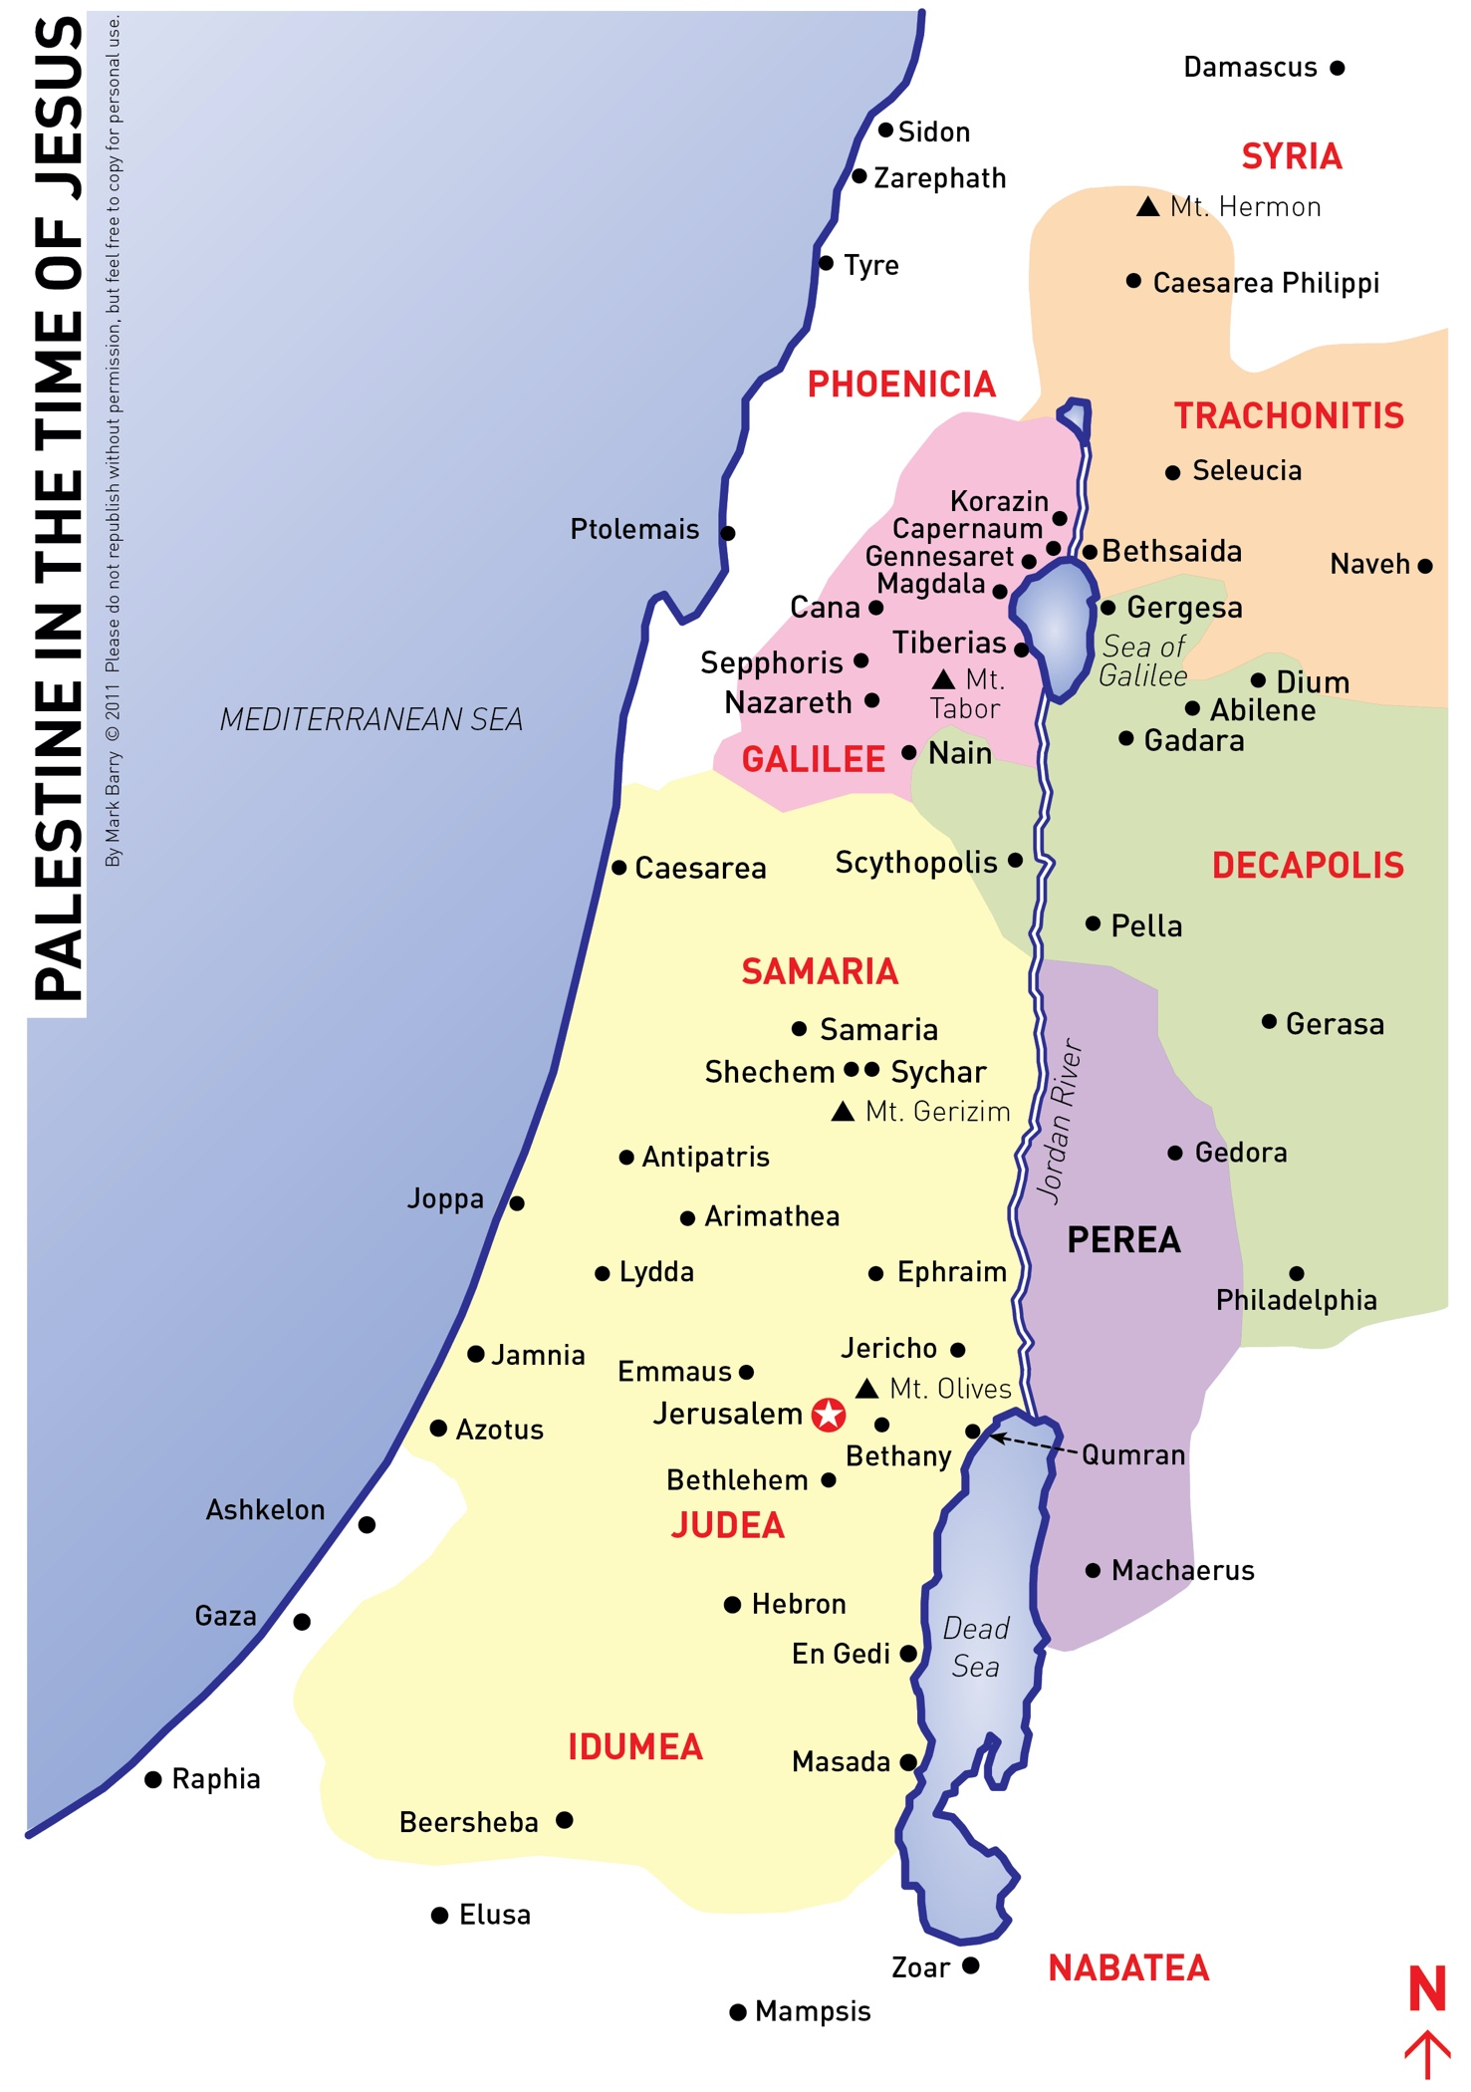

Passage: Date: (Page 1 of 2)
- What happens in the section you are reading? Can you summarize the key events in your own words?

- Who are the characters that appear in this section? How do they interact with Jesus? What do we learn about them?

- Is there anything in this section that seems unusual or surprising? Is there anything that seems to be particularly important? Tip: Look for things the characters say, or words that are repeated.

- Are there any connections to the Old Testament in this section (e.g quotations, Jewish customs or festivals)? Do you think these are significant? Why?

Passage: Date: (Page 2 of 2)
- What does this section reveal about who Jesus is, and what he came into the world to do?

- Have you read anything that reminds you of ideas in John’s Prologue or Purpose Statement (see p.14)? How does this section help to achieve John’s purpose?

- Is there anything you need to change about the way you follow Jesus as a result of this section? Tip: This might relate to what you think about Jesus, or yourself; How you approach other people, or church; or your level of confidence to keep believing in Jesus.

- Imagine a friend asks you, “Why should I bother with Jesus?” How would you persuade them to follow Jesus, using what you’ve learnt from this section?

