

Growth Groups Material
(5 studies on Romans 1-4)
Jan-Feb 2024



Teaching Schedule
In our gatherings we will work through a 5-part series: | 25-28 Jan  1-4 Feb  8-11 Feb  15-18 Feb  22-25 Feb | 1: Romans 1:1-17  2: Romans 1:18-32  3. Romans 2:1-3:8  4. Romans 3:9-31  5. Romans 4:1-25

Booklet Contents
Introduction | p.3
Study 1 (Romans 1:1-17) | p.7
Study 2 (Romans 1:18-32) | p.10
Study 3 (Romans 2:1-3:8) | p.14
Study 4 (Romans 3:9-31) | p.17
Study 5 (Romans 4:1-25) | p.21
Additional Resources
We’ve put together some additional resources that might help you as you make your way through this series:

https://jannalianglican.org.au/faithnotworks | 

Introduction
The book of Romans is one of the most well-known and influential of Paul’s New Testament letters. A church in Rome had likely developed very soon after the ascension of Jesus. There were people from Rome present in Jerusalem, on the Day of Pentecost, when Peter delivered his famous speech (Acts 2:10). Paul, though, had never been to Rome. After many years of missionary journeys around other parts of the ancient Mediterranean, Paul had plans to travel west, via Rome, towards Spain (Rom 15:22-24). So, he writes this letter to the church, most likely from Corinth, around 57AD, to pave the way. In it, he sets out his mature, comprehensive understanding of the Christian gospel, sharpened over many years of study and proclamation. Paul needed to answer doubters, explain how Jews and Gentiles could co-exist in God’s new people, and clarify just how it is that God can save people by faith and not works. That last phrase, ‘Faith Not Works’ is our summary of the theme of chapters 1-4.
As you will read, this letter is addressed to a real church, but it feels like a theology textbook. Close reading and understanding of Paul’s theology in Romans, pays immense dividends though. John Calvin, the 16th Century Reformer said of Romans:
If we have gained a true understanding of this epistle, we have an open door to all the most profound treasures of Scripture.
Today, it is as important as ever to be crystal clear regarding how we are saved. If we have clarity on this issue, we’ll learn to focus on the main things in the Christian life – Jesus and his work for us; we’ll grow in our assurance of God’s grace toward us; and we’ll be able to faithfully share the gospel with others and lead them to the same saviour we have found. There’s plenty at stake! We pray you will benefit greatly from examining this wonderful letter.

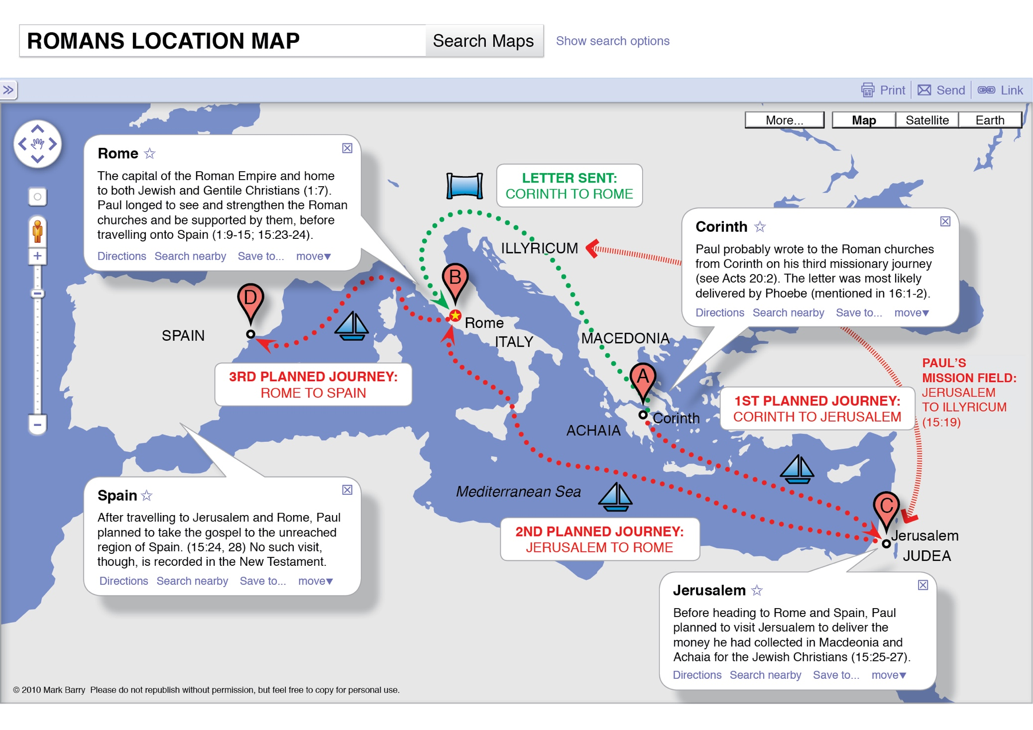
*Graphics produced by Mark Barry (Visual Unit): https://visualunit.me/tag/romans/
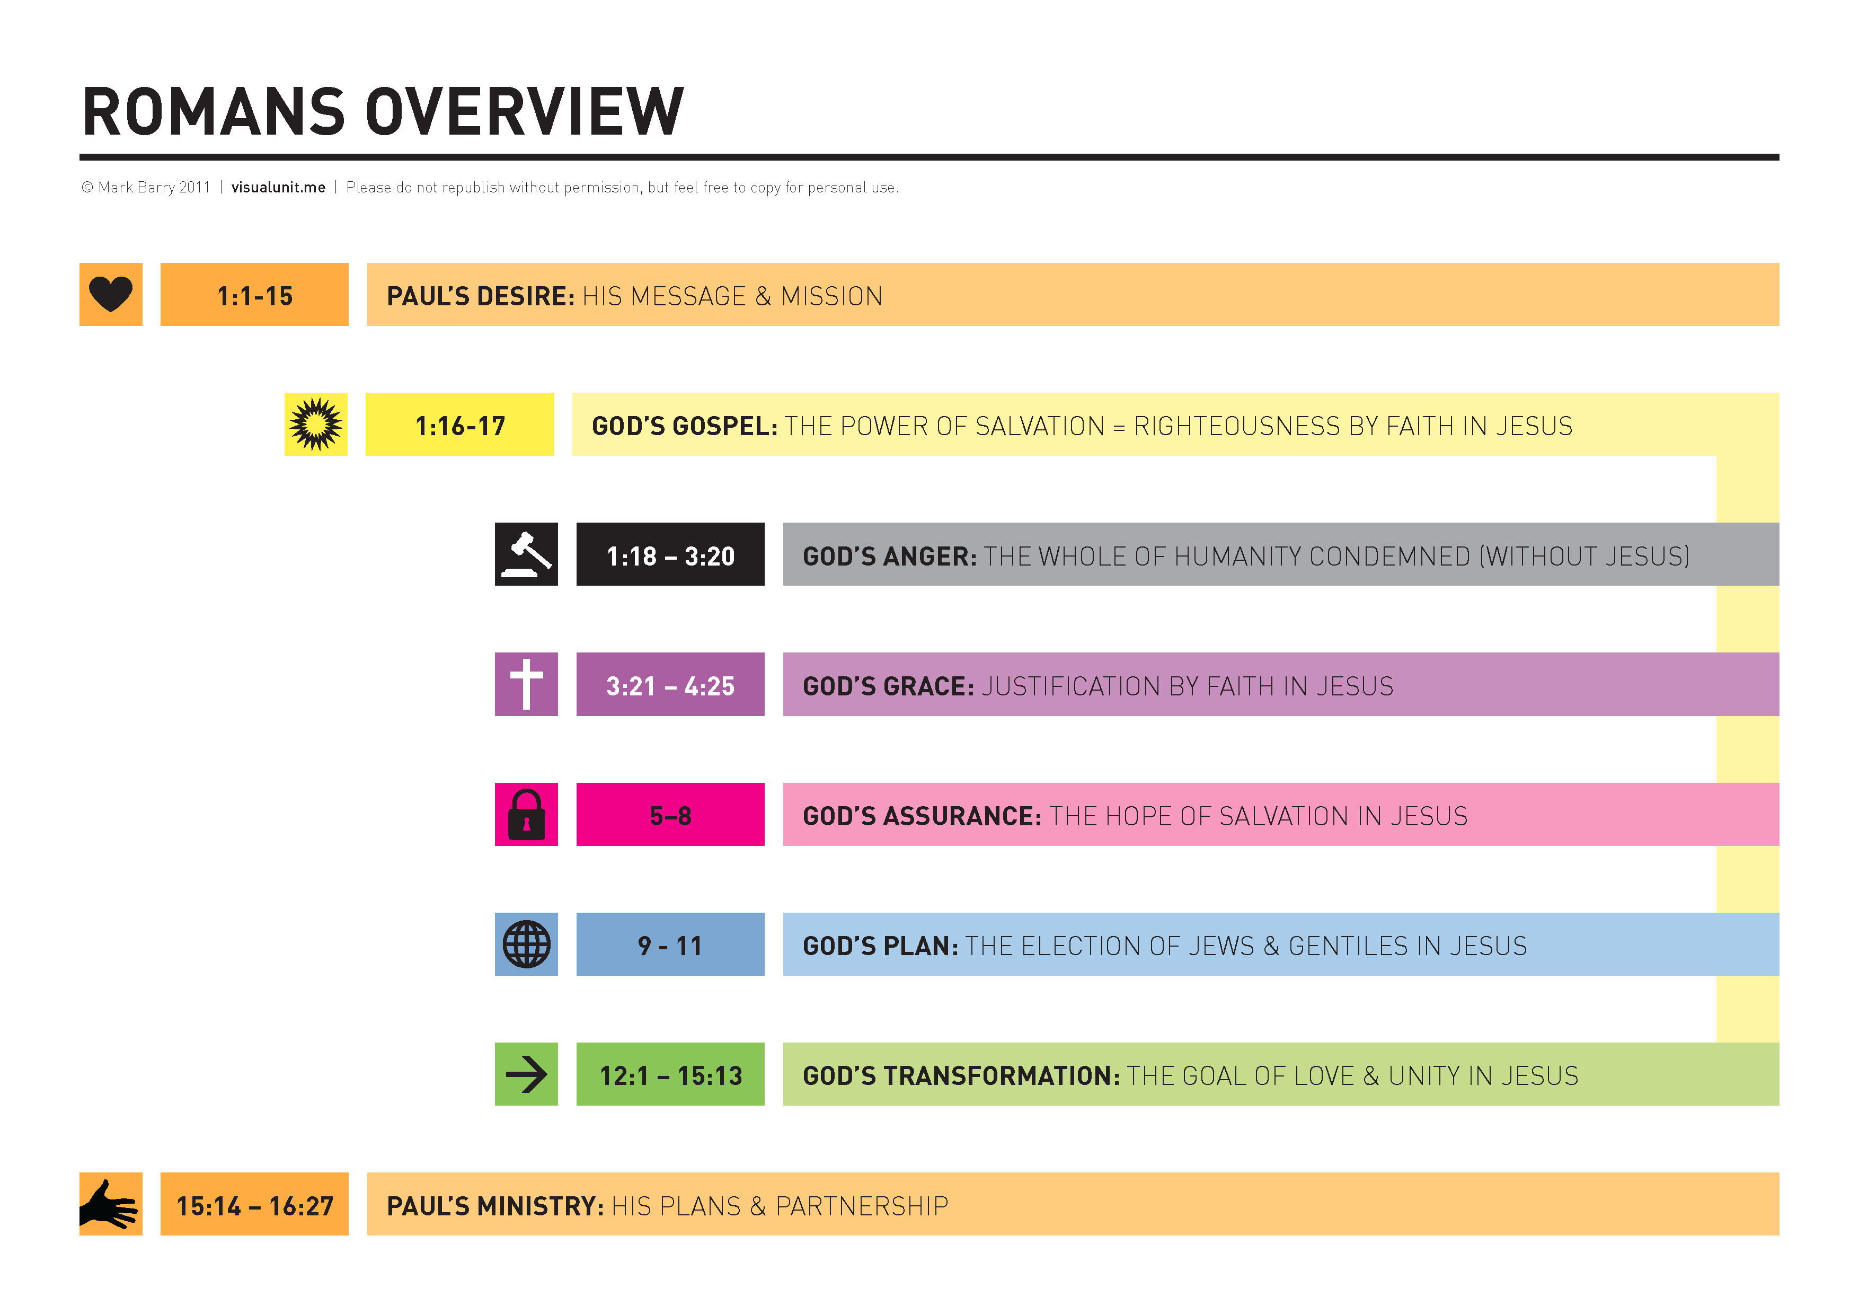
*Graphics produced by Mark Barry (Visual Unit): https://visualunit.me/tag/romans/
Page left intentionally blank (use for notes, prayer points etc)

Study 1 | Romans 1:1-17
Introduction
- The letter to the Romans is often said to be one of the most important books in the Bible. If you have read and studied Romans before, what has stuck in your memory? What makes this book so important? If you haven’t read Romans before, what do you think might cause people to ascribe such importance to it?

- Have you felt nervous or ashamed of sharing the gospel?

- Without referring to Romans, or any other outline, write down or share your best summary of the gospel: the Christian good news:

Read and Discuss
- Read Romans 1:1-7. What do we learn about:
  - Paul

  - The Gospel

- Read Romans 1:8-15. Why does Paul want to visit Rome?

- Read Romans 1:16-17. Paul says he is not ashamed of the gospel. What reasons does he give to explain his confidence?

- Consider the logical connection between verses 16 and 17. How is it that the gospel is the power of God for salvation?

Reflect and Apply
- Do you think we ought to be as driven to share the gospel as Paul is? Why or why not? What in today’s passage supports your view?

- Verses 1-7 declare that Jesus is the king of all people, and that all nations ought to respond to the gospel in obedience and faith. Why might we feel ashamed about this, or find it hard to share this truth with people in our workplaces/neighbourhoods etc.? What will help us persevere with confidence in sharing the gospel?

- According to Romans 1:1-17 how are people saved? How does this truth make you feel?

Study 2 | Romans 1:18-32
Introduction
- If you were to ask 100 people “What was wrong with the world?”, what answers would you get?

- If you asked those people: “What would fix what is wrong?”, what answers would you get?

- Is it possible to explain the gospel without offending people?

Read and Discuss
- This passage follows a pattern, with repeated cycles, consisting of a description of human sin, followed by consequences given by God. Consider the following sections. Can you identify the relevant parts:

 | Human sin | Consequences
v.18-24
v.25-27
v.28-32

- What does verse 32 add to the picture of human sin presented earlier in the passage?

- How, then, do we see the reality of God’s present wrath in the world around us?

Reflect and Apply
- How would you summarize what we learn here about the human condition? In what ways are we tempted to ‘water down’ this assessment.

- What are two or three created things that you are most tempted to treat as ‘gods’, believing that they can fulfil and satisfy you?

- In what was can you see that your desires are out of order? Do you honestly feel that you suffer from a senseless, darkened heart (v.21), or a corrupt mind (v.28)?

- Some people say that it’s not fair that God will judge those who haven’t heard about Jesus. What does this passage have to say about that?

Page left intentionally blank (use for notes, prayer points etc)

Study 3 | Romans 2:1-3:8
Introduction
- Review the key points from Romans 1:18-32. Do you think you are in the category of people described there?

- Do you ever compare yourself to people who aren’t Christian and find yourself looking down on them. When, and in what areas of life does this tend to happen for you?

Read and Discuss
- Read Romans 2:1-16. Who do you think Paul is addressing here? What is this person like? Does he have real people in mind?

- Paul speaks of the final judgment in verses 5-13. On what basis will God judge people? How does this match up with verses like Romans 1:16-17 and Romans 3:21-26? Are Christians really saved by faith as we’ve been led to believe?

- The Gentiles were non-Jews who didn’t have God’s revealed laws. How is it that they can be held accountable to God’s moral standards?

- Read Romans 2:17-29. Where were religious Jewish people placing their confidence for salvation? What was wrong about this?

- Read Romans 3:1-8. After considering chapter 2, why might Paul’s readers be confused about God’s treatment of the Jewish people?

- Who was at fault when the Jewish people failed to receive salvation through obedience to the Jewish laws?

Reflect and Apply
- What sort of religious privileges and outward signs might Christian people rely on for salvation (like the Jews had done with circumcision). What is wrong with this approach?

- Advanced Bible knowledge and lots of church involvement is both wonderful, and potentially dangerous. How can we grow in knowledge and service, but avoid the danger of hypocrisy.

- Why is the guilt of all people, Jew and Gentile alike, so crucial for us to understand if we’re to grasp the gospel properly?

Study 4 | Romans 3:9-31
Introduction
- Can you think of anything that every human being (in all places, at all times) has in common?

- Who is the most evil person you can think of. It might be a historical figure. How would you feel if God forgave their sin?

Read and Discuss
- Read Romans 3:9-20. What concept is repeated in verses 10b-12? What is the significance of this in Paul’s argument?

- What major conclusion does Paul arrive at in this section?

- Read Romans 3:21-26. What words seem to be important? Have a go at defining these words.

- According to this section, why was it essential for Jesus to die on the cross?

- What is our part in being justified?

- Read Romans 3:27-31. What is Paul’s main point in this section? How might this affect the way the Jews in the Roman church thought about themselves? About Gentile believers?

Reflect and Apply
- Does God throw away his commitment to justice when he forgives sinners?

- Read verses 22-24 again. This is an astonishing truth! What are the implications of this reality for other religions?

- Are there times when you feel that your acceptance by God is in jeopardy? What assurance can be found in these verses in times of doubt?

Page left intentionally blank (use for notes, prayer points etc)

Study 5 | Romans 4:1-25
Introduction
- What do people today understand by the word "faith"? Try and think of some sentences illustrating different ways the word might typically be used.

- “We have very little in common with people from the Old Testament?” Discuss.

Read and Discuss
- Read Romans 4:1-8. The word ‘credited’ comes up several times and is very important. Can you determine the meaning from it’s usage here?

- According to these verses, what is credited to whom? And on what basis?

- Read Romans 4:9-25. Why is the order of events in Abraham’s life so important to Paul’s argument here?

- What is the significance of the example of Abraham for Jew/Gentile relations in the new church?

- What was Abraham called to believe in? Why might this have been hard to believe?

- Are we better or worse off than Abraham in terms of reasons to trust God?

Reflect and Apply
- Is it right to say that God rewards faith with salvation? If you’re not sure, what words other than ‘reward’ would you use to describe the connection between faith and salvation.

- Some people describe Christian faith as a ‘leap in the dark’. What would you say about that, based on what we’ve learnt from this chapter?

- What can we learn from the example of Abraham?

- As a group, try to sum up the teaching of Romans 1-4. What have been Paul’s main points? What has struck you, in particular?

- Why is the message of Romans 1-4 very good news?


