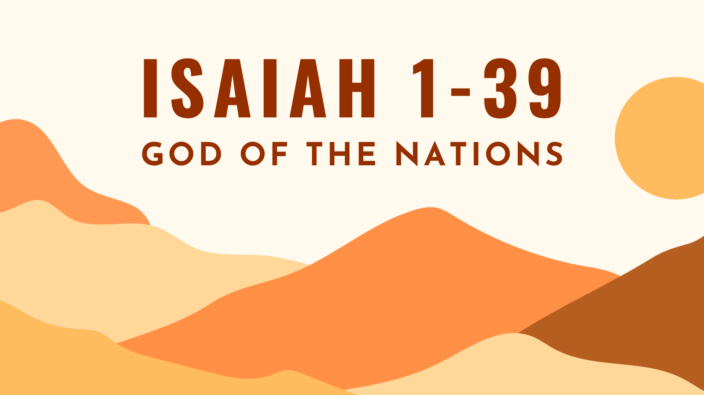

Growth Groups Material
(9 studies on Isaiah 1-39)
May-June 2024



Teaching Schedule
In our gatherings we will work through a 9-part series: | 2-5 May  9-12 May  16-19 May  23-26 May  30 May - 2 Jun  6-9 Jun  13-16 Jun  20-23 Jun  27-30 Jun | 1: Isaiah 1:1-2:4  2: Isaiah 5:1-30  3. Isaiah 6:1-13  4. Isaiah 8:11-9:7  5. Isaiah 11:1-12:6  6. Isaiah 13:1-14:2  7. Isaiah 24:1-23  8. Isaiah 35:1-10  9. Isaiah 36:1-37:7

Booklet Contents
Introduction | p.3
Study 1 (Isaiah 1:1-2:4) | p.6
Study 2 (Isaiah 5:1-30) | p.9
Study 3 (Isaiah 6:1-13) | p.12
Study 4 (Isaiah 7-8) | p.16
Study 5 (Isaiah 11:1-12:6) | p.19
Study 6 (Isaiah 13:1-14:2) | p.23
Study 7 (Isaiah 24-25) | p.26
Study 8 (Isaiah 35:1-10) | p.29
Study 9 (Isaiah 36-37) | p.32

Additional Resources
We’ve put together some additional resources that might help you as you make your way through this series:

https://jannalianglican.org.au/godofthenations/

Introduction

We’ve all heard of the book of Isaiah. It seems like one of those big and important books in the Old Testament, spanning 66 chapters. It’s quoted many times in the New Testament, second only to the Psalms in frequency. But making sense of it feels like a daunting prospect. It’s complex! Like lots of prophetic literature, there are strange images, and (to many minds) a frustrating lack of chronological, or even, logical order. Despite these hurdles, there is much to be gained from examining this part of God’s Word. It covers essential and profound themes such as the sovereignty of God, sin, judgment, salvation and new creation. This term, we’re focusing on the first part of the book, chapters 1-39. We can’t do it verse by verse. So we’ll focus on some of the key passages.

Isaiah chapters 1-39 were written in the context of the looming dominance of the neighbouring Assyrian Empire. Ultimately, this empire would bring about the destruction of the Northern Kingdom of Israel and threaten the existence of the Southern Kingdom (also known as Judah, or its capital Jerusalem). This crisis led the people of God to ask big questions like:
- Is God truly more powerful than the other godless nations?
- What is the role of God’s people in the world?
- If God judges, will they be destroyed totally? Will God still love them?
- What is the future of the Davidic monarchy (David’s line)?

As Isaiah’s prophetic vision gradually addresses these questions we will be confronted by God’s severe opposition to human sin and his determination to judge it. But at the same time, we’ll be comforted by God’s sure plan to extend mercy to his people and accomplish his saving plans for the world. We pray that God would teach us all wonderful things from this part of his word, and moreover, that our hearts and lives would be conformed into the likeness of Jesus through our learning.

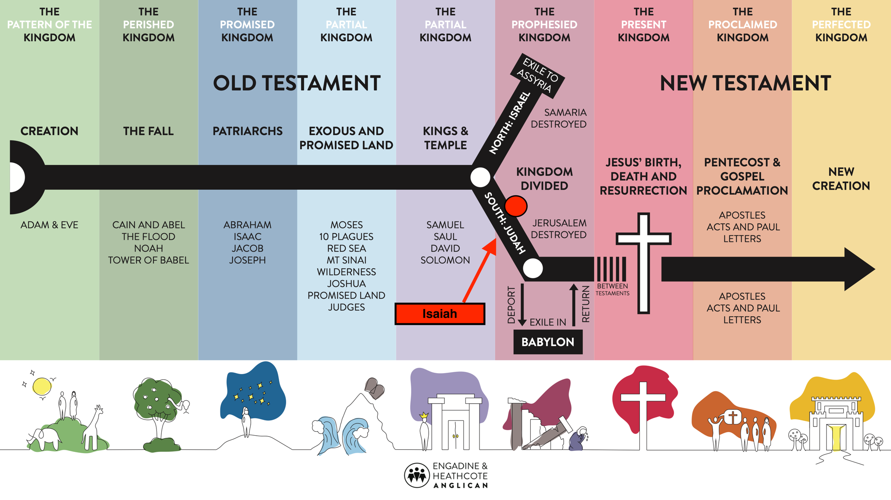

Page left intentionally blank (use for notes, prayer points etc)

Study 1 | Isaiah 1:1-2:4

Introduction
- As a group, have a go at coming up with a timeline of the main events in the Bible? Then mark where Isaiah would be placed. How would you go about finding out where Isaiah was located on the timeline?

- What do you understand by the term a ‘renovators delight’? Have you ever purchased a ‘renovators delight’ or seen a TV program focused on one? What typically happens to a ‘renovators delight’?

Read and Discuss
- Read Isaiah 1:1-2:4. What charges does God bring against his people?

- What are some of the images or analogies used to describe God’s people?

- How would you summarize God’s feeling towards his people? What is he proposing to do about it?

- Despite the gloomy outlook, can you identify which verses offer hope to the Israelites? What do they say?

- Read Acts 2:5-12, 22-24. What features of Isaiah 2:1-4 do you see being fulfilled?

Reflect and Apply

- Isaiah’s picture of Jerusalem (representing God’s people) is sometimes described as a ‘renovators delight’. How does the movement from chapter 1 to chapter 2 convey that idea?

- Kirk Patston, in his commentary, writes:
“The book of Isaiah often presents the severity of God, such as we encounter here [in chapter 1]. This is one of the reasons we need books like Isaiah. They do not let us escape the serious business of God’s holiness”.
Why do you think we need books like Isaiah that confront us with God’s holiness? How should we respond if we’re confronted by our sin and God’s holiness?

- Consider your response to question 7. We live in the last days, after Jesus’ resurrection. If this is the case, what point is there in us studying Isaiah this term?

Study 2 | Isaiah 5

Introduction
- Can you list all the metaphors used in the Bible to describe the church?

Read and Discuss
- Read Isaiah 5:1-7. What is the metaphor used here to describe God’s Old Testament people? What is the problem described? What is God going to do?

- How do these verses help us remember the history of relationship between God and his people? Why is this so important in understanding God’s response to Israel’s sin?

- Read Isaiah 5:8-25. These verses contain six cycles of ‘woe’. Can you identify the 6 sections? What is the essential category of sin that is highlighted in each section?

- Read Isaiah 5:26-30. What do these verses describe? What do we learn about God’s relationship to the nations that eventually conquered his people (e.g. Assyria, Babylon)?

Reflect and Apply
- Are there elements of Judah’s sin that you/we are guilty of today? What have we learnt about God’s feeling towards that sin?

- Why is the exposure of our sin and the threat of judgment a good thing for us?

- Read John 15:1-7. Jesus alludes to the vineyard imagery of Isaiah. Why is it good news that Jesus is the ‘true vine’. According to Jesus, what is the key for us in bearing fruit? How can we implement Jesus’ exhortation?

Study 3 | Isaiah 6

Introduction
- If you had to imagine seeing God, how would you describe what you see?

Read and Discuss
- Read Isaiah 6:1-4. What did Isaiah see in his vision. What impression of God does this vision convey?

- Read Isaiah 6:5-7. What is Isaiah’s response to what he sees. What does God do for him?

- Read 6:8-13. Can you summarize the message Isaiah is to deliver to the people? What is unusual about it?

- Is there any hope in this chapter?

Reflect and Apply
- In light of what we have read in Isaiah so far, how might Isaiah’s personal journey bring hope to those reading his message.

- People often reject the gospel, even though the true king, Jesus, has now come. How does Isaiah 6:9-10, and Jesus’ interpretation of it in Mt 13:10-17, help you understand and cope with this?

- Do you consider yourself to be sent by God to deliver his message? What qualifies you to speak on God’s behalf?

Page left intentionally blank (use for notes, prayer points etc)

Study 4 | Isaiah 7-9

Introduction
- What do you do when you face a threat in your life? Why are threats so good at revealing what we put our ultimate trust in?

Read and Discuss
- Read Isaiah 7:1-9 and 2 Kings 16:1-6. What crisis is facing King Ahaz? How does God meet him in his need?

- Read Isaiah 7:10-12 and 2 Kings 16:7-9. What is Ahaz’ response to God’s offer? Whom does Ahaz trust for political security?

- From 7:13 through to 8:8 God is announcing judgment against Judah because of their sin (and in particular, King Ahaz’s refusal to trust God). Briefly read through this section. Who will be God’s instrument of judgment?

- From 8:11-17, God is issuing an appeal to Isaiah about how he ought to be different from Ahaz and the other faithless Israelites. What should characterize Isaiah and other faithful Israelites?

Reflect and Apply
- Humanly speaking, where we stand with God is determined by whether we stand firm in the faith (Isaiah 7:9). What is one practical step you can take this week to stand firm in Christ?

- Read 1 Peter 3:13-15. What people or situations in life are you inclined to fear, more than you fear God? How does this passage help you deal with such fear?

- In this section of Isaiah we often read of ‘God with us’. Most famously, it’s there in 7:14, in the name Immanuel (which means God with us); as well us 8:10.

  - How conscious are you of God’s presence in your life and how does this affect the way you carry yourself in public and how you spend your private time?

  - Read Matthew 1:18-23. How might your understanding of ‘God with us’ evolve in light of this passage?

Study 5 | Isaiah 11-12

Introduction
- Do you ever find it hard to believe that God really will restore the world to order in the new creation? Why? Why not?

Read and Discuss
- Read Isaiah 11:1-9. This section focuses on one particular figure. From this passage, what do we learn about:

  - Who this is;

  - What they will be like;

  - What will result from their rule.

- Skim read 1 Samuel 16:1-13 and 2 Samuel 7:12-16. Who is Jesse, and what is the significance of this figure coming from the ‘stump of Jesse’?

- Read 11:10-12:6. We’ve learnt about this wonderful new ruler in the question above. How will the ruler impact the world at large, beyond the borders of Judah/Israel?

- Read the following NT verses. How does King Jesus fulfill the pictures of God’s ruler presented in Isaiah.

  - Matt 1:5-6, Rev 5:5

  - Luke 3:21-22;

  - Luke 2:52, Mark 13:54

  - Acts 1:8, Romans 15:8-9, 12,

Reflect and Apply
- Consider all the key events described in chapters 11 and 12. Which of these events have already occurred? Which are yet to occur? Which have begun and are ongoing?

- Verses 12:1-2, are a bit different from the rest of the section? How are they different? What makes these words suitable to be spoken by Christians today?

- Verses 1-6 of chapter 12 make a personal connection between personal joy in salvation and mission to others. What lessons can we derive from this in growing in our own personal evangelism.

Page left intentionally blank (use for notes, prayer points etc)

Study 6 | Isaiah 13-23

Introduction
- Does it ever feel like God’s people in the world are in the minority and the progress of gospel growth is being jeopardised by those who oppose Christianity? How do you respond when you feel like that?

Read and Discuss
- Pick a few of the passages listed below. For each passage, identify:
  - Which nation is being spoken about?
  - What are the sins of the nation?
  - What will God do in response to these sins?

Isaiah 14:3-23; 15:1-16:14; 17:1-11; 19:1-15

- To summarise, what is God’s view towards nations (and their people) that do not acknowledge him?

- Remember the political/military mistakes of King Ahaz. Read Isaiah 7:10-12, 2 Kings 16. What were these mistakes? How do these prophecies of judgment against the nations expose the folly of Ahaz’s approach?

- Commentary writer David Jackman, writes of Isaiah chapters 13-23:
“These prophecies are primarily designed for God’s people to hear […] we should not imagine Isaiah on a middle-eastern preaching tour, so much as instructing Judah and Jerusalem about God’s perspective, which they should share”
How would you sum up God’s perspective from these verses? Why was it important for God’s people in Isaiah’s time to understand and share this perspective?

Reflect and Apply
- Unlike rebellious Judah, we’re not likely to look to surrounding nations for hope and security. What things other than God are we tempted to look to for when it comes to:

  - personal fulfillment;

  - success in church ministry

  - safety and security.

- Read James 4:4. How is James’ warning to Christians similar to Isaiah’s message from these chapters? When does friendship with the world cross the line into being a problem for Christians? Are you in ‘friendship’ with the world in a manner that would exasperate God?

- These chapters demonstrate that our God truly is the God of the nations. He is ruler over all people and all of history. How might this comfort us as we consider current world events?

Study 7 | Isaiah 24-25

Introduction
- How often does the notion of God’s final judgment of the world enter your mind? If not very often, why are we reluctant to dwell on this idea?

Read and Discuss
- Read Isaiah 24:1-23. Can you sum up in one sentence, what this chapter is about?

- What images of judgment stand out to you the most? What is your emotional response to this imagery?

- This is a picture of God’s final judgment of the world. Let’s dig a bit deeper. Can you identify:

  - The reasons for judgment (e.g. why)

  - The scope of judgment (e.g. who is it aimed at)

  - The goal of judgment (e.g. what is God’s aim in judging)

- Read Isaiah 25:1-9. How do these verses show us that God’s judgment is a reason to praise Him?

- In verses 6-8, what can God’s people look forward to after judgment has been carried out?

Reflect and Apply

- Considering what we know about Isaiah’s time, and the biblical story at large, when do you think the events of chapter 24 take place?

- Why should the reality of God’s judgment against the world motivate us to seek the salvation of the lost? How might the imagery of chapter 24 help us to grow in that desire?

- Read 2 Peter 3:1-13.

  - Verse 3 describes people scoffing at the idea of God’s judgment. Do we still see that attitude today?

  - What is the reason that God hasn’t yet delivered his final judgment?

  - What ought to be the attitude of Christians as we wait for the final judgment?

Study 8 | Isaiah 35

Introduction
- Have a go at remembering the historical context that Isaiah and his readers were in. What features do you recall? What similarities might exist between their situation, and the situation of Christians today?

Read and Discuss
- Read Isaiah 35:1-7

  - What is your first impression of these verses?

  - These verses speak of a future time (future to Isaiah and his audience). Come up with two lists: things that will be there, and things that won’t be there.

- Verses 3-4 and issue encouragement to some people. What do we know about these people? What do these verses teach us about the connection between God’s judgment and his salvation.

- Read Isaiah 35:8-10.
  - What can we learn about the ‘road’ that as described?

  - Who will and won’t travel on this road?

  - Where does the road lead?

Reflect and Apply
- Read Matthew 11:1-6. Which part of Isaiah 35 does Jesus allude to. What point is he making?

- Do you think Isaiah 35 is fulfilled in Jesus first coming, or his second coming?

- Our world is full of examples of physical impairment and bodily disability. In fact, all of us have bodies that are plagued with weakness. Isaiah 35:5-6 pictures a time when these problems will no longer exist. Read Philippians 3:20-21. How do these realities expand our understanding of salvation?

- Verses 3-4 use future hope to encourage ongoing faith and endurance. How does future hope help Christians endure? What kind of trials in life should prompt us to remember our hope?

Study 9 | Isaiah 36-37

Introduction
- Reflect on the term so far. What big ideas and lessons have you taken out of our journey through Isaiah 1-39 so far?

Read and Discuss
- Read Isaiah 36:1-4. What is the situation facing King Hezekiah?

  - How would Hezekiah and the people have been feeling at this point?

  - The location referred to in verse 2 is the same place Isaiah met King Ahaz back in 7:3. What might be the significance of that?

- The events of chapters 36 and 37 are a bit easier to follow than the poetry and prophecy we’ve been reading for most of the term. Read through the following sections and come up with your own title and summary:
Passage | Title | Summary of main events/themes
36:4-10
36:13-20
37:1-4
37:5-7
37:8-13
37:14-20
37:21-38

- The question posed by the Assyrian spokesperson in 6:4 is “What are you relying on?” How does question this focus our attention on the central issue in these chapters?

- What do we learn about God in Hezekiah’s prayer (37:16-20), God’s response through Isaiah (37:21-35) and the downfall of the Assyrians (37:36-38)?

Reflect and Apply
- Consider you answers to question 5. How does what we know about God, bring comfort and assurance to us in times of doubt/trial? Is there something in your life presently challenging your trust in God? How could these truths help you?

- In what ways is King Hezekiah a good example to us that we should seek to emulate in our own lives?

- Isaiah’s account of these events reminds us of many themes we’ve already encountered this term: trusting God v trusting others, God’s commitment to his people and purposes, God’s rule over proud nations etc. What lessons from this term have stood out to you? What can you do this week to live in a way which demonstrates your learnings?

Page left intentionally blank (use for notes, prayer points etc)



