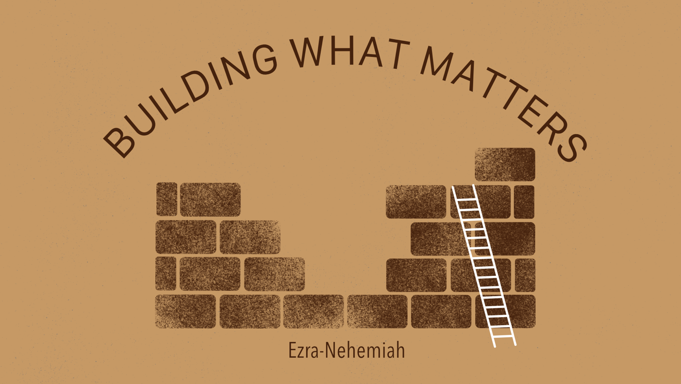

Growth Groups Material
(9 studies on Ezra-Nehemiah)
Apr-Jun 2026
MEMBERS VERSION



Teaching Schedule
In our gatherings we will work through a 9-part series | 30 Apr - 3 May  7-10 May  14-17 May  21-24 May  28-31 May  4-7 June  11-14 June  18-21 June  25-28 June | Ezra 1  Ezra 3-4  Ezra 7  Ezra 9-10  Nehemiah 1-2  Nehemiah 4  Nehemiah 7  Nehemiah 8-10  Nehemiah 10,13

Booklet Contents
Introduction | p.3
Study 1 (Ezra 1) | p.4
Study 2 (Ezra 3-4) | p.7
Study 3 (Ezra 7) | p.11
Study 4 (Ezra 9-10) | p.14
Study 5 (Nehemiah 1-2) | p.16
Study 6 (Nehemiah 4) | p.19
Study 7 (Nehemiah 7) | p.21
Study 8 (Nehemiah 8-10) | p.23
Study 9 (Nehemiah 10,13) | p.25
Lifeboat list activity | p.28

Additional Resources
We’ve put together some additional resources that might help you as you make your way through this series:  https://www.jannalianglican.org.au/ezra-nehemiah | 

Introduction

As we begin this series, Building What Matters, we step into the story of Ezra and Nehemiah—two books that tell of God’s people returning home after many years in exile. Jerusalem had been destroyed, the temple ruined, and the people scattered. But by God’s grace, a new chapter begins. Under Persian rule, groups of Israelites are allowed to return and rebuild—not just their city, but their life together as God’s people.

Ezra focuses on the rebuilding of the temple and the renewal of worship. Nehemiah tells the story of rebuilding Jerusalem’s walls and restoring the community. Together, they show us that God is not finished with his people, even after failure and judgement. He keeps his promises and works through ordinary people to bring about his purposes.

As you read, look out for a few key themes. Notice God’s faithfulness—how he keeps his word and provides what his people need. Watch for the importance of God’s word, as it shapes and reforms the community. Pay attention to prayer, repentance, and perseverance in the face of opposition. And see how leadership matters, as Ezra and Nehemiah guide God’s people with courage and humility.

These books are about building—but not just buildings. They are about building lives centred on God, building communities shaped by his word, and building faith that endures.

Our prayer is that, as we walk through this series together, God would be at work in us—helping us to build what truly matters for his glory.

Study 1 | Ezra 1:1-11

Introduction
- Discuss what you know, or have heard about the books of Ezra and Nehemiah

- Work as a group to come up with a timeline of the key Old Testament events. Have a go at placing Ezra and Nehemiah on this timeline.

Read and Discuss
- Read Deuteronomy 28:15,36-37 and 2 Chronicles 36:15-21. Why were the Jews sent into exile in Babylon?

- Read Isaiah 44:24-28 and Jeremiah 29:10-14. What hopes found in the prophets could the Jews look to, during their exile?

- Read Ezra 1:1-11. What is the key phrase/idea, repeated twice, which makes it clear that God is behind the events of Ezra 1?

- What evidence do we see that God’s judgment against his people was being lifted, and he was intent on blessing them?

Reflect and Apply
- What do we learn about the power of God in this passage? In relation to world affairs? In relation to powerful people? In relation to his own promises?

- God keeps his word. Ezra places this theme at the forefront (Ezra 1:1). What promises has God made to us that we can rest in, knowing that he will keep them? What promises from God do you find most difficult to trust?

- The Jews that returned to Jerusalem left their homes and prioritised the building of God’s temple. In what sense do they function as a positive example for Christians today?

Study 2 | Ezra 3-4

Introduction
- In our day and age, Christians are often considered out of touch, and perhaps even dangerous in some of their views. How does this make you feel? How should we think about any pressure or persecution we face?

Read and Discuss
- Read Ezra 3:1-12. How would you describe the attitude of the returned people towards God? What does the author emphasize to make this point? What is the response of the people to the foundations of the temple being completed?

- Chapters 4-6 describe assorted opposition that the Jews encountered during their temple rebuilding. The events are presented through the inclusion of a series of official letters. List and summarise the letters below:

Verses | From | To | Summary
4:6
4:7
4:8-16
4:17-23
5:6-17
6:6-12

- What was the outcome of the assorted disputes? How did the Jews celebrate the completion of the temple?

Reflect and Apply

- At the heart of relating to God, back then, as it is now, is sacrifice for sin and meeting God in his temple. Read Hebrews 9:1-15. How has Jesus perfected the functions originally represented by the temple and sacrificial system?

- God’s people now are also called to work towards the building of God’s “new temple”, the church, in response to the grace God has shown in saving us. What can we be doing to be building up the new temple?

- How might pursuing worship today endanger us like it did the Jews in Ezra’s time? What comfort can be found in the knowledge that God’s people have always experienced opposition?

- The theme of God’s sovereign care of his people (first seen in chapter 1) has continued amidst the opposition we’ve read about. How does this help us when we encounter difficult circumstances?

Study 3 | Ezra 7

Introduction
- What attributes make a leader worthy of following?

Read and Discuss
- Read Ezra 7:1-10. Even though the book is named after him, we’re only meeting Ezra now. What do we learn about Ezra and his character from these verses.

- Read Ezra 7:11-26. What was Ezra appointed to do by King Artaxerxes? How is this different to what we’ve read about in chapters 1-6? What does this new task signify?

- What features of Artaxerxes’ decree remind us of chapter 1? What is this repeated pattern teaching us?

Reflect and Apply
- For those in positions of Christan leadership (or for the rest of us, as we evaluate leaders), what about Ezra’s character ought to be emulated?

- In what ways does Ezra point to Jesus? In what ways is the ministry and leadership of Jesus superior to Ezra?

- In chapter 1-6 the temple rebuilding work was complete? And yet the mission of Ezra indicates that the work of restoring God’s people was not complete. The community needed to bring their lives into line with God’s law. Have you ever found yourself content with the formalities and structures of worship, without turning your attention to personal godliness? What has this development in the story of Ezra taught us about that attitude?
Page left intentionally blank (use for notes, prayer points etc)

Study 4 | Ezra 9-10
Introduction
- Do you think it’s good/right for Christians to grieve over our sin?

Read and Discuss
- Read Ezra 9:1-4. What is the concern raised and how does Ezra respond to the news?

- Read Deuteronomy 7:1-6. What was God’s concern with his people mixing with other nations? How does this help us understand the seriousness of the Jews marrying foreign women?

- Read Ezra 9:5-15. What stands out to you from Ezra’s prayer? How does Ezra’s recount of Israel’s history help expose the seriousness of sin?

- Read Ezra 10:1-4. Chapter 10 records the steps taken by the community after they become convicted of their sin. Why do you think this chapter is included in the book?

Reflect and Apply
- Have you ever felt weighty grief and shame over your sin, that compares to what Ezra and his generation felt? Why or why not?

- At the conclusion of his prayer Ezra prays: “Here we are before you with our guilt, though no one can stand in your presence because of this.” How is our situation before God different to that of Ezra and his peers?

- How do Ezra chapters 9-10 leave us longing for the coming of Christ? What do we have in common with Ezra’s generation that shows us our great need for a saviour

Study 5 | Nehemiah 1-3

Introduction
- Reflect on the series so far. What big themes have emerged from our study of Ezra?

Read and Discuss
- Read Nehemiah 1:1-2:8. What is the situation for God’s people at this time, and how does Nehemiah respond?

- What does Nehemiah appeal to in his prayer to God in verses 5-11.

- What features of chapter 2 remind us of what we’ve seen already throughout this series?

- From 2:11-3:32 we read about the work to rebuild Jerusalem’s walls. Skim over chapter 3. Why do you think the author has included so much detail about who did what?

Reflect and Apply
- Nehemiah’s heart broke when he heard that God’s city was in ruins. What situations in your life, community, or the world break your heart in a similar way? Do you feel that way when God’s church suffers or falters?

- In Nehemiah’s prayer, he is effectively praying “Lord, please do what you have said you will do?”. What value is there in repeating God’s own words back to him, when we pray?

- Chapter 3 gives us a picture of unity in diversity, as the people worked together to rebuild Jerusalem’s walls. Read Ephesians 4:11-16, and Romans 12:3-8. What similar themes emerge from these passages? What is the building work we are involved in?

Page left intentionally blank (use for notes, prayer points etc)

Study 6 | Nehemiah 4

Introduction
- “The work of growing God’s kingdom shouldn’t be hard. If it is we’re doing something wrong!” Discuss

Read and Discuss
- Read Nehemiah 4:1-14. How would you describe Sanballat’s and Tobiah’s reactions to the building of the walls of Jerusalem?

- Read Nehemiah 4:15-23. How would you describe the manner in which the Israelites work in these verses?

- Opposition and intimidation towards Nehemiah continues throughout chapter 6. Read Nehemiah 6:15-16. To whom does Nehemiah attribute the success of the building project?

Reflect and Apply
- A friend from another church says to you, “Our church is undertaking a building project in the spirit of Nehemiah. We are trusting God to protect us from any opposition, and to provide for all our needs.” Is this a valid application of what we learn from Nehemiah? How does the New Testament change our understanding of God’s promises to us?

- What we can we learn from these chapters about the relationship between God’s power, and our own efforts, in overcoming challenges?

- Read John 15:19-21, 1 Peter 4:12-17, Matt 5:11-12. How should we understand hostility experienced as Christians? How should we respond to it?

Study 7 | Nehemiah 7

Introduction
- What do you hope to be remembered for?

Read and Discuss
- Read Nehemiah 7. The list Nehemiah records here is the same as what is found in Ezra 2. Who does this list record? What categories do you notice?

- What purpose does Nehemiah have for reviewing this list? How do verses 61-65 reinforce this principle?

- Why might it have been important for Israelite genealogy to be preserved?

Reflect and Apply
- Imagine this list being read and heard by later generations of Israelites, and listeners hearing the name of their great-grandparents being read out. What reaction do you think they would have had?

- Genealogy is no longer the pre-requisite for inclusion in God’s people. Read 1 Peter 2:1-10. What are the essential criteria for belonging to God’s people now? What is our purpose as God’s people?

- Lots of names, including in lists, are named in the New Testament too. See Romans 16, for example. What does this teach us about God’s personal knowledge of each one of us?

Study 8 | Nehemiah 8

Introduction
- What was ‘Your One Thing’ from the last Ezra-Nehemiah sermon you heard at church? If you weren’t at the weekend gatherings, what’s ‘One Thing’ that has stood out to you during the series so far?

Read and Discuss
- Read Nehemiah 8. Describe what happens in these verses? What is being read from?

- What might have led the people to weep (8:9)? What would be the grounds for celebration and joy, that the Levites encourage?

- Read Nehemiah 9. How does the structure of this corporate confession contrast God’s goodness with Israel’s sin?

Reflect and Apply
- Broadly speaking, chapters 8-10 speak of celebration, mourning and then commitment. How do each of these three things continue to characterize an appropriate Christian response to God? What do we celebrate? What do we mourn? What do we commit to?

- Consider the shape of a Christian gathering now, like church? What elements of Nehemiah 8-10 should we expect to continue? What will be different? What explains these differences?

- Should we be more or less confident about receiving God’s mercy compared to Ezra and Nehemiah’s generation? Why or why not?

Study 9 | Nehemiah 10-13

Introduction
- Have you ever promised to do something but failed to deliver? How did you feel about your failure? What caused it?

Read and Discuss
- Read Nehemiah 9:38, 10:28-39. What is behind the vows being made? What specifics vows are made by the people? Use the table below to record your answers
Verses | Vow
10:30
10:31
10:32-39

- Read Nehemiah 13:4-31. Referring to each of the three vows referred to above, identify the verses in chapter 13, which describe those vows being broken. How was the vow broken? Who broke it? You may wish to use the additional table below:
Vow (Ch 10) | Vow Broken (Ch 13)
10:30
10:31
10:32-39

- How does Nehemiah react to the sin of the people? Read verses 11, 17, 19, 21, 22, 25, 28 and 30, and then summarize his reaction. Do you think Nehemiah’s response is justified?

Reflect and Apply
- As we’ve charted the trajectory of the people’s behaviour from chapter 10 (vow) to chapter 13 (sin – vow’s broken), what have we learnt about human nature? Is anything different for Christians, compared to Nehemiah’s generation?

- In many ways, the story of Nehemiah ends with disappointment. How does this train us to long for the coming of Christ? What unfulfilled hopes from Ezra-Nehemiah does Jesus resolve?

- Think back over the series as a whole:
  - What new things have you learnt?
  - How have you been surprised?
  - What encouragement will you take with you as you follow Jesus?
  - What links to the person and work of Christ have you identified?

Praying for our Lifeboat lists

 | We know that everyone’s greatest need in life is to be reconciled with God through Jesus so that their sins can be forgiven. We want lost people to be saved, and know the eternal hope of salvation, rather than perish under God’s judgment.
A tool we use to help us pray regularly is our lifeboat list. These are bookmarks upon which we can list three people that we’re deliberately praying for and actively working towards sharing Jesus with.  In our groups, it would be excellent to share with each other who is on our lifeboat lists, and pray together for each of these people, and our efforts to reach them.  You might like to use the next two pages to record the name of the people you are praying for. |  | 

Praying for our lifeboat lists

Group Member | Lifeboat list

Praying for our lifeboat lists

Group Member | Lifeboat list

Page left intentionally blank (use for notes, prayer points etc)



