Music Lovers Morning Concert
- 📅 Date: Thursday, 17 September 2026
- 📍 Venue: Kenmore Uniting Church, 982 Moggill Road, Kenmore
- 🕙 Time: 10:00 AM – 11:30 AM (includes short interval for morning tea)
- 💵 Entry: $10 at the door (includes morning tea)
- 📞 Enquiries: Church Office on 3378 4505 or kenmoreuc01@gmail.com

Featured Performer
🎸 Matthew Teakle is a Brisbane-based classical guitarist, cellist, and educator. He studied jazz guitar at the Queensland Conservatorium, Griffith University, graduating with First Class Honours and a University Medal. Matthew is known for his versatility, performing styles from hip hop to modern classical music. He regularly performs with the Queensland Youth Symphony Orchestra and Brisbane Philharmonic Orchestra as a cellist, and holds the principal Guitar chair in the Queensland Jazz Orchestra.

We look forward to a splendid morning of music and community. Please join us!

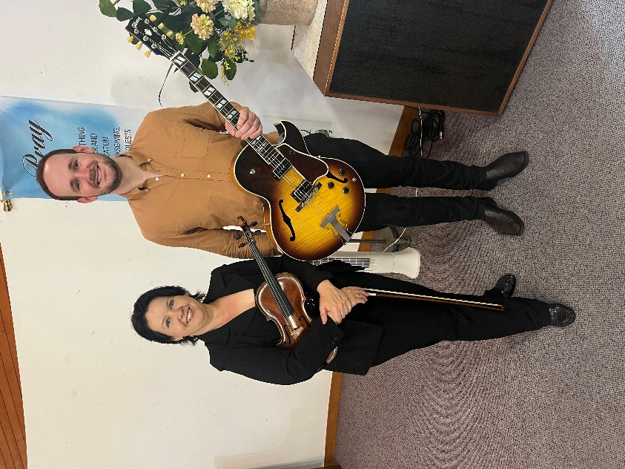

Matthew, pictured here with the amazing Irina Lgotkina, from last year’s appearance at Music Lovers.

