MUSIC LOVERS @ KENMORE UNITING CHURCH


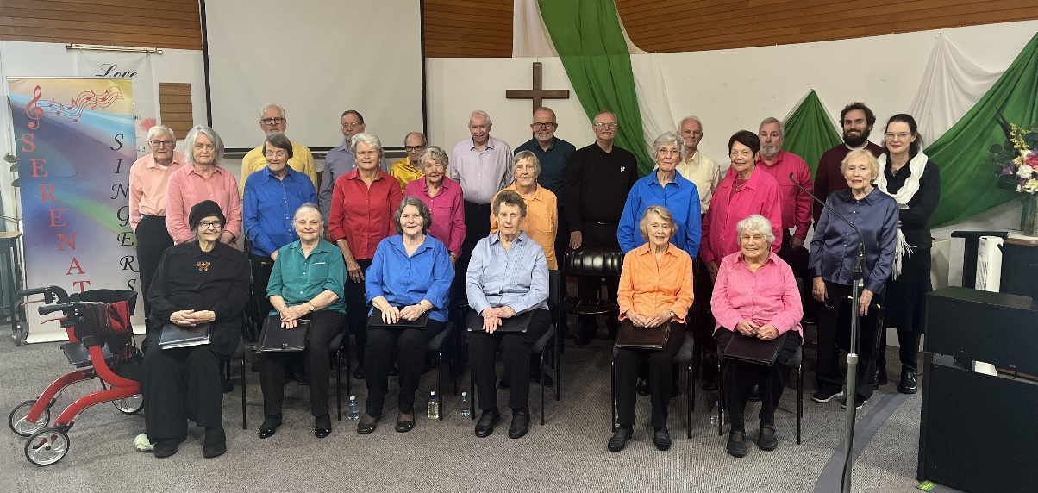

Music Lovers at Kenmore invite you to their August Concert to be held
on Thursday August 20th at 10 am.

On this occasion we will be welcoming back a community choir
‘The Serenata Singers’.

Entry $10 at the door, which
includes a light morning tea.
All welcome.

Kenmore Uniting Church, 982 Moggill Road.

