There is no charge for this program. donations to assist the costs of providing this program are gratefully received.



As one of Queensland’s largest aged care providers, BlueCare provides a range of services to support people in their homes, in our local community centres, our aged care residences and in our retirement villages.

Our mission and values commit us to actively listen to the needs of each person we assist and shape our services to meet their unique needs and circumstances.

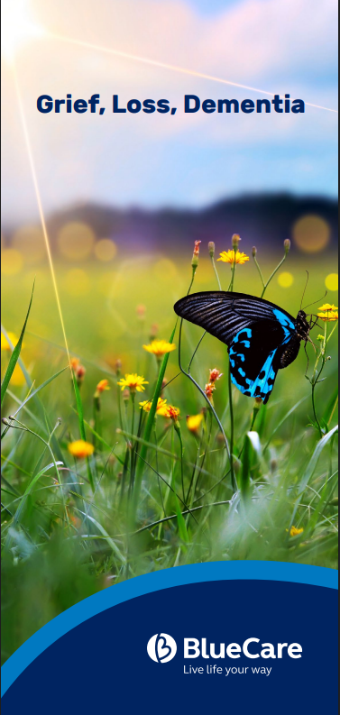

Grief, Loss and Dementia
Thursday 1st – 29th October 2026

10am-12.00pm

The Hall
Good Shepherd Anglican Church
615 Brookfield Road
Brookfield

Local Group Facilitators:

David Savage, Ann Hewson and Jane Mitchell

Places are limited and registration is essential.

Enquiries and Registration:

Mobile: 0458 075 377

GriefandLossProgram@bluecare.org.au

www.bluecare.org.au/services/grief-and-loss-programs

Forms can also be delivered to Kenmore Brookfield Anglican Church
1036 Moggill Rd. Kenmore Q4069

Grief, Loss and Dementia Program

The unique experience of caring for someone living with dementia, is that feelings of grief and loss may be experienced while the person is still with you. This grief, however, can change over time. This is referred to as ambiguous loss. Carers also experience something called disenfranchised grief, a grief experience that is not recognised, or under recognised by yourself or others.

Aim of the Blue Care Grief, Loss & Dementia Program:

- to provide information on dementia and grief & loss experienced when a loved one is living with Dementia
- to offer practical advice and promote self-care
- to provide emotional and social support
- to provide effective resilience strategies.

The Group

The Group meets regularly, with trained facilitators, to provide emotional, social and practical support for group members. This is a structured program of around two hours per week over five weeks. Participants benefit from sharing their experiences in the safety of a small group.

The Program is suitable for family members/primary carers/support person of a person living with dementia.

Confidentiality is respected at all times.

Grief, Loss and Dementia Program

Registration Form

Please complete the following information:

Name: _______________________________

Address: _____________________________

___________________________________

Phone: ______________________________

Email: _______________________________

Age: ________________________________

Name of your loved one living with dementia:

____________________________________

What is the relationship between you and your loved one living with dementia?

My __________________________________

Are you their primary carer? Yes / No

How did you hear about Blue Care’s Grief, Loss & Dementia Program? ___________________

