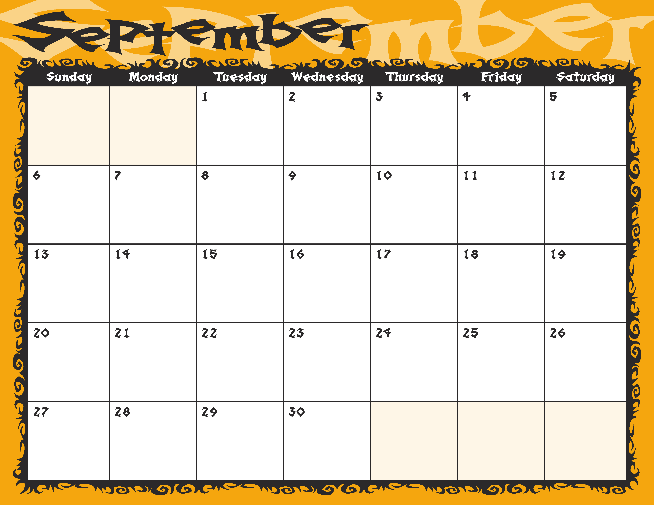
Granite

Family
Worship
Labor Day
Granite




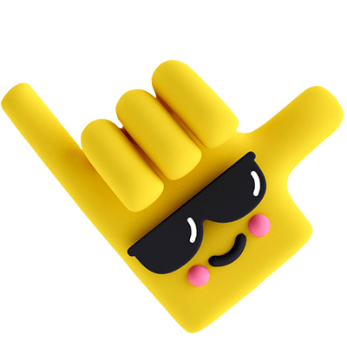


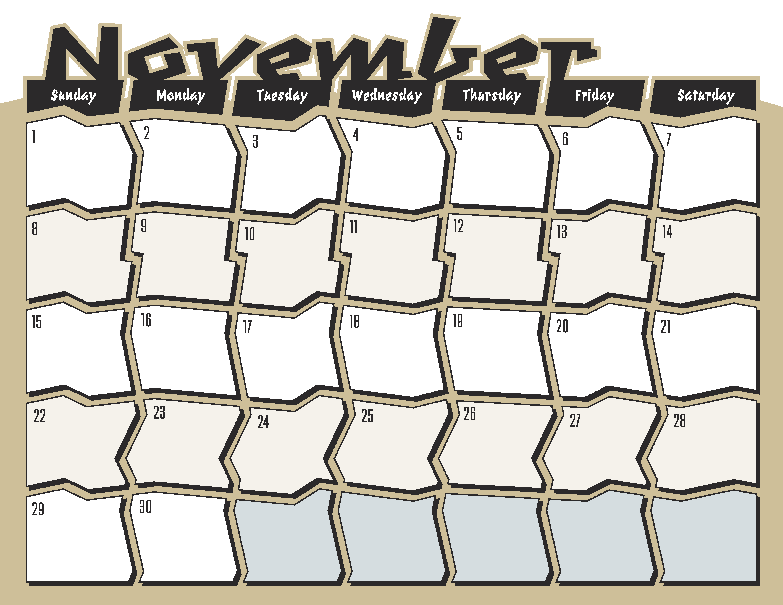
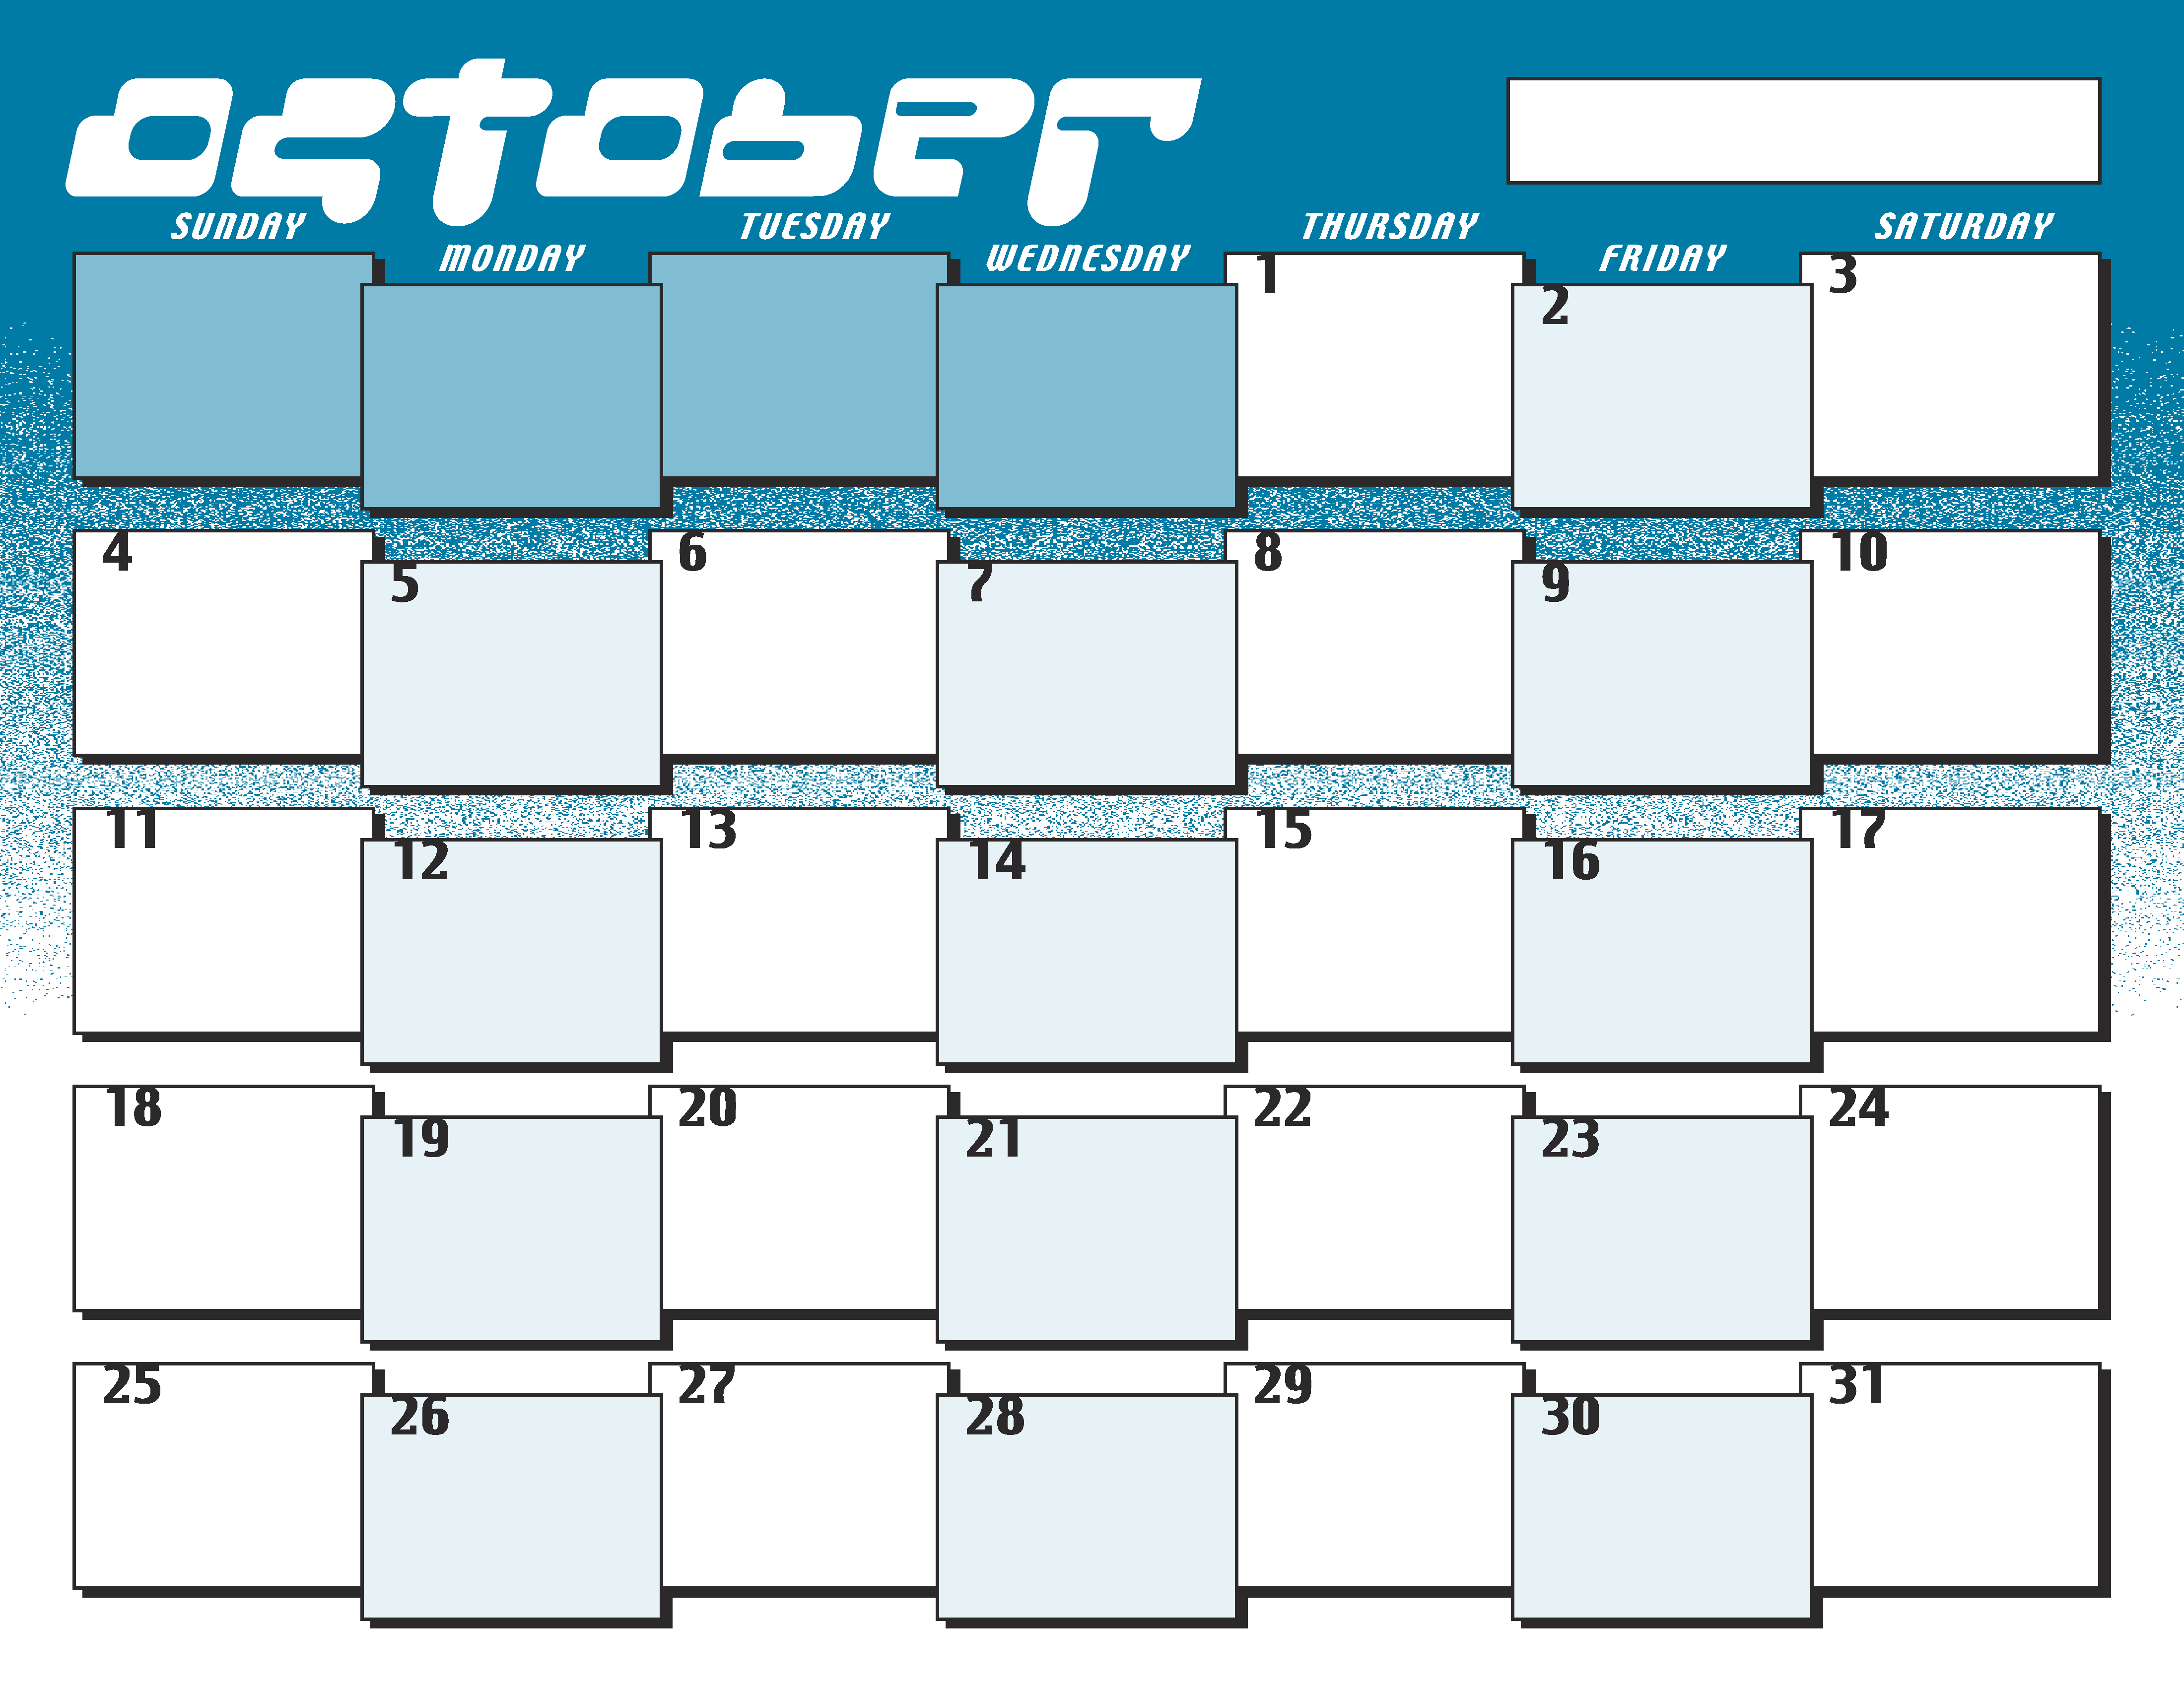

Granite
Veterans Day
Scandia Day
Happy Birthday
McKenna
Stavropoulos

Happy Birthday
Dmitry
Ruckert

Eleanor Elias
Happy Birthday
Estebon Ruckert
Happy Birthday

Thanksgiving
Halloween
No
Granite
Granite
Granite
Movie Night
Granite
Granite
Granite
Granite
Laser-Tag
Granite
Granite
Granite
Sunday
Rendezvous
Sunday
Rendezvous
Sunday
Rendezvous
Family
Worship
Family
Worship
Sunday
Rendezvous
Sunday
Service
Sunday
Rendezvous
Family
Worship
Sunday
Rendezvous
Sunday
Rendezvous
Sunday
Rendezvous
Fall Events
Middle School

