

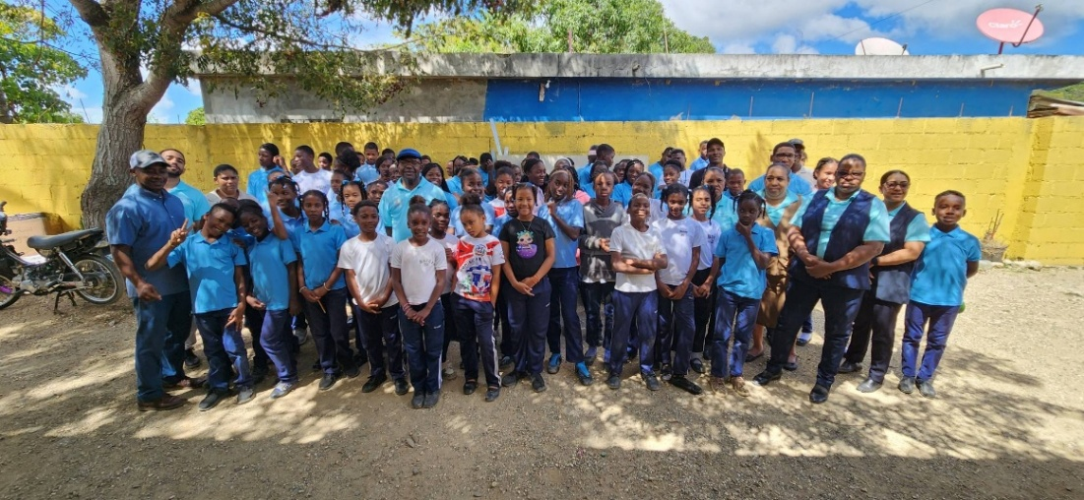
Founded in 1999 by Jean Luc Phanord, the School at Batey 35 is a private Christian institution in La Romana, Dominican Republic providing free Christian education to children in 4th thru 7th grade. These children are often known as “Sugar Cane Kids” because their parents earn a meager living working in the sugar cane fields and most are uneducated. It was the vision of Jean Luc to give these children the opportunity to break the cycle of poverty and create better lives for themselves. The students are taught academic subjects as well as personal care, hygiene, and life skills.
39 people, including 3 members of Spry Church, went on a mission trip to the Dominican Republic from February 28 to March 8, 2026. The trip is organized by Christ American Baptist Church, Spring Grove. CABC has set up a local Board of Directors who work hand in hand with the Board of Directors for the School at Batey 35, which is one of Spry Church’s mission partners.
We began preparing for our trip last August by planning our lesson themes, developing accompanying plays, crafts, games and music to share with the students. Our theme was sin, confession and forgiveness and forgiving others. On the last day, we handed out to the students and staff bags filled with supplies. We also sent food bags home at the end of the week.
In addition to the time spent at the school, we were able to provide food bags and clothing to the people living at Batey 35 as well as 4 other bateys. The students come to the Batey 35 School from as many as 6-8 surrounding bateys , so it is wonderful to assist those families as well. A truck begins making rounds early in the morning to stop at these bateys providing a way for the students to come to the school.
Would you like to learn more about this mission partner? Please contact Sharon Smith at (717) 515-1572.

April’s Mission Partner Spotlight
School at Batey 35, Dominican Republic
April 2026 Newsletter

SPRY CHURCH MISSIONS PARTNERS



For more information, please contact the church’s partner liaison listed below or use the QR code for the Missions page on Spry’s website.

Good News Global
Contact: David Smith
dpsmith005@gmail.com



The Tipton Family
Contact: Lisa Snyder
lisa.a.snyder@icloud.com

Illuminations Bible Translation
Contact: Pam Myers, SSC
pamela.myers@perspectives.org



New Life Childrens Home
Contact: Molly Loyer
mollyturner12@hotmail.com



Spry Church Food Pantry
Contact: Virginia Houser
vhouser1@comcast.net

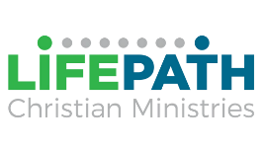

School at Batey 35, DR
Contact: Sharon Smith
skwsmith05@gmail.com
LifePath
Contact: Molly Loyer
mollyturner12@hotmail.com

Volunteer Updates
LifePath: There will be a meeting with anyone interested in volunteering at LifePath on Sunday, May 17th at 12:30 at SSC. A light lunch will be provided. Our primary focus will be (1) Ministry of Presence, (2) Activities/games, (3) Men’s Bible Study. We will gather ideas and plan activities/games and Bible Study for the next 3-4 monthly visits. Then people can sign up for each visit to LifePath to carry out the plans. Please, come and join us. Everyone is welcome! Bring ideas to share! Spry Church is committed to support people in need in our community. Be a part of it! If anyone is interested in joining us in these volunteer opportunities or have questions, contact Sharon Smith (717) 515-1572 or Becky Beck (717) 873-4878.
Good News Global: Volunteers willing to be a part of leading a Bible Study inside the prison, as well as people willing to write letters to inmates. Contact David Smith 717-968-1899.
Spry Church Food Pantry: Prayer Room volunteers needed on Thursday mornings. Contact Virginia Houser 717-891-1980.
Do you like to create or make things? Help is needed to create lobby displays in both campuses for our mission partners. Please contact Molly Loyer or Lisa Snyder for more information (contact info can be found above).

