**Hope Despite Weakness**

**Romans 15:1-7**

**Engage the Scripture:**

How does “ought” in verse 1 imply “fruit not fertilizer”?

What are the three ways the Spirit invites us to respond in verse 2?

How does Christ taking our reproach in verse 3 give us a foundation to accept others?

How do Bible characters encourage us in verse 4?

What does our unity in verse 5 build to in verse 6?

What does our acceptance in Christ motivate?

**Engage the Spirit:**

Describe one of your favorite Bible characters, how are you encouraged by him or her?

How does your weakness lead you to humility?

How does your acceptance lead you to hope?

What are the beliefs and actions which the Lord is calling you to update today?

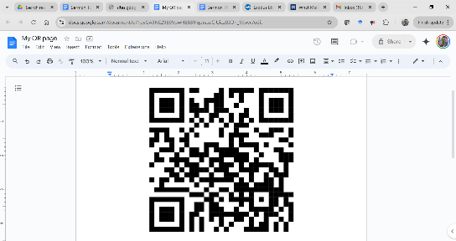

… more of Daniel’s Sabbatical learnings.