Sermon-Aligned Life Group Guide
  - Sunday, August 16, 2026
Ephesians 5:25-27
Connection Points
1. New Discipleship Groups Begin in September!
Take your next step in growing deeper in God’s Word alongside others. New groups begin in September, with opportunities for men, women, and co-ed groups. Register at beechhaven.org/wednesdays
- Money Made for More | Co-ed | Wednesdays, Sept. 2–Oct. 7
Discover how a biblical view of money can shape contentment, stewardship, security, generosity, and lasting legacy.
- Just War Theory | Men | Sept. 2, One Night Only
Think biblically about war, peace, government authority, military service, and the Christian’s response to conflict.
- See for Yourself | Men | Wednesdays, Sept. 9–Nov. 11
Learn practical tools to study the Bible for yourself with greater confidence, understanding, and joy.
- Abide | Women | Tuesdays, Sept. 1–Nov. 3
Study 1, 2, and 3 John and discover what it means to abide in Christ and walk faithfully in truth and love.
- Daniel | Women | Wednesdays, Sept. 2–Nov. 11
Walk through the book of Daniel and learn to trust the sovereign God who rules over every kingdom and circumstance.

Main Point
Christ did not give Himself for a feeling but for a body, so our love for Jesus must move us beyond sentiment into substantive love and belonging within His church.

Sermon Synopsis
Christ’s love for the church is demonstrated by His sacrificial death, His ongoing work of sanctifying her, and His promise to one day present her as a spotless and glorious bride. Because Jesus has given Himself completely for His church and is committed to transforming and cherishing her, Christians cannot settle for a sentimental attachment to Christianity while remaining relationally distant from His people. We are called to move from “vibe” to substance—from merely attending and appreciating the church to being known, loving others, and participating in the communal life through which Christ is shaping His Bride.

LEAN IN
- What is something you once really liked but eventually realized was mostly hype? What changed your mind?
Leader note: This question is designed to hook the group into thinking about and discussing the distinction between an ongoing, sacrificial love for something or someone, and a “flash in the pan” enthusiasm that comes quickly and often dissipates quickly. The transition is this: “What kind of love does Jesus have for the church, and how does this impact the way we love the church?”

LOOK DOWN

Read Ephesians 5:25-27
- Paul says, “Christ loved the church.” What does the rest of this passage tell us about what Christ’s love actually looks like? How does His love move beyond sentiment into action?
Cf. John 15:13; Romans 5:6–8; and 1 John 3:16–18

- V. 25 says Christ “gave himself” for the church. Why is self-giving essential to biblical love?
Leader Note: Self-giving or self-sacrifice is the purest form of love and actually transforms the one who gives to look more like Jesus (Cf. Ephesians 5:1-2). Self-giving impacts both the one who receives and the one who gives.
- V. 26 says Christ gave Himself for the church “to make her holy.” Why is it significant that Jesus did not merely forgive the church but is also committed to transforming her?
Leader Note: At the moment we trust Jesus, we are saved for eternity (Justification). And from that moment, God begins a life-long process of refining our character (Sanctification). There is always opportunity for us to grow. Cf. Philippians 1:6.
- Pastor Rob emphasized that Scripture is one of the primary means through which Christ “washes” His church (v.26) and present her in splendor, holy, and blameless, but also stressed that sanctification is communal: God often uses other believers, suffering, and our own repentance as means of transformation.
Leader Note: Sketch Powlison’s diagram (below) on the board and ask your group how they have seen God create greater holiness in them through each of these means.

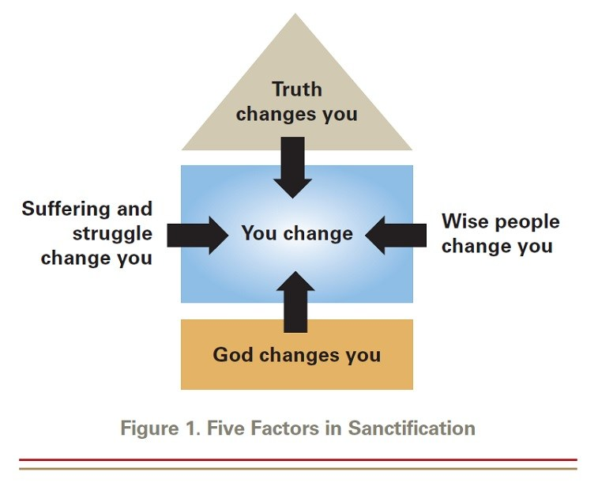

LOOK IN
- What is the difference between loving “Christianity” and loving Christ’s actual people?
- If Christ is actively sanctifying His church, how should that affect the way we respond when we encounter the church’s imperfections? How do we want people to respond to our own imperfections?

Leader Note: Patience and long-suffering apply in these kinds of scenarios but not fear of man or avoidance. We are peacemakers, not peacekeepers. See Prov. 15:31-32.

- How do you decide which areas of your life you allow other believers to know, challenge, encourage, or need you in—and which areas you tend to protect behind a “safe” boundary?

LOOK OUT
- Society pushes people to maintain an external image of flawlessness, youth, and perfection, often leading to anxiety and exhaustion. How does the biblical reality of a church made radiant by Christ's work (rather than human performance) offer a radical message of rest and true freedom to an exhausted culture?

- Secular culture often frames love primarily as emotional compatibility, mutual self-fulfillment, or a contract that lasts as long as it is convenient. How does Christ’s model of sacrificial, covenantal, and purifying love undo the modern definition of romance and commitment?

- Pastor Rob said that “warm feelings toward Christianity” can exist without behavior, belief, or belonging. Why is that distinction important when talking with someone who says, “I like Jesus, but I don't really need the church”?

GOSPEL CONVERSATION STARTERS
- When someone expresses skepticism about the church due to the flaws of church people they know, validate their pain and use this passage to pivot to Christ. You can say: "You're completely right that Christians and churches are full of flaws and wrinkles. But the beauty of the gospel is that the church isn't a museum for flawless people; it’s a hospital for the broken. Jesus didn't come for people who have it all together; He gave His life to wash and rescue a messy bride, making us holy by His grace alone."

CLOSING PRAYER
We stand in awe of the depth of Your love—a love that did not wait for us to clean up our own lives, but instead sent Christ to lay down His very life for us. Thank You for the grace that washes over us through Your Word, smoothing away our brokenness and freeing us from the weight of our failures.
May you, the God of peace, sanctify us completely. And may our whole spirit, soul, and body be kept sound and blameless until the coming of our Lord Jesus Christ. You are faithful; You will do it.

