Sermon-Aligned Life Group Guide
  - Sunday, July 26, 2026
Nehemiah 10
Connection Points
- Wednesday Nights Return – August 5
- Wednesday Nights are back beginning August 5, and we'd love for you to join us as we gather in the middle of the week for biblical teaching and community.
- This August, all adults are invited to one churchwide discipleship group, Origin Story, led by Pastor Rob. Together, we'll explore the opening chapters of Genesis and discover how God's design for creation shapes the way we understand Him, ourselves, and the world today. This group will meet in the Commons at 6:15PM.
  - Our Men's, Women's, and Co-Ed Discipleship Groups will begin in September. You can learn more about these opportunities at beechhaven.org/wednesdays
- Wednesday Night Schedule
  - 5:15 PM – Wednesday Night Dinner. You can make your reservation on the Wednesdays page
  - 6:15 PM – Origin Story (Adults), HYFI (Beech Kids), FUSED (Beech Students), Choir Rehearsal

Main Point
A God-centered life is not sustained by stronger commitment but by trusting and following the One who perfectly kept the covenant for us.
Sermon Synopsis
God is not merely one priority among many but the rightful center of every area of life, so our relationships, resources, and decisions are meant to be ordered under His lordship rather than competing alongside other commitments. Nehemiah 10 illustrates this through Israel's covenant to honor God in both their closest relationships and their stewardship of time, money, worship, and generosity, revealing that true repentance produces concrete obedience rather than vague good intentions. Yet Israel's eventual failure to keep these vows points beyond human resolve to Jesus Christ, who perfectly kept the covenant on our behalf and continually draws His people back to a God-centered life through His grace.

LEAN IN
- When you make a significant commitment in life (like a gym membership, a job contract, or a marriage), what helps you stay faithful to it when the initial excitement wears off?

LOOK DOWN

Read Nehemiah 10
Leader Note: Feel free to skim through vv. 1-27. You can note these are the names of prominent people identified as the political leader (the governor Nehemiah), the priests (vv. 2–8), the Levites (vv. 9–13), and the heads of the people (v. 14–27).

- As you read vv. 28-39, ask the group to identify the categories of commitment the people pledged themselves to keep. Is there a theme that connects all of these?

Leader Note: There can be different ways to categorize but note: relational purity (highlighted through marriage); honoring the sabbath by restricting commerce; honoring the year of Jubilee by letting the land remain fallow and canceling debt; giving to support the work of ministry.

- Read Deuteronomy 5:29, which explains that God gave the commandments so that "it might go well" with His people. With that in mind, what specific troubles or consequences were the people in Nehemiah trying to avoid by making these strict oaths?

Leader Note: Cf. 2 Cor. 6:14-18 for the frustration of being unequally yoked relationally; Cf. Gen. 2:2 on the importance of rest; Cf. Deut. 15:1-4 about alleviating poverty; and Philp. 4:15-17 on ensuring a viable worship and ministry of God.

- What value do you think sharing a public commitment versus having unstated intentions had for the people in keeping their vows? What does public commitment communicate about accountability before God? What does public commitment do internally for the person making the commitment? Cf. Matthew 10:32-33; Romans 10:9-10.

- The chapter ends with the declaration: "We will not neglect the house of our God." Why do you think this statement serves as the climax of the covenant?
Leader Note: The people saw the value of protecting the home (v. 30), putting boundaries around the pursuit of business or work (v. 31), and that a religious and spiritual community was so vital that is was worth supporting financially (v. 32ff). Collectively, this communicates that every act is an act of worship.

LOOK IN
- The people made concrete commitments instead of vague promises. How does a person move from fuzzy notions of “I want or need to do better” to making something concrete? Can you pray about something concrete as an action step for yourself?

- Pastor Rob shared a couple of pie charts (below). How much is God at the core of your life and is that core growing?

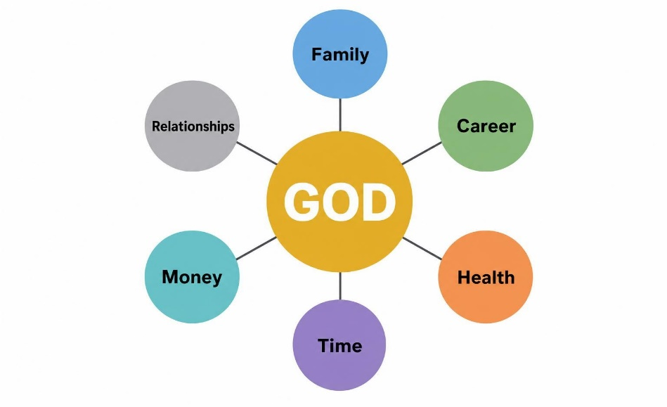
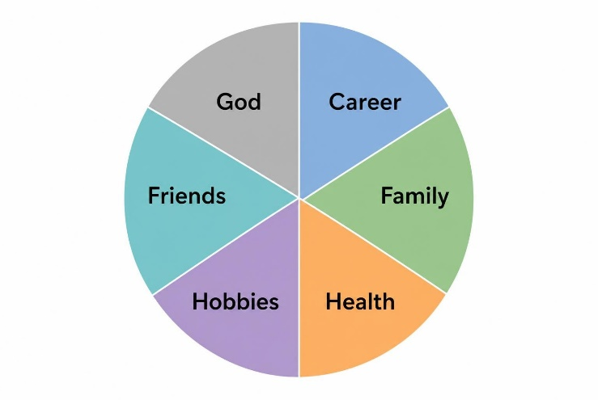

- For reflection (and action??): The people recognized specific areas where they had previously compromised (like Sabbath-breaking and intermarriage) and built guardrails to protect their faithfulness. What is one area of compromise in your life where you need to establish healthy boundaries or invite trusted friends to hold you accountable?

LOOK OUT
- Our culture often views commitment as something to avoid if it limits personal freedom. How does Nehemiah 10 present commitment differently? Does the gospel reinforce or redirect this understanding?
Leader Note: The gospel teaches that there no one is righteous (Rom. 3:10) and that attempting in our own strength to keep the law will always end up in failure. While the law is powerless to make righteous, God can and does (Philp. 3:9). Only faith in Christ sets us free (Galatians 2:16).

- Many people assume Christianity is mainly about private belief. How does this chapter show that genuine faith shapes public life, finances, relationships, and priorities?

GOSPEL CONVERSATION STARTERS
- "Why can't we keep our promises?" Many people have experienced broken promises—both giving them and receiving them. Nehemiah 10 opens the door to discuss why our deepest problem isn't simply a lack of effort but a sinful heart that needs God's transforming grace.

- "What makes someone acceptable to God?" The people make many commitments, yet the rest of biblical history shows they still fail. This provides an opportunity to explain that acceptance with God ultimately comes not through our faithfulness but through Christ's perfect obedience on our behalf (Romans 5:19).

- The Broken Promises Connection: Many people have been deeply hurt by broken promises—whether from a spouse, a parent, a politician, or an institution. You can share honestly about Nehemiah 10: despite the people’s best intentions to sign a contract with God, human history shows they failed to keep it. Use this to pivot to the beauty of the New Covenant: the Gospel is the good news that where we fail to keep our promises to God, Jesus perfectly fulfilled the covenant for us.

CLOSING PRAYER
Father, thank You for being perfectly faithful even when we are not. Thank You that You never abandon Your covenant or fail to keep Your promises. Give us hearts that gladly obey You—not out of fear or obligation, but because we have experienced Your grace through Jesus Christ. Shape our homes, our priorities, our generosity, and our worship so that every part of our lives reflects our devotion to You. Help us encourage one another toward faithfulness and become people whose lives display the hope of the gospel to those around us. Amen.

