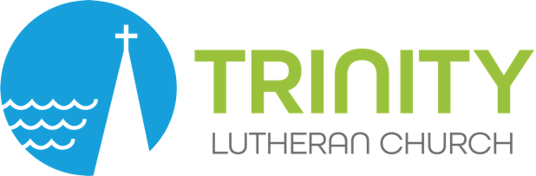

GROUPS AND TEAMS COVENANT FORM

Group Name:

Group Members:

Group Leader:

Group Coach/Staff Liaison:

Group Purpose:

Desired results and plans:
(Specific, attainable/assignable, realistic/rewarding, plans that Intersect with the present and are informed by the past. Task Teams may want to include measurable/tangible timetables, etc. Attach separate sheet if necessary).

Group Values:
Reflecting our five core values of – Exceptional Worship, Radical Hospitality, Lifelong Faith Formation, Authentic Community and Compassionate Action

Starting/ending dates:

Dates/times and location of meetings:

Schedule for leading devotions, personal check in and prayer:

A couple best practices and reminders for small groups
- Begin and end on time. Respect each other’s time and be accountable to each other. Try your best to show up and make sure everyone knows when and where. If you can’t, call or text your group leader.
- Be a listener first and try to make sure everyone can have a little time to share.
- What’s said in small group stays in small group. Keep stories confidential. Vulnerability leads to deeper understanding and mutuality.
- Speak from your own experience. This is a place to practice grace and non-judgement. Work to avoid advice, unless someone asks for it.
- Lift each other up and notice the gifts that everyone brings. Grow together.
- Remember Trinity’s mission/vision statement: Because God first loved us, we live as Jesus in the world, loving God and loving neighbor!

