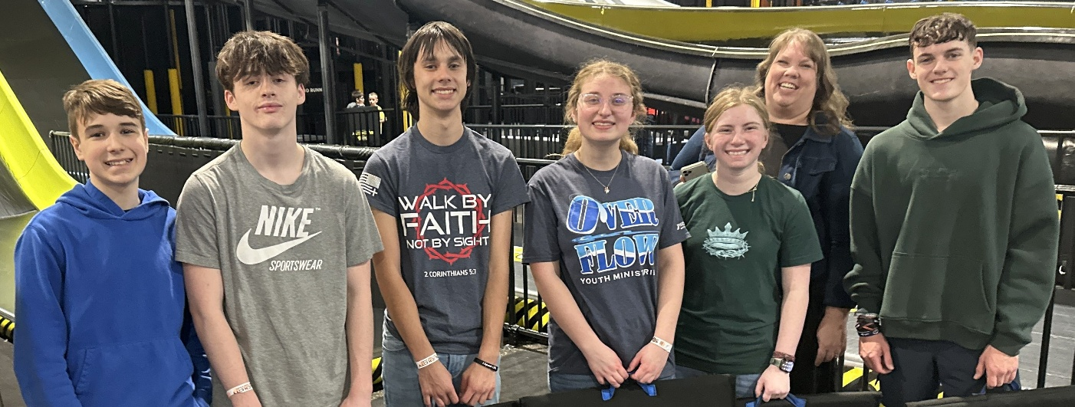

Overflow High School
Spring/Summer 2026

High School Youth Group Gatherings
Sundays 6 to 8 PM (Doors Open at 5:30 PM)
(4/12, 4/19, 5/3, 5/17, 5/31)

Night of Worship Sunday, April 26th 6-8 PM

Painting with Mom at Art & Clay on Main
Saturday, May 2nd 9 AM to 1:30 PM

Super Summer Final Registration Due Monday, May 4th

Senior Sunday May 17th

New Freshmen Move Up Day Sunday May 31st

Worship with Upstate Youth Wednesday, June 3rd

Cedar Point June 18th

Crossings Camp Payments Due Sunday, June 21st $377

Super Summer June 23th – 27th

Crossings Camp July 9th – 13th

Mega Sports Camp July 20th – 23rd
