Deacon Care Teams
Small Group Discussion Questions
Join our congregation for worship in-person or online at 10:30 am each Sunday via our Grantham Church YouTube Channel. If you ever miss a message, the sermons are always posted to the recent sermons page at our website and at the Grantham Church Podcast the following day, along with the small group discussion questions under Worship Resources. Thank you for staying connected with us!
Sunday, November 14th 2021
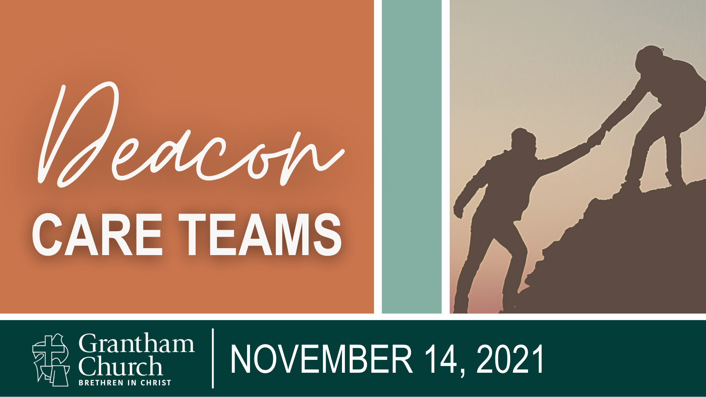

Sermon Title: Deacon Care Teams
Scripture Reading: Matthew 27:55-56; Acts 6:1-7; Galatians 5:13-14, 6:2
Sermon Focus: The first followers of Christ had no manual for how to “do” the work of the Church. They had the Old Testament, the example and teachings of Jesus, and the Spirit to guide them. Therefore, when there was a need they were fairly pragmatic in responding to it. In this message, Pastor David shares how Grantham Church has responded to congregational care needs in the past, and then introduces us to our new Deacon Care Teams—a model that allows us all to participate in meeting needs.

Thank you for going deeper in conversation with your small group in person, by phone, or video call. Use the following questions to help guide your small group discussion:
- In

