The Gospel of the Kingdom (5 of 7)
Small Group Discussion Questions
Join our congregation for worship in-person or online at 10:30 am each Sunday via our Grantham Church YouTube Channel. If you ever miss a message, the sermons are always posted to the recent sermons page at our website and at the Grantham Church Podcast the following day, along with the small group discussion questions under Worship Resources. Thank you for staying connected with us!
Sunday, October 10th 2021
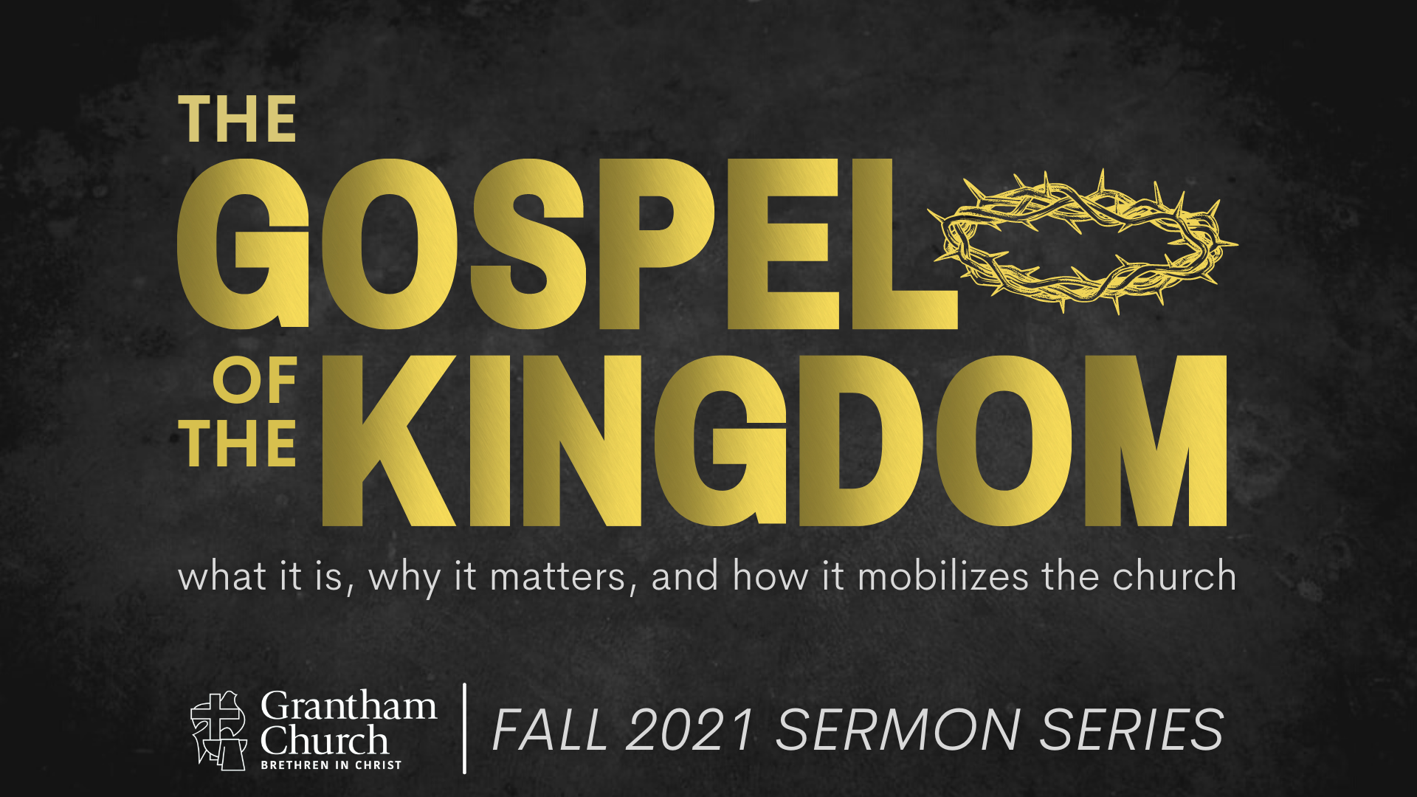

Sermon Series Focus: The world seems to be falling apart and the darkness is visible all around us. It raises questions like, “What is God doing about it? Where are things going? How should we respond to it all?” Jesus said, “The kingdom of God has come near. Repent and believe the good news!” But what is this gospel of the kingdom? And how do we partner with God as believers in his good news? Join us for our fall sermon series as we explore the redemptive story of God and what it looks like when the gospel intersects with our lives and impacts the world through the local church.

Sermon Title: Gospel Living
Scripture Reading: Ephesians 1:3-23; 2:8-10; 3:14-21; 4:1
Sermon Focus: The gospel is not just good advice about what we can do or how we can live. It’s good news about what God has done for us in Christ and how we get to live in response to that. The gospel story affects every part of our lives. In the fifth message of our series, Pastor Melissa invites us to consider the core components of living in light of the gospel and how it leads to a life of freedom and joy.
Thank you for going deeper in conversation with your small group in person, by phone, or video call. Use the following questions to help guide your small group discussion:
- What are some of the lenses through which people look at life? Another way to consider this: what are the narratives/stories that people live by?
- Read Ephesians 1:3-14 where Paul describes God’s chosen and adopted people. What are some of the blessings that God’s people have? How does one receive these blessings?
- Take a look at the “orphan mindset vs. adoption mindset” chart. What stands out to you? Are there ways you can recognize in your life that you might be living with an orphan mindset? What might it look like to live more out of the adoption side in that area of your life?
Orphan Mindset | Adoption Mindset
- Ungrateful, bitter, cynical  - Tears down others  - Prideful, defensive  - Anxious, insecure  - Performance-oriented  - Lonely | - Assurance that you are loved  - Doesn’t feel need to prove oneself  - Able to receive criticism  - Can confess failures  - Leads to life of joy and freedom  - Welcomes others

- Read Paul’s two prayers for the Ephesians in 1:15-23 and 3:14-21. What do you notice about the power Paul is longing for God’s people to grasp? What does this power enable us to do?
Further study: You may not have time in your group, but this week, consider taking time to skim chapters 4-6 of Ephesians. Is there something that stands out to you for how Paul describes what it looks like to live in light of the gospel in any of these areas?
- What is an area of your life where you might be operating out of your own strength? It might be an internal struggle, a challenging relationship at home or work or with a neighbor or friend, something you are trying to do in/for the community, etc. Pray together that God would fill you with his Spirit and enable you to live according to his power and purpose in that area.

