Unexpected (4 of 4)
Small Group Discussion Questions

SUNDAY WORSHIP DURING THE COVID-19 PANDEMIC
The global pandemic COVID-19 has forced us to adjust and adapt how we do church and stay connected to one another as a congregation. We’re not closed as a church, we’re just doing church differently! So, please stay connected to the body at Grantham Church. Join our congregation for worship online at 10:30 am each Sunday morning. Follow the worship liturgy and watch our Vimeo videos at granthamchurch.org/liturgy.

As usual, the sermons will be posted to the recent sermons page on our website and at the Grantham Church Podcast the following day, along with the small group discussion questions under Worship Resources. Thank you for engaging with us online!

Sunday, December 20th 2020
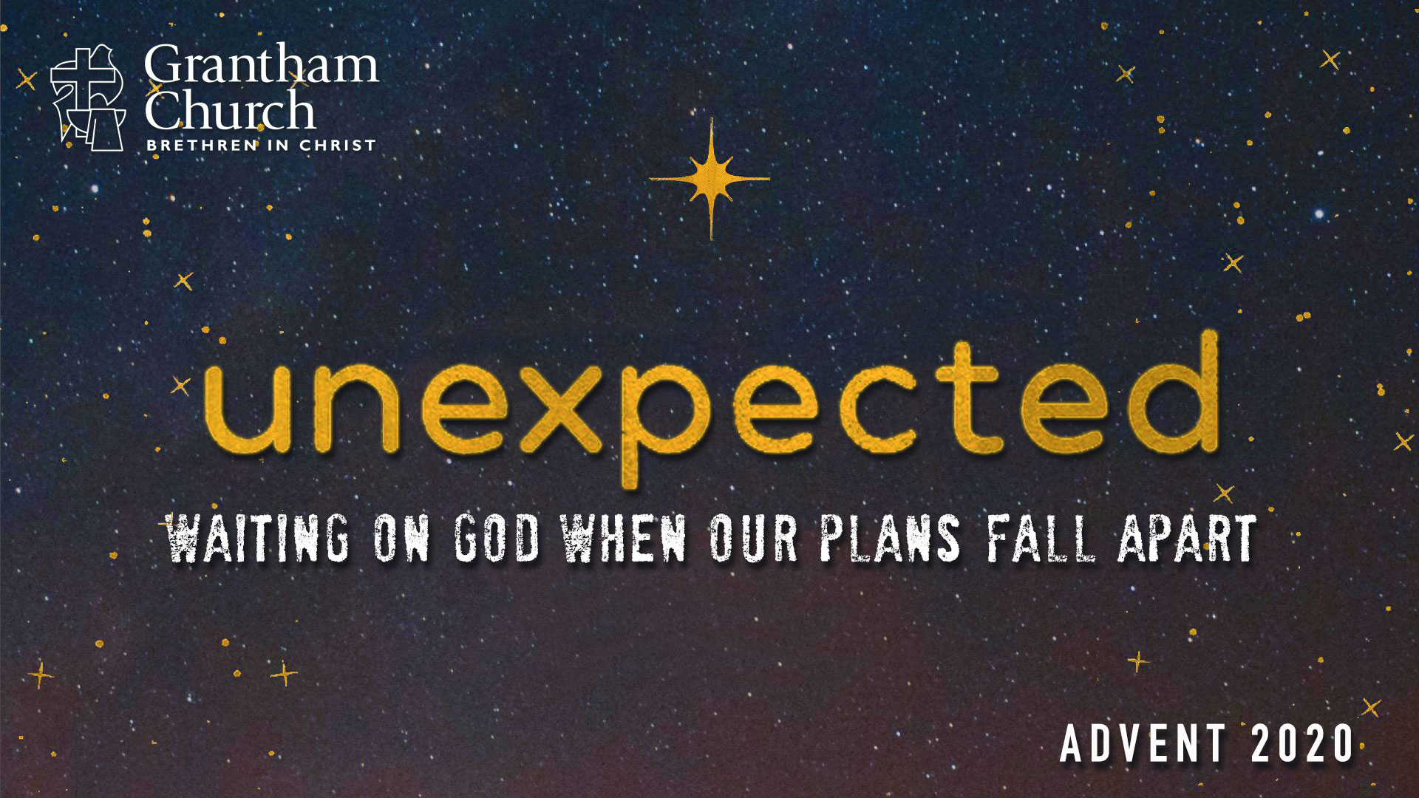

Sermon Title: Nothing Is Impossible with God
Scripture Reading: Matthew 1:19-25; Mark 10:27; Luke 1:26-38; Hebrews 10:36-39
Sermon Focus: They were betrothed, but not married. And then Mary was visited by an angel. Joseph had a dream. They were told they would be the parents to the Son of God, the Messiah. This news and the events that followed were unexpected. As we look at their story, we see that it was a time filled with great joy right alongside fear, struggle, and uncertainty. Listen as Pastor David invites us to imagine how they felt and says that we too can believe in God’s power to do the impossible.
Thank you for going deeper in conversation with your small group in person, by phone, or video call! Use the following questions to guide your small group discussion:

- Read Luke 1:26-38 together. This may be an old familiar story to you. However, what do you still find interesting, surprising, and encouraging about it today?

- Pastor David gave a few reasons why he believes in the virgin birth. He said:
“(1) I believe in Genesis 1:1 (that God created the universe), and so a virgin birth is nothing for God; (2) I recognize, as Ancient Near Eastern people would, that claiming a virgin birth is scandalous, yet Matthew and Luke still tell this story, which I believe adds to its credibility (much like the early disciples claiming that Jesus was raised from the dead); also (3) Scientists will tell you that a virgin birth is theoretically possible (as it’s happened with fish and reptiles), although highly unlikely with humans. And so, I choose to believe that the Holy Spirit made it possible for Mary to conceive without Joseph’s help by providing the necessary proteins and chromosomes needed from male sperm to create a male child.”

What do you think about these reasons? Are there other things you would add? What might some theological reasons be for the virgin birth? Discuss together.
- What did you think of the movie clip from The Nativity Story? Imagine what Mary’s news would have sounded like to Joseph and her parents, and what the villagers in Nazareth would have thought. Imagine how Mary felt. Are there ways that you can relate to what Mary might have felt, and what others felt too?

- Think about how both Mary and Joseph respond to all of the unexpected things that happened. What do you find admirable and inspiring about them?

- Think about this story: the appearance of angels, a pregnant unmarried teen, a baby born in a manger, pagan astrologers, lowly shepherds, a wicked king, the slaughter of innocent little boys, and an escape to Egypt. What does it say about God that he would send his Son into the world in this way? Also, what do we lose when we approach and celebrate Christmas without all of these elements?

- Reflect together on these takeaways:
1. God comes to those who are meek, humble, and righteous.
2. We are limited in our power, but God can do all things by his Spirit.
3. We must not live as defeated victims but press on as righteous people of faith.

How is God speaking to you about each of these as you look back on this year?

