Passing on the Peace
Small Group Discussion Questions
Join our congregation for worship in-person or online at 10:30 am each Sunday via our Grantham Church YouTube Channel. If you ever miss a message, the sermons are always posted to the recent sermons page at our website and at the Grantham Church Podcast the following day, along with the small group discussion questions under Worship Resources. Thank you for staying connected with us!
Sunday, May 1st, 2022
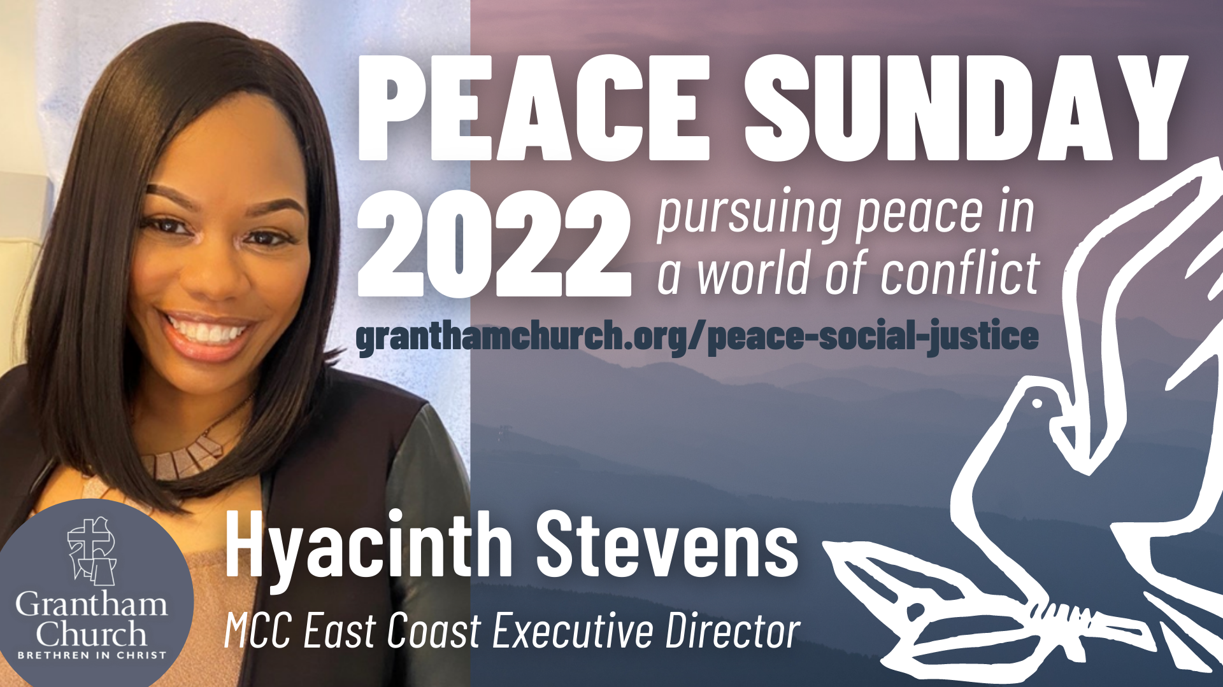

Peace Sunday Guest Speaker: Hyacinth Stevens, MCC East Coast Executive Director
Sermon Title: Passing on the Peace
Scripture Reading: John 14:27

Sermon Focus: The cross, the resurrection, and peace. The risen Jesus told his disciples, “Peace I leave with you; my peace I give you. I do not give to you as the world gives. Do not let your hearts be troubled and do not be afraid.” Let's unwrap some of the mysteries of Jesus' transferable parting gift: Peace. In Passing on the Peace, Hyacinth Stevens invites us to be peacemakers in the way of Christ.

Thank you for going deeper in conversation with your small group in person or by video call. Use the following questions to help guide your small group discussion:
- What

