Still Canoeing the Mountains
Small Group Discussion Questions
Join our congregation for worship in-person or online at 10:30 am each Sunday via our Grantham Church YouTube Channel. If you ever miss a message, the sermons are always posted to the recent sermons page at our website and at the Grantham Church Podcast the following day, along with the small group discussion questions under Worship Resources. Thank you for staying connected with us!
Sunday, June 27th 2021
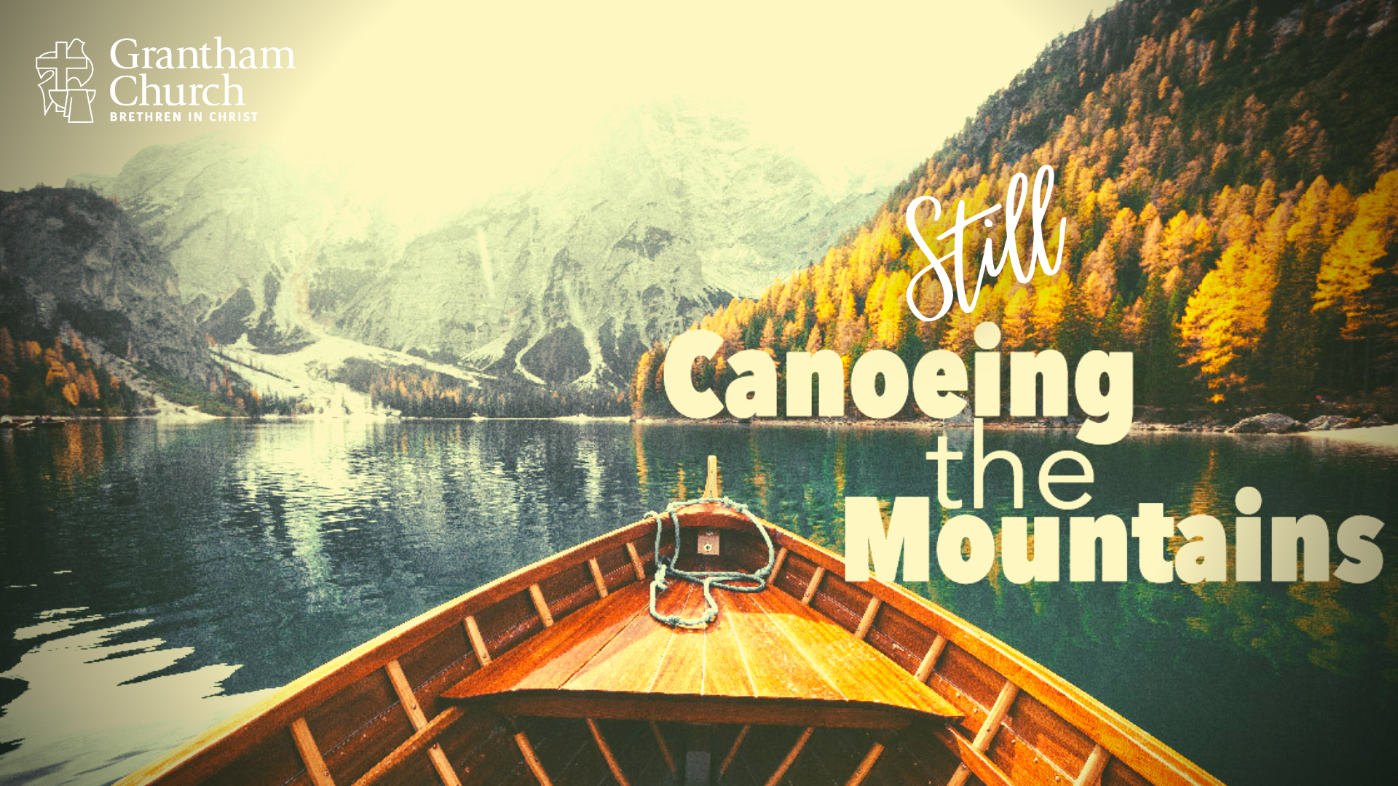

Sermon Title: Still Canoeing the Mountains
Scripture Reading: Proverbs 29:18; Luke 12:54-56; Ephesians 3:20-21
Sermon Focus: It was predicted that the pandemic would accelerate our post-Christian culture and push the church further into the margins of American society. We are now seeing signs that is happening. Needless to say, we are still “canoeing the mountains” as we learn to navigate these changes and challenges as a church. Listen as Pastor David shares the mission and vision work leadership has done this past year and how our congregation is being invited into the strategic planning process.

Thank you for going deeper in conversation with your small group in person, by phone, or video call. Use the following questions to help guide your small group discussion:
- Pastor David

