A HISTORY OF ST. PATRICK CHURCH – MILFORD, NH ESTABLISHED AUGUST 1895

The present St. Patrick Church on 34 Amherst Street is the gathering place for Catholics and guests in the towns of Amherst, Brookline, Milford, Mont Vernon.
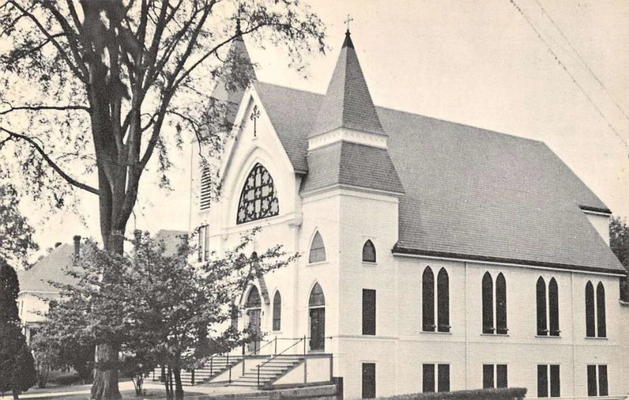
The creation of the Souhegan Mill was one of the principal reasons for a Catholic settlement in Milford. Its history and heritage date back to 1848 when the first Catholic family, that of Patrick O'Connor, settled in the Souhegan Mill Pond area. The first known official visit of a priest was in November 1853 was by Rev. William McDonald to administer the Sacrament of the Sick to Mrs. James Finerty. In February1855, the first Mass was celebrated in the home of Patrick O’Connor by a missionary priest, Fr. Donnelly, who later became the Bishop in Clogher, Ireland. 30 people were in attendance. In 1856, regular celebration of the Mass began by Rev. John O’Donnell who lived in Nashua.
The infant congregation set out to build the 1st St. Patrick Church on land on the lower end of Souhegan Street which was financed by the O’Connor and Finerty families. In 1864, the small church was enlarged to twice its capacity and dedicated in 1867. In 1868, Rev. Patrick Houlehan took charge of the St. Patrick mission church. In 1870, the Most Reverend David William Bacon (First Bishop of Portland Maine) administered the Sacrament of Confirmation for the 1st time. In 1876, Rev. E.E. Buckle became Pastor the mission church and services were held twice a month until 1890 serving the towns of Milford and Wilton.
On October 8,1890, the site of the present property on 34 Amherst St. was acquired by Bishop Denis Mary Bradley (1st Bishop of Manchester). As the population grew, it became necessary to build a larger church. Rev. Buckle first administered the construction of the new church followed by Rev. P. L. McEvoy (1891); Rev. George Marshall (1894). The present church (basement only) was begun in 1890, at a cost of $20,000. For many years (because of lack of funds) the basement of the church served as the place of worship. In August 1895, Bishop Denis Bradley established St. Patrick Church as a parish.
Rev. Henry Lennon (1915) was to lead the completion of the upstairs of the new church building. The 1st thing that was done was to purchase the old Fuller residence adjoining the church property for a rectory. In 1916, the upstairs of the church was finished in oak with beautiful pews, new stained-glass windows and a pipe organ. The cost of finishing the church was $30,000.00. The first Mass was held on Easter Sunday and the church was dedicated on June 15, 1916. A campaign was initiated to pay off the church debt of $12,500. In 1919, ninety devoted families and their pastor accomplished that goal and the mortgage was burned by members of the parish community at the Town Hall. The basement was renovated to serve as a Sunday school classroom.
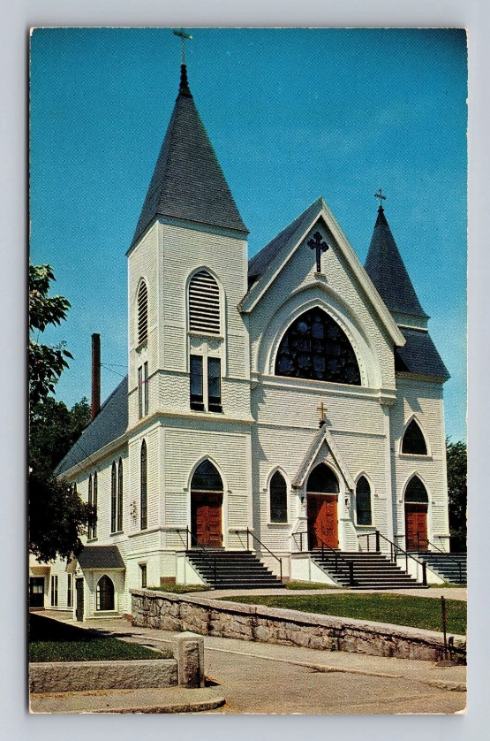
Following the Second Vatican Council and the liturgical changes that were required, the interior of the Church was redecorated in 1966.
In 1976, there was a need to create a Religious Education Facility. Through the donations of many generous parishioners, the Religious Education Center was built and completed in 1977. The building has proven to be of invaluable use for many gatherings, committee meetings, and religious education classes.
In 1987, a three-year fund drive was initiated to repair and renovate the church and Religious Education Center. Later, an elevator was also installed to accommodate our senior and disabled parishioners. In 2008, air conditioning was installed in the church as a result of fundraising. Air-conditioning in the parish hall and sacristy was installed in the winter of 2017.
In addition, we offer a brief history of the former Infant Jesus of Prague Mission on Main Street, Route 130, Brookline, NH: Infant Jesus Chapel, as a mission of St. Patrick, was built largely through the efforts and generosity of Dr. Charles A. Brusch of Cambridge, Massachusetts. Dr. Brusch purchased the property on which the chapel rests in 1939. Because construction took place during the war years, materials were difficult to obtain, resulting in a church built of materials and furnishings from various and unique sources. The task was finished in a year and a half and deeded to the Diocese of Manchester, debt free. The first Mass was celebrated on June 20, 1943, with dedication of the chapel two weeks later on July 5. The Rt. Rev. Jeremiah S. Buckley, Vicar General of the Diocese of Manchester, officiated. Across the street from the chapel and set in an outdoor shrine is an Infant of Prague statue made of marble which was carved by a Roman Sculptor. The statue was also donated by Dr. Brusch and was dedicated on October 13, 1949. In 1983, plans were begun to build a meeting hall at the rear of the chapel and it was completed the following year. It was dedicated to Dr. Brusch during a ceremony on March 4, 1984, by the Most Reverend Odore J. Gendron, D.D., Bishop of Manchester. The chapel was closed on September 9, 2007. On April 4, 2008, the chapel was sold to the Town of Brookline, NH.
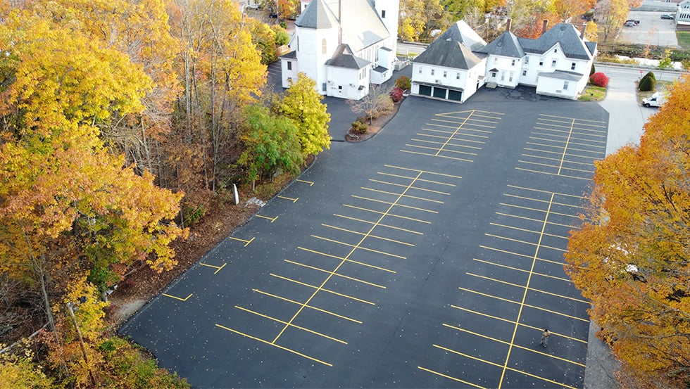

PASTORS OF ST. PATRICK CHURCH
(1) Rev. George Marshall 1895-1915
(2) Rev. Henry Lennon 1915-1937
(3) Rev. Edmond Quirk 1938-1946
(4) Rev. T. Francis Hogan 1946-1957
(5) Rev. Walter Blackenship 1957-1962
(6) Rev. William Dolan 1962-1969
(7) Rev. Laurence Gardner 1969-1971
(8) Rev. James Fennessey 1971-1975
(9) Rev. William Shanahan 1975-1982
(10) Rev. John Barrett 1982-1986
(11) Rev. Richard Thompson 1986-1994
(12) Rev. Andrew Cryans 1994-2006
(13) Rev. John Keegan, SJ 2006-2016
(14) Rev. Dennis Audet 2016-present

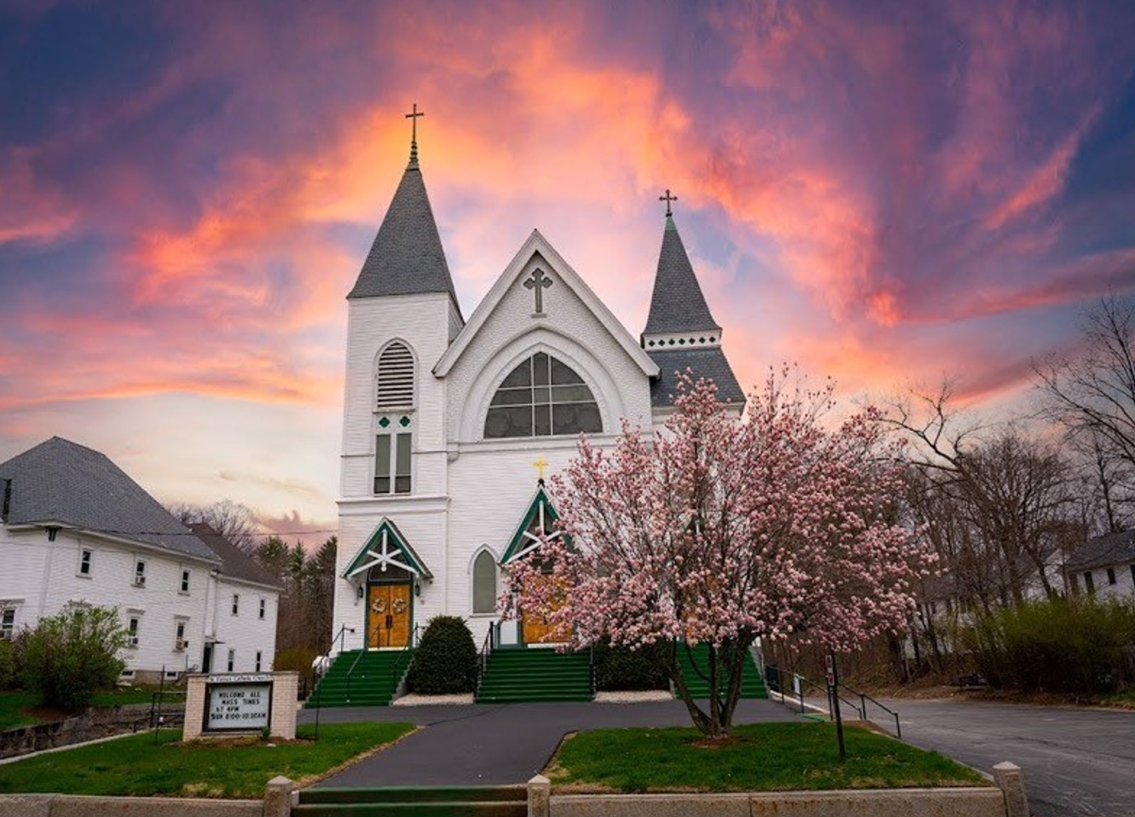

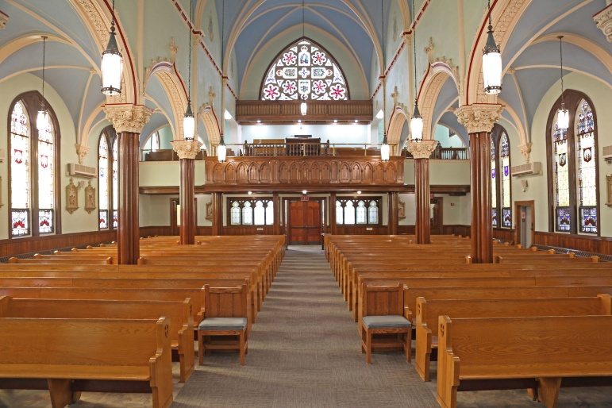
ST. PATRICK BREASTPLATE
St. Patrick's Breastplate is a popular prayer attributed to one of Ireland’s most beloved patron saints. According to tradition, St. Patrick wrote it in 433 A.D. for divine protection before successfully converting the Irish King Leoghaire and his subjects from paganism to Christianity. (The term breastplate refers to a piece of armor worn in battle.)

I arise today
Through a mighty strength, the invocation of the Trinity, Through belief in the Threeness,
Through confession of the Oneness of the Creator of creation.

I arise today
Through the strength of Christ's birth with His baptism,
Through the strength of His crucifixion with His burial, Through the strength of His resurrection with His ascension,
Through the strength of His descent for the judgment of doom.

I arise today
Through the strength of the love of cherubim,
In the obedience of angels, In the service of archangels,
In the hope of resurrection to meet with reward,
In the prayers of patriarchs, In the predictions of prophets, In the preaching of apostles, In the faith of

confessors,
In the innocence of holy virgins, In the deeds of righteous men.

I arise today, through The strength of heaven, The light of the sun,
The radiance of the moon,
The splendor of fire, The speed of lightning, The swiftness of wind, The depth of the sea, firmness of rock.

I arise today, through God's strength to pilot me, God's might to uphold me, God's wisdom to guide me,
God's eye to look before me, God's ear to hear me,
God's word to speak for me, God's hand to guard me, God's shield to protect me, God's host to save me
From snares of devils, From temptation of vices,
From everyone who shall wish me ill, afar and near.

I summon today
All these powers between me and those evils,
Against every cruel and merciless power
that may oppose my body and soul, Against incantations of false prophets,
Against black laws of pagandom, Against false laws of heretics, Against craft of idolatry,
Against spells of witches and smiths and wizards,
Against every knowledge that corrupts man's body and soul; Christ to shield me today Against poison, against burning,
Against drowning, against wounding, So that there may come to me an abundance of reward.

Christ with me, Christ before me, Christ behind me, Christ in me, Christ beneath me, Christ above me, Christ on my right, Christ on my left,
Christ when I lie down, Christ when I sit down, Christ when I arise,
Christ in the heart of every man who thinks of me,
Christ in the mouth of everyone who speaks of me,
Christ in every eye that sees me, Christ in every ear that hears me.

