

Thanks for checking out our sermon-based Study Guides! If you’ve never used our Study Guides before, you’ll find some basic instructions beginning at the bottom of page 2.

NEW this year: These study guides will be written by thoughtful and experienced Life Group Leaders. As always, use these guides as a head-start in your own preparation as the needs and culture is different from each group. And of course, please continue to give us feedback.

Life Group Study Guide
for the Sermon given on October 2, 2022
by Pastor Bryan Wilkerson
“Freedom!” - Exodus 5-14

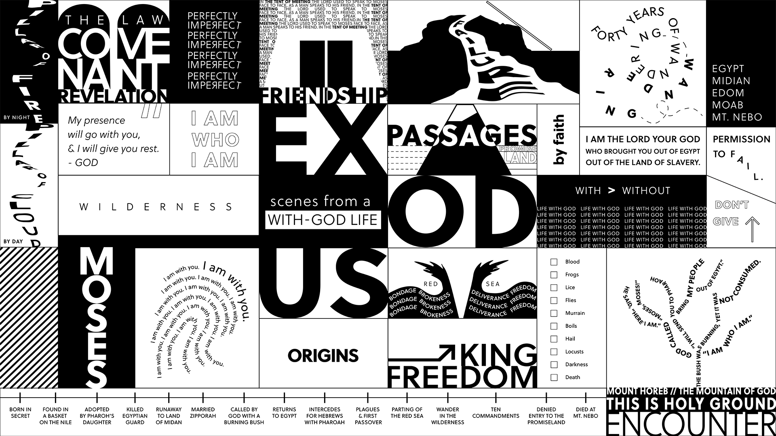

Question: Why is the story (Exodus 5-14) here, and what does it mean for us?
Bottom Line: We are all in bondage to something until we trust and follow the only One who can set us free.

-----

If this is your first time back, welcome to the new ministry year and if you took a break this summer, welcome back to this Life Group (new year, new name :)

Our new Fall Series is called “Exodus.” Today we will be jumping right into the life of Moses, identify our points of connection, and consider what insights and wisdom we can apply to our lives.

We are excited to try to something a little new this year, and that is utilize some of the gifting and passion of talented and experienced group leaders and so much of this study has been created by one of our seasoned Life Group Leaders. Thank you for being here today.

Let’s begin in prayer before we begin reading and discussing our text.

Main Scripture Reading: Exodus 5-14 (open your Bible or Bible app)

Group Discussion Questions

- One of the teaching points of the message was that there are three internal forces that often prevent us from becoming our best selves:
  - Guilt: I did something bad
  - Shame: I am bad
  - Fear: Something bad is going to happen
What comes to your mind when you consider these forces? How have you wrestled with one or some of these forces? If you have found freedom from these forces, what were the contributing factors that helped?

- Exodus gives an account of the 10 plagues God used to punish Pharaoh for not allowing Moses’ people to leave Egypt. Let’s take a look at these and consider what questions do you have about them, whether it be their historicity or their meaning - Which do you find the most intriguing?
The 10 Plagues:
1. Turning water to blood: Ex. 7:14-24
2. Frogs: Ex. 7:25–8:11/15
3. Lice or gnats: Ex. 8:12–15/8:16–19
4. Wild animals or flies: Ex. 8:16–28/8:20–32
5. Pestilence of livestock: Ex. 9:1–7
6. Boils: Ex. 9:8–12
7. Thunderstorm of hail and fire: Ex. 9:13–35
8. Locusts: Ex. 10:1–20
9. Darkness for three days: Ex. 10:21–29
10. Death of firstborn son: Ex. 11:1-12:36

- Exodus 7:3-4 says, “But I will harden Pharaoh’s heart, and though I multiply my miraculous signs and wonders in Egypt, he will not listen to you. Then I will lay my hand on Egypt and with mighty acts of judgment I will bring out...my people the Israelites.”
There has been much debate to the question of the hardening of Pharoah’s heart and God’s active involvement. One possibility is that God allowed Pharaoh to harden his heart. Another is that God actively hardened his heart. How do you approach this question, what questions might it raise and more importantly, how can we make sure that our hearts never become similarly stubborn and calloused?

- E. Stanley Jones was a Christian missionary, theologian and author. He said, “If you don’t surrender to God, don’t think you don’t surrender. Everyone surrenders - to something.” What do you think this means?

- How does the above quote apply to the Israelites (read Exodus 14:11-12 and 30-31)?

- (Leader, Please Note – Not everyone needs to answer this Question):

Pastor Bryan mentioned Grace Chapel’s Celebrate Recovery Ministry. Part of their practice is how you introduce yourself to the group and what hurt, hangup, or habit you are trying to recover from. How would you introduce yourself at Celebrate Recovery? “Hello my name is __________________. I am in recovery from __________________.”

- If there something that is holding you back from living your best life or someone you love, what prayer of deliverance can we ask Jesus for today?

Homework Until Next Time:
Ask the members of your LG to complete the Discipleship Planning Tool and the GPS Assessment Tool before your next meeting. Here is some fresh language:

We’re all on a journey; where is yours taking you?

The beauty of the way of Jesus is that it’s not just good for us, it’s good for the world around us. But that kind of beautiful life doesn’t come from just hearing the words of Jesus; it comes from putting them into practice. Three kinds of practice, actually:
- The with-God life of our personal habits and routines;
- The with-others life of our genuine and life-changing relationships; and
- The for-the-world life that makes an impact beyond our immediate homes and families, into our communities and beyond.

Growing as disciples of Jesus will make a Kingdom difference in our world and a transformative difference in our lives as believers and as a group. And these resources are helpful in identifying the next steps for our journeys.

Let’s Pray
-------------------
Support for the Leader (These Teaching Points are provided to help the group leader make connections from the message to their group with both insights from the Biblical text and also opportunities in the life of our church).

Teaching Points:
- We are all in bondage to something. It stops us from living our best lives, from realizing our hopes and dreams.
- There are 3 internal forces that prevent us from becoming our best selves:
  - Guilt: I did something bad
  - Shame: I am bad
  - Fear: Something bad is going to happen
- Sin is not so much about breaking rules, but about breaking relationships (living life without God)
- We cannot overcome our hurts, habits and hang-ups in our own strength. Only with God, through the power of Holy Spirit, can we break the chains that are holding us back.
- Jesus died on the cross to forgive our sins and to set us free to become the people God intended us to be. When we say yes to Jesus, we choose to live life with God.

For Further Biblical Study:

Genesis 15:12-16
¹² As the sun was setting, Abram fell into a deep sleep, and a thick and dreadful darkness came over him. ¹³ Then the Lord said to him, “Know for certain that for four hundred years your descendants will be strangers in a country not their own and that they will be enslaved and mistreated there. ¹⁴ But I will punish the nation they serve as slaves, and afterward they will come out with great possessions. ¹⁵ You, however, will go to your ancestors in peace and be buried at a good old age. ¹⁶ In the fourth generation your descendants will come back here, for the sin of the Amorites has not yet reached its full measure.”

Exodus 7:1-5
7 Then the Lord said to Moses, “See, I have made you like God to Pharaoh, and your brother Aaron will be your prophet. ² You are to say everything I command you, and your brother Aaron is to tell Pharaoh to let the Israelites go out of his country. ³ But I will harden Pharaoh’s heart, and though I multiply my signs and wonders in Egypt, ⁴ he will not listen to you. Then I will lay my hand on Egypt and with mighty acts of judgment I will bring out my divisions, my people the Israelites. ⁵ And the Egyptians will know that I am the Lord when I stretch out my hand against Egypt and bring the Israelites out of it.”

Hebrews 3:12-19
¹² See to it, brothers and sisters, that none of you has a sinful, unbelieving heart that turns away from the living God. ¹³ But encourage one another daily, as long as it is called “Today,” so that none of you may be hardened by sin’s deceitfulness. ¹⁴ We have come to share in Christ, if indeed we hold our original conviction firmly to the very end. ¹⁵ As has just been said:
“Today, if you hear his voice,
do not harden your hearts
as you did in the rebellion.”^{[c]}

¹⁶ Who were they who heard and rebelled? Were they not all those Moses led out of Egypt? ¹⁷ And with whom was he angry for forty years? Was it not with those who sinned, whose bodies perished in the wilderness? ¹⁸ And to whom did God swear that they would never enter his rest if not to those who disobeyed? ¹⁹ So we see that they were not able to enter, because of their unbelief.

Romans 6:20-23
²⁰ When you were slaves to sin, you were free from the control of righteousness. ²¹ What benefit did you reap at that time from the things you are now ashamed of? Those things result in death! ²² But now that you have been set free from sin and have become slaves of God, the benefit you reap leads to holiness, and the result is eternal life. ²³ For the wages of sin is death, but the gift of God is eternal life in^{[b]} Christ Jesus our Lord.

How to Use These Study Guides:
- Consider sending out the Scripture passage to your group members ahead of time.
- Begin each meeting with a short time of checking in with one another.
- You may want to begin the discussion by reading the Scripture passage together out loud, or by summarizing the passage if everyone has read it ahead of time.
- Don’t feel like you need to discuss every question included in the Study Guide. Pick one or two to start with, and see how the conversation flows.
- If your group meets over Zoom:
  - You may need to do more overt facilitating over Zoom than you would in person. Feel free to call on people to invite them to share.
  - Try to be sensitive to attention spans over Zoom—keep the meetings shorter than they would be in person.
- Be sure to set aside time for sharing prayer requests and praying together.

Group Leader Support: Please reach out to your Campus Pastor or your Coach if you have any questions about leading your group or concerns about your group dynamic. If you have questions about or feedback on the Study Guides, please reach out to Pastor Tim or Pastor Rachel from the Group Life team.

