

Thanks for checking out our sermon-based Study Guides! If you’ve never used our Study Guides before, you’ll find some basic instructions beginning at the bottom of page 2.

NEW this year: These study guides will be written by thoughtful and experienced Life Group Leaders. As always, use these guides as a head-start in your own preparation as the needs and culture is different from each group. And of course, please continue to give us feedback.

Life Group Study Guide
for the Sermon given on October 23, 2022
by Pastor Bryan Wilkerson
“FRIENDSHIP” - Exodus 33:7-23

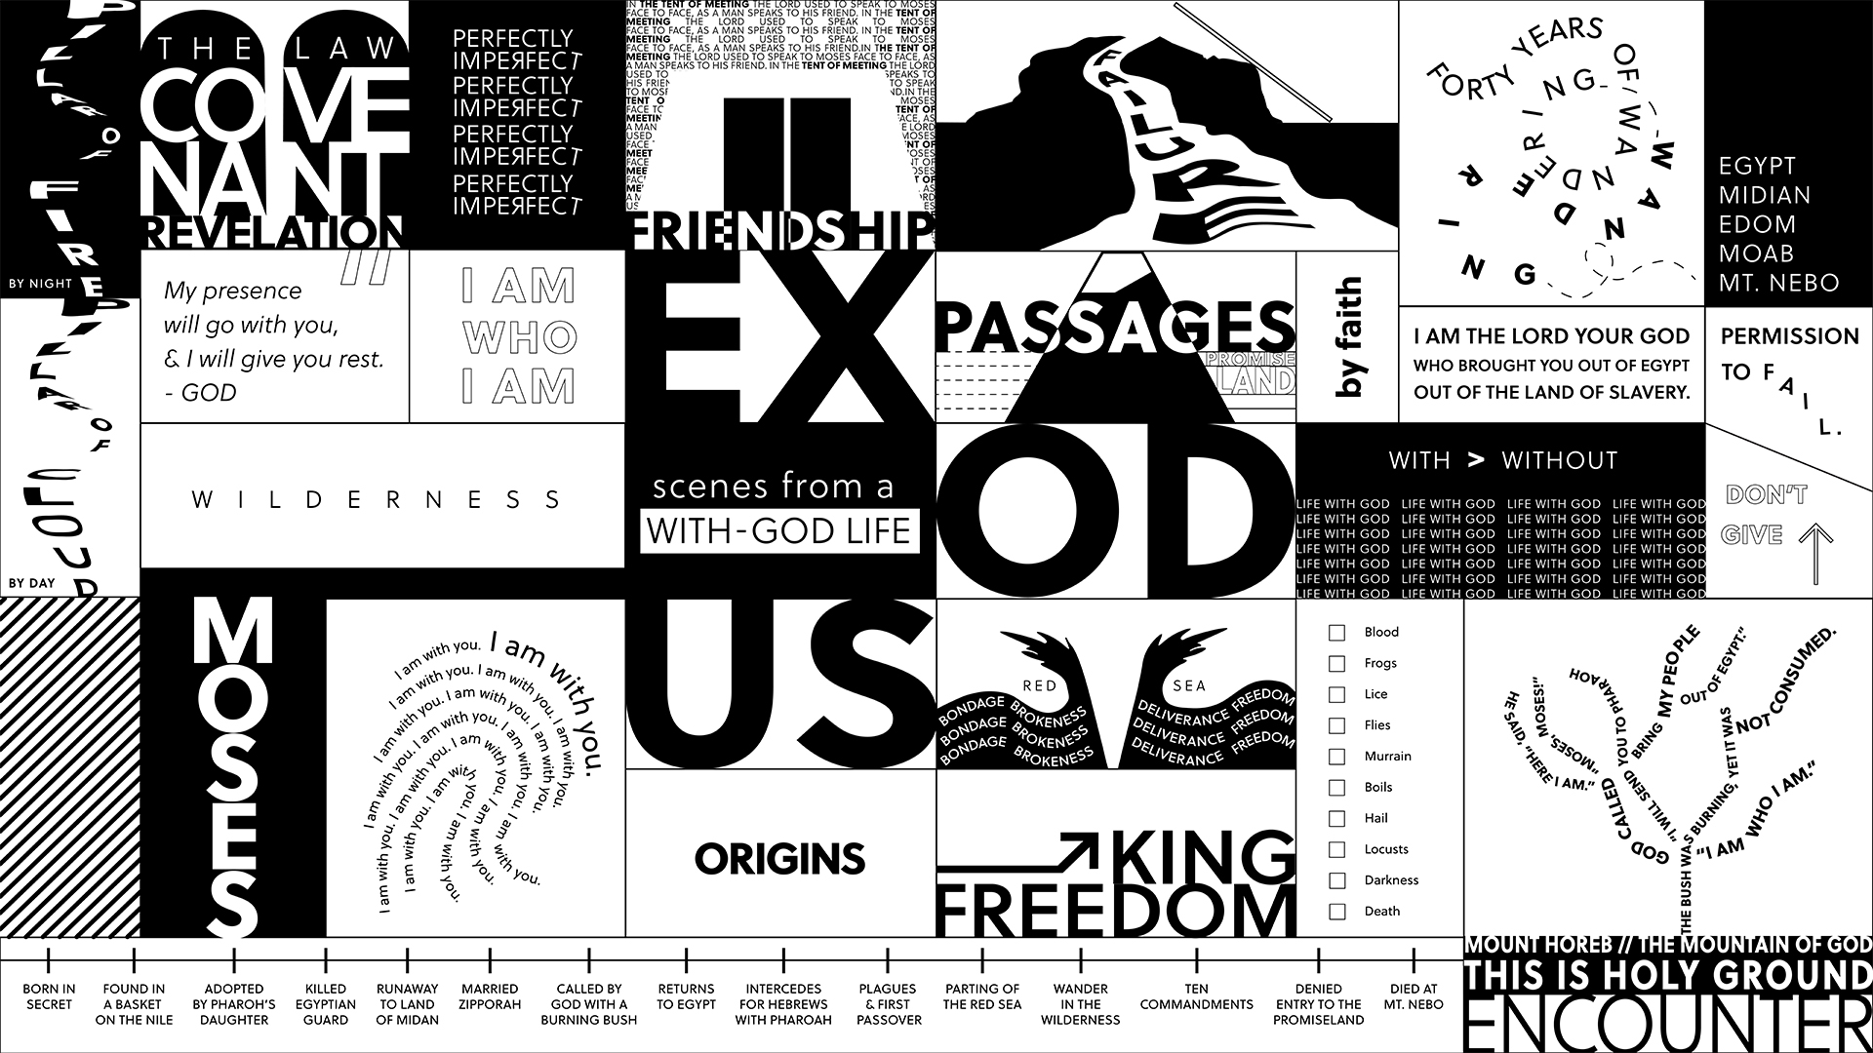

Question: Where do we get this idea of a personal relationship with God and how is such a thing even possible?
Bottom Line: A With-God life thrives on an honest, searching, lifelong conversation.

-----

In this sermon series of A With-God Life, we have been reading from the book of Exodus and taking a closer look at the relationship between God and Moses.

Christianity, as we understand it, is not just adherence to a creed, or a code of conduct, or a set of rituals. We like to say, “Christianity is not a religion; it is a relationship.”
Where do we get this idea of a personal relationship with God? Does the Bible really teach it, or is it just wishful thinking; a privatized, customized, Americanized brand of spirituality? If it IS a real thing, what does prayer have to do with having a relationship with God, and how can we be sure that we are experiencing it?

In answering these questions, we are continuing our journey through the Book of Exodus through the sermon series, “Scenes from a With-God life.” This phrase “With-God” is another way to describe a personal relationship with God. As of last week, Moses and Israel just made their way out of Egypt and through the wilderness. It’s been a long and windy journey, but we will focus on one scene today described in Exodus 33:7-23.

Thank you for being here today. Let’s begin in prayer before we begin reading and discussing our text.

Main Scripture Reading: Exodus 33:7-23

The Tent of Meeting
⁷ Now Moses used to take a tent and pitch it outside the camp some distance away, calling it the “tent of meeting.” Anyone inquiring of the Lord would go to the tent of meeting outside the camp. ⁸ And whenever Moses went out to the tent, all the people rose and stood at the entrances to their tents, watching Moses until he entered the tent. ⁹ As Moses went into the tent, the pillar of cloud would come down and stay at the entrance, while the Lord spoke with Moses. ¹⁰ Whenever the people saw the pillar of cloud standing at the entrance to the tent, they all stood and worshiped, each at the entrance to their tent. ¹¹ The Lord would speak to Moses face to face, as one speaks to a friend. Then Moses would return to the camp, but his young aide Joshua son of Nun did not leave the tent.

Moses and the Glory of the Lord
¹² Moses said to the Lord, “You have been telling me, ‘Lead these people,’ but you have not let me know whom you will send with me. You have said, ‘I know you by name and you have found favor with me.’ ¹³ If you are pleased with me, teach me your ways so I may know you and continue to find favor with you. Remember that this nation is your people.”
¹⁴ The Lord replied, “My Presence will go with you, and I will give you rest.”
¹⁵ Then Moses said to him, “If your Presence does not go with us, do not send us up from here. ¹⁶ How will anyone know that you are pleased with me and with your people unless you go with us? What else will distinguish me and your people from all the other people on the face of the earth?”
¹⁷ And the Lord said to Moses, “I will do the very thing you have asked, because I am pleased with you and I know you by name.”
¹⁸ Then Moses said, “Now show me your glory.”
¹⁹ And the Lord said, “I will cause all my goodness to pass in front of you, and I will proclaim my name, the Lord, in your presence. I will have mercy on whom I will have mercy, and I will have compassion on whom I will have compassion. ²⁰ But,” he said, “you cannot see my face, for no one may see me and live.”
²¹ Then the Lord said, “There is a place near me where you may stand on a rock. ²² When my glory passes by, I will put you in a cleft in the rock and cover you with my hand until I have passed by. ²³ Then I will remove my hand and you will see my back; but my face must not be seen.”

Group Discussion Questions

- Pastor Bryan begins with a scene from “The Apostle” where a preacher named Sonny (played by Robert Duvall) has an intimate, unreserved and expectant conversation with God. How would you describe your own conversations with God?

- Bryan pointed out that in the ancient world, the concept of talking to God, to converse with God, was a “novel concept.” Even the concept of a personal God coming near people to have a relationship cannot be observed in the dominant religious systems. We will take a moment to pause here to ask, “do you have this kind of relationship with God? Do you feel free to talk to God anywhere, anytime, about anything?”

- Jesus regularly talks to His heavenly Father. In Matthew 6:6 Jesus tells his followers to do the same, “Go into your room, close the door and pray to your Father, who is unseen.” As Bryan asked, do you have a “tent of meeting” – a place you go on a regular basis to spend time with God, as you might with a friend? Where do you pray?

- In the aftermath of the incident with the golden calf , we observe Moses in how he honestly and boldly approaches God concerning the people of Israel. We see Moses interceding for his people here. Have you approached God with such bold, honest searching prayers on behalf of a group of people?

- Out of the seven spiritual practices presented in the Discipleship Planning Tool, 62% of those who completed the tool were interested in growing in prayer. For those who took the tool, which spiritual practice did you choose? How has the journey been going so far?

- Pastor Bryan shared with us a simple template for prayer (Thank you/ Forgive me/ Help me). Are there other methods/ formats/ ways that have been helpful in your communication with God?

- Share prayer requests and take time to pray together.

- If you completed the Discipleship Planning Tool and or the GPS Assessment Tool, please consider sharing how the journey has been with your group.

Take Home Message:
You really can have a personal relationship with God, and that relationship thrives on honest, searching, lifelong conversation with God.

Homework Until Next Time:
Ask the members of your LG to complete the Discipleship Planning Tool and the GPS Assessment Tool before your next meeting. Here is some fresh language:

We’re all on a journey; where is yours taking you?

The beauty of the way of Jesus is that it’s not just good for us, it’s good for the world around us. But that kind of beautiful life doesn’t come from just hearing the words of Jesus; it comes from putting them into practice. Three kinds of practice, actually:
- The with-God life of our personal habits and routines;
- The with-others life of our genuine and life-changing relationships; and
- The for-the-world life that makes an impact beyond our immediate homes and families, into our communities and beyond.

Growing as disciples of Jesus will make a Kingdom difference in our world and a transformative difference in our lives as believers and as a group. And these resources are helpful in identifying the next steps for our journeys.

Let’s Pray
-------------------
Support for the Leader (These Teaching Points are provided to help the group leader make connections from the message to their group with both insights from the Biblical text and also opportunities in the life of our church).

Teaching Points:
- Christianity is a relationship
- God desires a personal relationship with us, which is sustained by a conversation that we call prayer
- God wants to know what is going on in your heart
- Our prayers with God should be:
  - Honest and direct
  - Searching: to search our own hearts and God’s heart, and discern what ‘s really happening with us and God, and with those we love
  - Lifelong
- Some spiritual practices:
  - Prayer = talking and listening to God
  - Scripture = reading and applying the Bible to Life
  - Meditation = silence and reflection
  - Searching = investigating and wresting with faith
- A simple prayer template:
  - Thank you, Lord for ______________
  - Forgive me, Lord for ______________
  - Help me, Lord for _________________
- If you have not yet done so, please spend 15-20 minutes to complete the Discipleship Planning Tool (grace.org/the journey) and the GPS Assessment Tool (grace.org/volunteer)

For Further Biblical Study:

Genesis 18:16-33

Abraham Pleads for Sodom
¹⁶ When the men got up to leave, they looked down toward Sodom, and Abraham walked along with them to see them on their way. ¹⁷ Then the Lord said, “Shall I hide from Abraham what I am about to do? ¹⁸ Abraham will surely become a great and powerful nation, and all nations on earth will be blessed through him.^{[a]} ¹⁹ For I have chosen him, so that he will direct his children and his household after him to keep the way of the Lord by doing what is right and just, so that the Lord will bring about for Abraham what he has promised him.”
²⁰ Then the Lord said, “The outcry against Sodom and Gomorrah is so great and their sin so grievous ²¹ that I will go down and see if what they have done is as bad as the outcry that has reached me. If not, I will know.”
²² The men turned away and went toward Sodom, but Abraham remained standing before the Lord.^{[b]} ²³ Then Abraham approached him and said: “Will you sweep away the righteous with the wicked? ²⁴ What if there are fifty righteous people in the city? Will you really sweep it away and not spare^{[c]} the place for the sake of the fifty righteous people in it? ²⁵ Far be it from you to do such a thing—to kill the righteous with the wicked, treating the righteous and the wicked alike. Far be it from you! Will not the Judge of all the earth do right?”
²⁶ The Lord said, “If I find fifty righteous people in the city of Sodom, I will spare the whole place for their sake.”
²⁷ Then Abraham spoke up again: “Now that I have been so bold as to speak to the Lord, though I am nothing but dust and ashes, ²⁸ what if the number of the righteous is five less than fifty? Will you destroy the whole city for lack of five people?”
“If I find forty-five there,” he said, “I will not destroy it.”
²⁹ Once again he spoke to him, “What if only forty are found there?”
He said, “For the sake of forty, I will not do it.”
³⁰ Then he said, “May the Lord not be angry, but let me speak. What if only thirty can be found there?”
He answered, “I will not do it if I find thirty there.”
³¹ Abraham said, “Now that I have been so bold as to speak to the Lord, what if only twenty can be found there?”
He said, “For the sake of twenty, I will not destroy it.”
³² Then he said, “May the Lord not be angry, but let me speak just once more. What if only ten can be found there?”
He answered, “For the sake of ten, I will not destroy it.”
³³ When the Lord had finished speaking with Abraham, he left, and Abraham returned home.

Exodus 32:7-14
⁷ Then the Lord said to Moses, “Go down, because your people, whom you brought up out of Egypt, have become corrupt. ⁸ They have been quick to turn away from what I commanded them and have made themselves an idol cast in the shape of a calf. They have bowed down to it and sacrificed to it and have said, ‘These are your gods, Israel, who brought you up out of Egypt.’
⁹ “I have seen these people,” the Lord said to Moses, “and they are a stiff-necked people. ¹⁰ Now leave me alone so that my anger may burn against them and that I may destroy them. Then I will make you into a great nation.”
¹¹ But Moses sought the favor of the Lord his God. “Lord,” he said, “why should your anger burn against your people, whom you brought out of Egypt with great power and a mighty hand? ¹² Why should the Egyptians say, ‘It was with evil intent that he brought them out, to kill them in the mountains and to wipe them off the face of the earth’? Turn from your fierce anger; relent and do not bring disaster on your people. ¹³ Remember your servants Abraham, Isaac and Israel, to whom you swore by your own self: ‘I will make your descendants as numerous as the stars in the sky and I will give your descendants all this land I promised them, and it will be their inheritance forever.’” ¹⁴ Then the Lord relented and did not bring on his people the disaster he had threatened.

John 15:9-17

⁹ “As the Father has loved me, so have I loved you. Now remain in my love. ¹⁰ If you keep my commands, you will remain in my love, just as I have kept my Father’s commands and remain in his love. ¹¹ I have told you this so that my joy may be in you and that your joy may be complete. ¹² My command is this: Love each other as I have loved you. ¹³ Greater love has no one than this: to lay down one’s life for one’s friends. ¹⁴ You are my friends if you do what I command. ¹⁵ I no longer call you servants, because a servant does not know his master’s business. Instead, I have called you friends, for everything that I learned from my Father I have made known to you. ¹⁶ You did not choose me, but I chose you and appointed you so that you might go and bear fruit—fruit that will last—and so that whatever you ask in my name the Father will give you. ¹⁷ This is my command: Love each other.

How to Use These Study Guides:
- Consider sending out the Scripture passage to your group members ahead of time.
- Begin each meeting with a short time of checking in with one another.
- You may want to begin the discussion by reading the Scripture passage together out loud, or by summarizing the passage if everyone has read it ahead of time.
- Don’t feel like you need to discuss every question included in the Study Guide. Pick one or two to start with, and see how the conversation flows.
- If your group meets over Zoom:
  - You may need to do more overt facilitating over Zoom than you would in person. Feel free to call on people to invite them to share.
  - Try to be sensitive to attention spans over Zoom—keep the meetings shorter than they would be in person.
- Be sure to set aside time for sharing prayer requests and praying together.

Group Leader Support: Please reach out to your Campus Pastor or your Coach if you have any questions about leading your group or concerns about your group dynamic. If you have questions about or feedback on the Study Guides, please reach out to Pastor Tim or Grace Lee (our new Ministry Coordinator for Discipleship, Women’s Groups and Life Groups) from the Group Life team.

