

Thanks for checking out our sermon-based Study Guides! If you’ve never used our Study Guides before, you’ll find some basic instructions beginning at the bottom of page 2.

NEW this year: These study guides will be written by thoughtful and experienced Life Group Leaders. As always, use these guides as a head-start in your own preparation as the needs and culture is different from each group. And of course, please continue to give us feedback.

Life Group Study Guide
for the Sermon given on May 7, 2023
by Pastor Tim Ghali
A SAVIOR FOR THE WORLD - Revelation 5:1-14

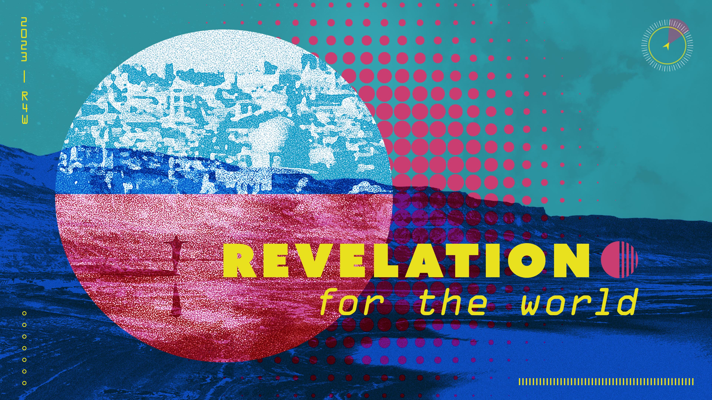

Question: What is the book of Revelation about?

Bottom Line: Because the Lamb of Jesus was victorious over death and doom, we can live in the hope of divine deliverance.

Our new sermon series is called “Revelation – For The World”. Last week Pastor Bryan discussed Revelation chapter 1 and provided a brief overview of the book. We learned that Revelation tells the story of God’s victory over evil through Christ and invites us to play our part in that story. Today Pastor Tim is going to take us through chapter 5, reminding us not to fear doomsday scenarios, but to live in the present and future hope of the Day of the Lord and God’s promise of a new heaven and a new earth.

Main Scripture Reading: Revelation 5:1-14
5 Then I saw in the right hand of him who sat on the throne a scroll with writing on both sides and sealed with seven seals. ² And I saw a mighty angel proclaiming in a loud voice, “Who is worthy to break the seals and open the scroll?” ³ But no one in heaven or on earth or under the earth could open the scroll or even look inside it. ⁴ I wept and wept because no one was found who was worthy to open the scroll or look inside. ⁵ Then one of the elders said to me, “Do not weep! See, the Lion of the tribe of Judah, the Root of David, has triumphed. He is able to open the scroll and its seven seals.”
⁶ Then I saw a Lamb, looking as if it had been slain, standing at the center of the throne, encircled by the four living creatures and the elders. The Lamb had seven horns and seven eyes, which are the seven spirits^{[a]} of God sent out into all the earth. ⁷ He went and took the scroll from the right hand of him who sat on the throne. ⁸ And when he had taken it, the four living creatures and the twenty-four elders fell down before the Lamb. Each one had a harp and they were holding golden bowls full of incense, which are the prayers of God’s people. ⁹ And they sang a new song, saying:
“You are worthy to take the scroll
and to open its seals,
because you were slain,
and with your blood you purchased for God
persons from every tribe and language and people and nation.
¹⁰ You have made them to be a kingdom and priests to serve our God,
and they will reign^{[b]} on the earth.”
¹¹ Then I looked and heard the voice of many angels, numbering thousands upon thousands, and ten thousand times ten thousand. They encircled the throne and the living creatures and the elders. ¹² In a loud voice they were saying:
“Worthy is the Lamb, who was slain,
to receive power and wealth and wisdom and strength
and honor and glory and praise!”
¹³ Then I heard every creature in heaven and on earth and under the earth and on the sea, and all that is in them, saying:
“To him who sits on the throne and to the Lamb
be praise and honor and glory and power,
for ever and ever!”
¹⁴ The four living creatures said, “Amen,” and the elders fell down and worshiped.

Group Discussion Questions

- Why do people, in general, seem so intrigued by doomsday scenarios? Are there any examples that seem to capture your attention more than others?

- Why do some in the church see Revelation more about the end of the world (God’s judgement) than about the revelation of the love, work, and salvation of Jesus?

What factors are hindering people from accepting the invitation to join in that Kingdom work of redemption?

- If you have any questions or comments about the images, symbols, or references to the Old Testament, discuss them with your group.

- After reading through Revelation 5:1-14, are there any images or words that resonate with you or spark wonder, joy, and worship?

- How does seeing Jesus in this way shape our understanding of doomsday or end of the world scenarios? How might this change the way that we view and interact with the people around us?

Take Home Message:
The book of Revelation proclaims to the whole world that a better world is possible – that because of Jesus’ work on the cross, we can all experience complete goodness, forgiveness, salvation and redemption.

Homework Until Next Time:
Ask the members of your LG to complete the Discipleship Planning Tool and the GPS Assessment Tool before your next meeting. Here is some fresh language:

We’re all on a journey; where is yours taking you?

The beauty of the way of Jesus is that it’s not just good for us, it’s good for the world around us. But that kind of beautiful life doesn’t come from just hearing the words of Jesus; it comes from putting them into practice. Three kinds of practice, actually:
- The with-God life of our personal habits and routines;
- The with-others life of our genuine and life-changing relationships; and
- The for-the-world life that makes an impact beyond our immediate homes and families, into our communities and beyond.

Growing as disciples of Jesus will make a Kingdom difference in our world and a transformative difference in our lives as believers and as a group. And these resources are helpful in identifying the next steps for our journeys.

Let’s Pray
Support for the Leader (These Teaching Points are provided to help the group leader make connections from the message to their group with both insights from the Biblical text and also opportunities in the life of our church).

Teaching Points:
- Apocalyptic literature: a type of biblical literature that emphasizes the lifting of the veil between heaven and earth and the revelation of God and his plan for the world

- From Lords of War to Lamb of Life: the way of the world is selfish desire (e.g., pride, greed, lust) in contrast to the sacrificial love demonstrated by Jesus’ death on the cross to restore our relationship with God

- From Fear of Death to Worship of the Giver of Life: earthly rulers use fear to control their people, whereas believers experience joy when they praise, sing and worship Jesus

- From Doomsday Scenarios to Divine Deliverance: instead of focusing on our fears, let us pray to God, hope in Jesus and move forward in the power of the Holy Spirit

How to Use These Study Guides:
- Consider sending out the Scripture passage to your group members ahead of time.
- Begin each meeting with a short time of checking in with one another.
- You may want to begin the discussion by reading the Scripture passage together out loud, or by summarizing the passage if everyone has read it ahead of time.
- Don’t feel like you need to discuss every question included in the Study Guide. Pick one or two to start with, and see how the conversation flows.
- If your group meets over Zoom:
  - You may need to do more overt facilitating over Zoom than you would in person. Feel free to call on people to invite them to share.
  - Try to be sensitive to attention spans over Zoom—keep the meetings shorter than they would be in person.
- Be sure to set aside time for sharing prayer requests and praying together.

Group Leader Support: Please reach out to your Campus Pastor or your Coach if you have any questions about leading your group or concerns about your group dynamic. If you have questions about or feedback on the Study Guides, please reach out to Pastor Tim or Grace Lee from the Group Life team.

