

Thanks for checking out our sermon-based Study Guides! If you’ve never used our Study Guides before, you’ll find some basic instructions beginning at the bottom of page 2.

NEW this year: These study guides will be written by thoughtful and experienced Life Group Leaders. As always, use these guides as a head-start in your own preparation as the needs and culture is different from each group. And of course, please continue to give us feedback.

Life Group Study Guide
for the Sermon given on September 18, 2022
by Pastor Bryan Wilkerson
“Beginnings” - Exodus 1-2

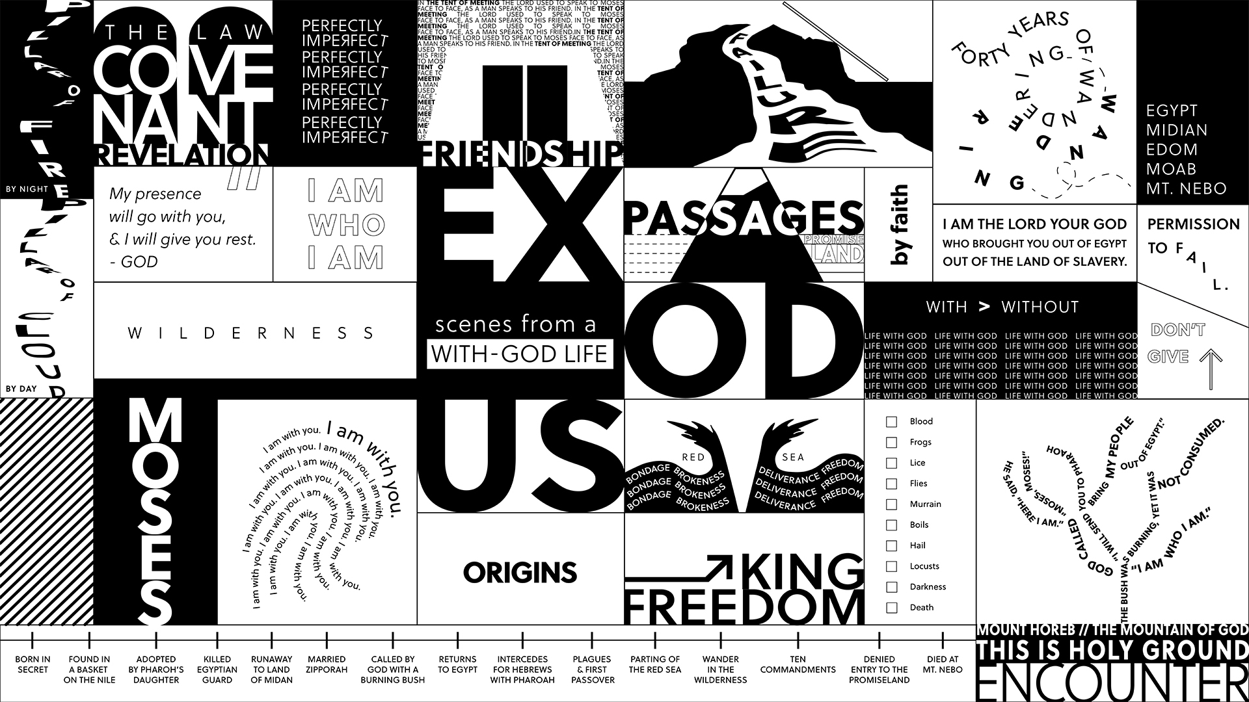

Question: What does your birth story reveal about you?
Bottom Line: From the beginning, God has been forming you for life with Him, and with others, for the good of the world around you. Are you ready to say yes to that life?

-----

If this is your first time back, welcome to the new ministry year and if you took a break this summer, welcome back to this Life Group (new year, new name :)

Grace Chapel did something new for the start of the fall and that was to kick-off the year with “Vision Week” which included two Vision Sermons, the first week with Campus Pastors, and this past Sunday with Pastor Bryan beginning the new Fall Series called “Exodus.” Today we will be jumping right into the life of Moses, identify our points of connection, and consider what insights and wisdom we can apply to our lives.

We are excited to try to something a little new this year, and that is utilize some of the gifting and passion of talented and experienced group leaders and so much of this study has been created by one of our seasoned Life Group Leaders. Thank you for being here today.

Let’s begin in prayer before we begin reading and discussing our text.

Main Scripture Reading: Exodus 2

Group Discussion Questions

- How does Exodus 1-2 fit into Israel’s history?
(Help for Leader: It’s the origin story of Moses, the prophet and leader that God will use to deliver the children of Israel out of Egypt.)

- In the opening of the sermon, Pastor Bryan asked, “What does your birth story reveal about you?” Tell us about your birth story and how it has shaped your character or affected the trajectory of your life?

- Read Exodus 2:1-10. Identify the many moments of God working in the beginning of Moses’ life.

- Chapter 2:11-25 take a dramatic turn as Moses murders an Egyptian out of anger. Yet God still chooses him to lead the Israelites out of slavery. What does this teach us about God’s character? What does that show us in Moses’ life? What does it mean to you?

- Bryan stated “From the beginning, God has been forming us for life with Him and with others, for the good of the world around us.” Describe a moment or a season when that was a hard truth to accept and describe a time when it felt very natural.

- If you have completed either the Discipleship Planning Tool or the GPS Assessment, what have you learned either about yourself or about the next steps in your journey?

- Moses was uniquely suited for a calling orchestrated by God. And you are also uniquely suited for your own calling. What personality traits, talents, gifts or experiences that have formed you for a particular type of ministry? (Feel free to think outside the box of traditional ministry programing and remember that ministry is any work dedicated to the building of God’s kingdom in service, relationship, worship and beyond.

Take Home Message:
“From the beginning, God has been forming us for life with Him and with others, for the good of the world around us.”

Homework Until Next Time:
Ask the members of your LG to complete the Discipleship Planning Tool and the GPS Assessment Tool before your next meeting. Here is some fresh language:

We’re all on a journey; where is yours taking you?

The beauty of the way of Jesus is that it’s not just good for us, it’s good for the world around us. But that kind of beautiful life doesn’t come from just hearing the words of Jesus; it comes from putting them into practice. Three kinds of practice, actually:
- The with-God life of our personal habits and routines;
- The with-others life of our genuine and life-changing relationships; and
- The for-the-world life that makes an impact beyond our immediate homes and families, into our communities and beyond.

Growing as disciples of Jesus will make a Kingdom difference in our world and a transformative difference in our lives as believers and as a group. And these resources are helpful in identifying the next steps for our journeys.

Let’s Pray
-------------------
Support for the Leader (These Teaching Points are provided to help the group leader make connections from the message to their group with both insights from the Biblical text and also opportunities in the life of our church).

Teaching Points:
- If you have not yet done so, please spend 15-20 minutes to complete the Discipleship Planning Tool (grace.org/the journey) and the GPS Assessment Tool (grace.org/volunteer)
- The story of your birth can shape your character and could also determine the direction of your life.
- Your personality, talents and life experiences were also designed for your unique role in God’s story.
- Before the beginning of time, God had a plan and purpose for your life. You were born into the story of God’s redemption of mankind. To realize your role in His story, you must first accept Jesus as your Lord and savior. Wherever you are (physically, mentally, spiritually), God is ready to meet you.

For Further Biblical Study:

Psalm 139:13-16 (NIV)
13 For you created my inmost being;
you knit me together in my mother’s womb.
14 I praise you because I am fearfully and wonderfully made;
your works are wonderful, I know that full well.
15 My frame was not hidden from you
when I was made in the secret place,
when I was woven together in the depths of the earth.
16 Your eyes saw my unformed body;
all the days ordained for me were written in your book
before one of them came to be.

Ephesians 2:10 (NIV)
10 For we are God’s handiwork, created in Christ Jesus to do good works, which God prepared in advance for us to do.

Ephesians 1:11 (NIV)
11 In him we were also chosen,[a] having been predestined according to the plan of him who works out everything in conformity with the purpose of his will,

Romans 8:28 (NIV)
28 And we know that in all things God works for the good of those who love him, who[a] have been called according to his purpose.

2Timothy 1:9 (NIV)
9 He has saved us and called us to a holy life—not because of anything we have done but because of his own purpose and grace. This grace was given us in Christ Jesus before the beginning of time.

How to Use These Study Guides:
- Consider sending out the Scripture passage to your group members ahead of time.
- Begin each meeting with a short time of checking in with one another.
- You may want to begin the discussion by reading the Scripture passage together out loud, or by summarizing the passage if everyone has read it ahead of time.
- Don’t feel like you need to discuss every question included in the Study Guide. Pick one or two to start with, and see how the conversation flows.
- If your group meets over Zoom:
  - You may need to do more overt facilitating over Zoom than you would in person. Feel free to call on people to invite them to share.
  - Try to be sensitive to attention spans over Zoom—keep the meetings shorter than they would be in person.
- Be sure to set aside time for sharing prayer requests and praying together.

Group Leader Support: Please reach out to your Campus Pastor or your Coach if you have any questions about leading your group or concerns about your group dynamic. If you have questions about or feedback on the Study Guides, please reach out to Pastor Tim or Pastor Rachel from the Group Life team.

