

Thanks for checking out our sermon-based Study Guides! If you’ve never used our Study Guides before, you’ll find some basic instructions beginning at the bottom of page 2.

NEW this year: These study guides will be written by thoughtful and experienced Life Group Leaders. As always, use these guides as a head-start in your own preparation as the needs and culture is different from each group. And of course, please continue to give us feedback.

Life Group Study Guide
for the Sermon given on October 9, 2022
by Pastor Tim Ghali
“Talking About My Revelation” - Exodus 19-20

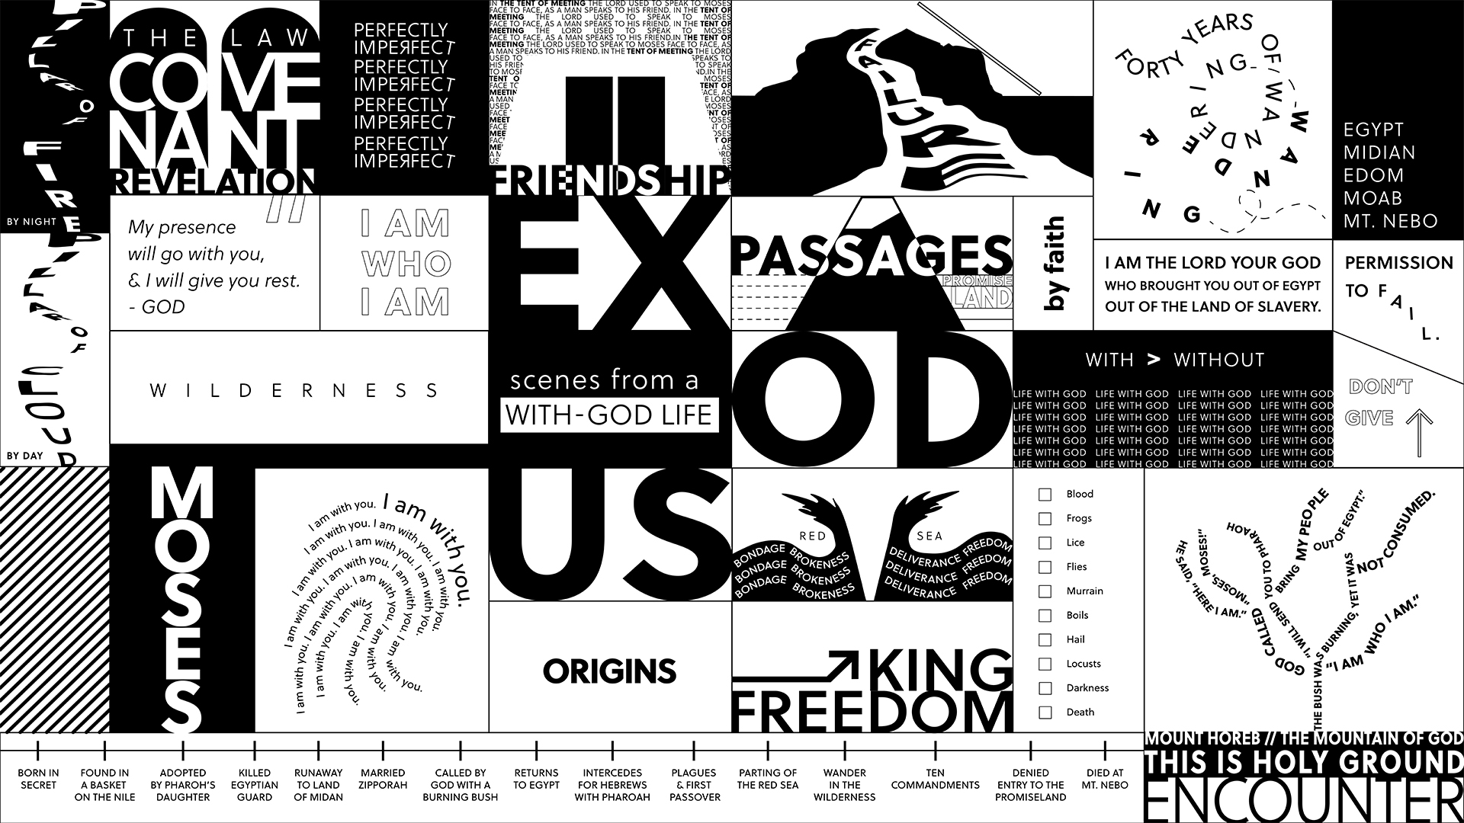

Question: When we experience something extraordinary, maybe even miraculous, was that actually God?
Bottom Line: God is trying to reveal truth to us, in different ways, for different reasons, at different times … will we have ears to hear it, will we have eyes to see it, will we have the hearts to receive these revelations?

-----

If this is your first time back, welcome to the new ministry year and if you took a break this summer, welcome back to this Life Group (new year, new name :)

We just crossed the halfway mark on our Fall Series called “Exodus.” Throughout this series, we have been covering a lot of Scriptural ground across the second book of the Bible, Exodus and looking in at key scenes in Moses’ life like “Origins” (Moses’ birth/adoption into Pharoah’s home), the “Encounter” at the Burning Bush , “Freedom” as in last week’s story of the children of Israel dramatically fleeing Egypt after the 10 Plagues and today we we’re talking about receiving “Revelation” from God. Each week we see God in every scene. Each week we see God with Moses. Each week we receive an invitation on how to live – this is the With-God Life - and it’s a journey.

We are excited to try to something a little new this year, and that is utilize some of the gifting and passion of talented and experienced group leaders and so much of this study has been created by one of our seasoned Life Group Leaders. Thank you for being here today.

Let’s begin in prayer before we begin reading and discussing our text.

Main Scripture Reading: Exodus 19-20
Exodus 20:1-17
20 And God spoke all these words:
² “I am the Lord your God, who brought you out of Egypt, out of the land of slavery.
³ “You shall have no other gods before^{[a]} me.
⁴ “You shall not make for yourself an image in the form of anything in heaven above or on the earth beneath or in the waters below. ⁵ You shall not bow down to them or worship them; for I, the Lord your God, am a jealous God, punishing the children for the sin of the parents to the third and fourth generation of those who hate me, ⁶ but showing love to a thousand generations of those who love me and keep my commandments.
⁷ “You shall not misuse the name of the Lord your God, for the Lord will not hold anyone guiltless who misuses his name.
⁸ “Remember the Sabbath day by keeping it holy. ⁹ Six days you shall labor and do all your work, ¹⁰ but the seventh day is a sabbath to the Lord your God. On it you shall not do any work, neither you, nor your son or daughter, nor your male or female servant, nor your animals, nor any foreigner residing in your towns. ¹¹ For in six days the Lord made the heavens and the earth, the sea, and all that is in them, but he rested on the seventh day. Therefore the Lord blessed the Sabbath day and made it holy.
¹² “Honor your father and your mother, so that you may live long in the land the Lord your God is giving you.
¹³ “You shall not murder.
¹⁴ “You shall not commit adultery.
¹⁵ “You shall not steal.
¹⁶ “You shall not give false testimony against your neighbor.
¹⁷ “You shall not covet your neighbor’s house. You shall not covet your neighbor’s wife, or his male or female servant, his ox or donkey, or anything that belongs to your neighbor.”

Group Discussion Questions

- Pastor Tim began the sermon with a personal story of how a stranger announced his family’s “exodus out of infertility”. Have you experienced something extraordinary or miraculous? If so, do you view this event as luck, karma, God’s hand at work in your life or something else?
- Exodus 20:18-21 describes how the Israelites present at Mount Sinai reacted to the rollout of the 10 Commandments. If you were there, how would you have reacted?

¹⁸ When the people saw the thunder and lightning and heard the trumpet and saw the mountain in smoke, they trembled with fear. They stayed at a distance ¹⁹ and said to Moses, “Speak to us yourself and we will listen. But do not have God speak to us or we will die.”
²⁰ Moses said to the people, “Do not be afraid. God has come to test you, so that the fear of God will be with you to keep you from sinning.”
²¹ The people remained at a distance, while Moses approached the thick darkness where God was.
- Which of the 10 Commandments are easy for you to obey? Which ones do you struggle with?

- Moses introduces the Israelites to life with God by delivering them from slavery in Egypt and bringing them to the Promised Land. Jesus introduces us to life with God by dying on the cross for our sins and promising God’s Kingdom here on earth and in heaven. Compare and contrast their personalities, the messages they delivered and the people that they lead.

- Over the last few weeks, were there times that you have felt God reaching out to you? If so, how has he captured your attention and what is it that you think he wants you to do?

Take Home Message:
There is a lifelong set of God-given revelations that Jesus has for you as He leads you on an Exodus out of your old life.

Homework Until Next Time:
Ask the members of your LG to complete the Discipleship Planning Tool and the GPS Assessment Tool before your next meeting. Here is some fresh language:

We’re all on a journey; where is yours taking you?

The beauty of the way of Jesus is that it’s not just good for us, it’s good for the world around us. But that kind of beautiful life doesn’t come from just hearing the words of Jesus; it comes from putting them into practice. Three kinds of practice, actually:
- The with-God life of our personal habits and routines;
- The with-others life of our genuine and life-changing relationships; and
- The for-the-world life that makes an impact beyond our immediate homes and families, into our communities and beyond.

Growing as disciples of Jesus will make a Kingdom difference in our world and a transformative difference in our lives as believers and as a group. And these resources are helpful in identifying the next steps for our journeys.

Let’s Pray
-------------------
Support for the Leader (These Teaching Points are provided to help the group leader make connections from the message to their group with both insights from the Biblical text and also opportunities in the life of our church).

Teaching Points:
- If you have not yet done so, please spend 15-20 minutes to complete the Discipleship Planning Tool (grace.org/the journey) and the GPS Assessment Tool (grace.org/volunteer)
- Divine Revelation: a spiritual truth from God
- God does not speak to most of us in an audible voice, but through Scripture, small group discussions, worship songs, and sometimes even through strangers
- Sometimes the revelation from God that we receive leads us to the next step of our journey, to reconciliation with someone or God, to miraculous life-changing moments or to receiving God’s unconditional and extraordinary love

For Further Biblical Study:

Exodus 20:18-21
¹⁸ When the people saw the thunder and lightning and heard the trumpet and saw the mountain in smoke, they trembled with fear. They stayed at a distance ¹⁹ and said to Moses, “Speak to us yourself and we will listen. But do not have God speak to us or we will die.”
²⁰ Moses said to the people, “Do not be afraid. God has come to test you, so that the fear of God will be with you to keep you from sinning.”
²¹ The people remained at a distance, while Moses approached the thick darkness where God was.
Deuteronomy 10:12-13
¹² And now, Israel, what does the Lord your God ask of you but to fear the Lord your God, to walk in obedience to him, to love him, to serve the Lord your God with all your heart and with all your soul, ¹³ and to observe the Lord’s commands and decrees that I am giving you today for your own good?

Psalm 111:10
The fear of the Lord is the beginning of wisdom;
all who follow his precepts have good understanding.
To him belongs eternal praise.

Jeremiah 31:33-34
³³ “This is the covenant I will make with the people of Israel
after that time,” declares the Lord.
“I will put my law in their minds
and write it on their hearts.
I will be their God,
and they will be my people.
³⁴ No longer will they teach their neighbor,
or say to one another, ‘Know the Lord,’
because they will all know me,
from the least of them to the greatest,”
declares the Lord.
“For I will forgive their wickedness
and will remember their sins no more.”

Ezekial 36:26-27
²⁶ I will give you a new heart and put a new spirit in you; I will remove from you your heart of stone and give you a heart of flesh. ²⁷ And I will put my Spirit in you and move you to follow my decrees and be careful to keep my laws.

Matthew 5:17
¹⁷ “Do not think that I have come to abolish the Law or the Prophets; I have not come to abolish them but to fulfill them.”

Romans 8:1-4
¹Therefore, there is now no condemnation for those who are in Christ Jesus, ² because through Christ Jesus the law of the Spirit who gives life has set you^{[a]} free from the law of sin and death. ³ For what the law was powerless to do because it was weakened by the flesh,^{[b]} God did by sending his own Son in the likeness of sinful flesh to be a sin offering.^{[c]} And so he condemned sin in the flesh, ⁴ in order that the righteous requirement of the law might be fully met in us, who do not live according to the flesh but according to the Spirit.

How to Use These Study Guides:
- Consider sending out the Scripture passage to your group members ahead of time.
- Begin each meeting with a short time of checking in with one another.
- You may want to begin the discussion by reading the Scripture passage together out loud, or by summarizing the passage if everyone has read it ahead of time.
- Don’t feel like you need to discuss every question included in the Study Guide. Pick one or two to start with, and see how the conversation flows.
- If your group meets over Zoom:
  - You may need to do more overt facilitating over Zoom than you would in person. Feel free to call on people to invite them to share.
  - Try to be sensitive to attention spans over Zoom—keep the meetings shorter than they would be in person.
- Be sure to set aside time for sharing prayer requests and praying together.

Group Leader Support: Please reach out to your Campus Pastor or your Coach if you have any questions about leading your group or concerns about your group dynamic. If you have questions about or feedback on the Study Guides, please reach out to Pastor Tim or Pastor Rachel from the Group Life team.

