

Thanks for checking out our sermon-based Study Guides! If you’ve never used our Study Guides before, you’ll find some basic instructions beginning at the bottom of page 2.

NEW this year: These study guides will be written by thoughtful and experienced Life Group Leaders. As always, use these guides as a head-start in your own preparation as the needs and culture is different from each group. And of course, please continue to give us feedback.

Life Group Study Guide
for the Sermon given on February 12, 2023
by Pastor Ruthie Seiders
“THE ORDER OF THE TOWEL” - Philippians 2:1-11



Question: How do we move from a self-centered life to an others-centered life?

Bottom Line: Moving from a self-centered to an others-centered life involves risk, commitment, vulnerability, and trust.

We are moving along our winter series called “One Another: The Risk of a With-Others Life”. So far, we have discussed the importance of love, empathy, communication and forgiveness.

Today we are going to look at one of the letters of encouragement the apostle Paul wrote to the church in Philippi. The purpose of this letter was to explain how to shift from a self-centered life to an “others-centered” life.

Let’s begin in prayer before we begin reading and discussing our text.

Main Scripture Reading: Philippians 2:1-11

2 Therefore if you have any encouragement from being united with Christ, if any comfort from his love, if any common sharing in the Spirit, if any tenderness and compassion, ² then make my joy complete by being like-minded, having the same love, being one in spirit and of one mind. ³ Do nothing out of selfish ambition or vain conceit. Rather, in humility value others above yourselves, ⁴ not looking to your own interests but each of you to the interests of the others.
⁵ In your relationships with one another, have the same mindset as Christ Jesus:
⁶ Who, being in very nature^{[a]} God,
did not consider equality with God something to be used to his own advantage;
⁷ rather, he made himself nothing
by taking the very nature^{[b]} of a servant,
being made in human likeness.
⁸ And being found in appearance as a man,
he humbled himself
by becoming obedient to death—
even death on a cross!
⁹ Therefore God exalted him to the highest place
and gave him the name that is above every name,
¹⁰ that at the name of Jesus every knee should bow,
in heaven and on earth and under the earth,
¹¹ and every tongue acknowledge that Jesus Christ is Lord,
to the glory of God the Father.

Group Discussion Questions

- Pastor Ruthie began the sermon with a tale of a European monastery going through tough times. The few remaining monks became bitter and self-centered. However, when they heard that Jesus was living among them their attitudes changed. They lived with greater passion, energy, and enthusiasm, which had a positive impact on the surrounding towns and villages.

If you knew that Jesus lived among you, how do you think this would change your own attitude and behavior?

- Read Philippians 2:1-2. See if you can answer yes to any of the four points below. Take turns sharing one specific experience.

- If you have encouragement from being united with Christ
- If you have any comfort from his love
- If you have a common sharing in the Spirit
- If you have experienced any tenderness and compassion

- Read Philippians 2:3-4. Paul warned against selfish ambition or vain conceit. Ruthie shared how selfish ambition can lead to a downfall of communities, church not exempted. Humility is the antidote.

- How did Jesus model humility?
- How can we also live a life of humility for others?
- Is there anyone Jesus is calling you to serve with the same humility and love?

- Pastor Ruthie concluded the message with the four attitudes we need to adopt to move from a self-centered life to an others-centered life: risk, commitment, vulnerability, and trust. She states, “when it comes to having the mind of Christ in our relationships it means we will need to take a RISK, we need to make a COMMITMENT, which involves being willing to be VULNERABLE, which takes TRUST.”

- As you grow toward an others-centered life, which of the four attitudes is God highlighting to you?

- Ruthie shared that one of the first steps in the call to consider others’ interests above our own is in baptism. In baptism, we have been commissioned into “the order of the towel,” to serve as Jesus served his disciples. Take turns sharing personal baptism testimonies (feel free to have 1-2 people share per life group session throughout the semester).

Take Home Message:
We can shift from a self-centered life to an others-centered life when we keep focused on what Jesus has done for us. Our joy will not be complete until we accept that Christ died on the cross for our sins, seek forgiveness from those we have hurt, offer forgiveness to those who have offended us, and serve one another in humility and love.

Homework Until Next Time:
Ask the members of your LG to complete the Discipleship Planning Tool and the GPS Assessment Tool before your next meeting. Here is some fresh language:

We’re all on a journey; where is yours taking you?

The beauty of the way of Jesus is that it’s not just good for us, it’s good for the world around us. But that kind of beautiful life doesn’t come from just hearing the words of Jesus; it comes from putting them into practice. Three kinds of practice, actually:
- The with-God life of our personal habits and routines;
- The with-others life of our genuine and life-changing relationships; and
- The for-the-world life that makes an impact beyond our immediate homes and families, into our communities and beyond.

Growing as disciples of Jesus will make a Kingdom difference in our world and a transformative difference in our lives as believers and as a group. And these resources are helpful in identifying the next steps for our journeys.

Let’s Pray
-------------------
Support for the Leader (These Teaching Points are provided to help the group leader make connections from the message to their group with both insights from the Biblical text and also opportunities in the life of our church).

Teaching Points:
- Four ways to live in harmony with the body of Christ:
  - Be like-minded with one another: despite individual differences, work together and serve one another and have the attitude of Jesus
  - Have the same love: unconditional, sacrificial love (agape)
  - Be one in Spirit: a spirit of harmony that unites people together
  - Be of one mind: a unity of mind and love

- “God’s people must learn to live as Christ: caring for the needs of others as first priority” – Gordon Fee

- Humility – a right attitude towards self and God

- A humble person looks at himself realistically, not puffed up, not put down, but has a healthy self-awareness and a desire to elevate others

- Moving from a self-centered life to an others-centered life, we must adopt 4 key attitudes:

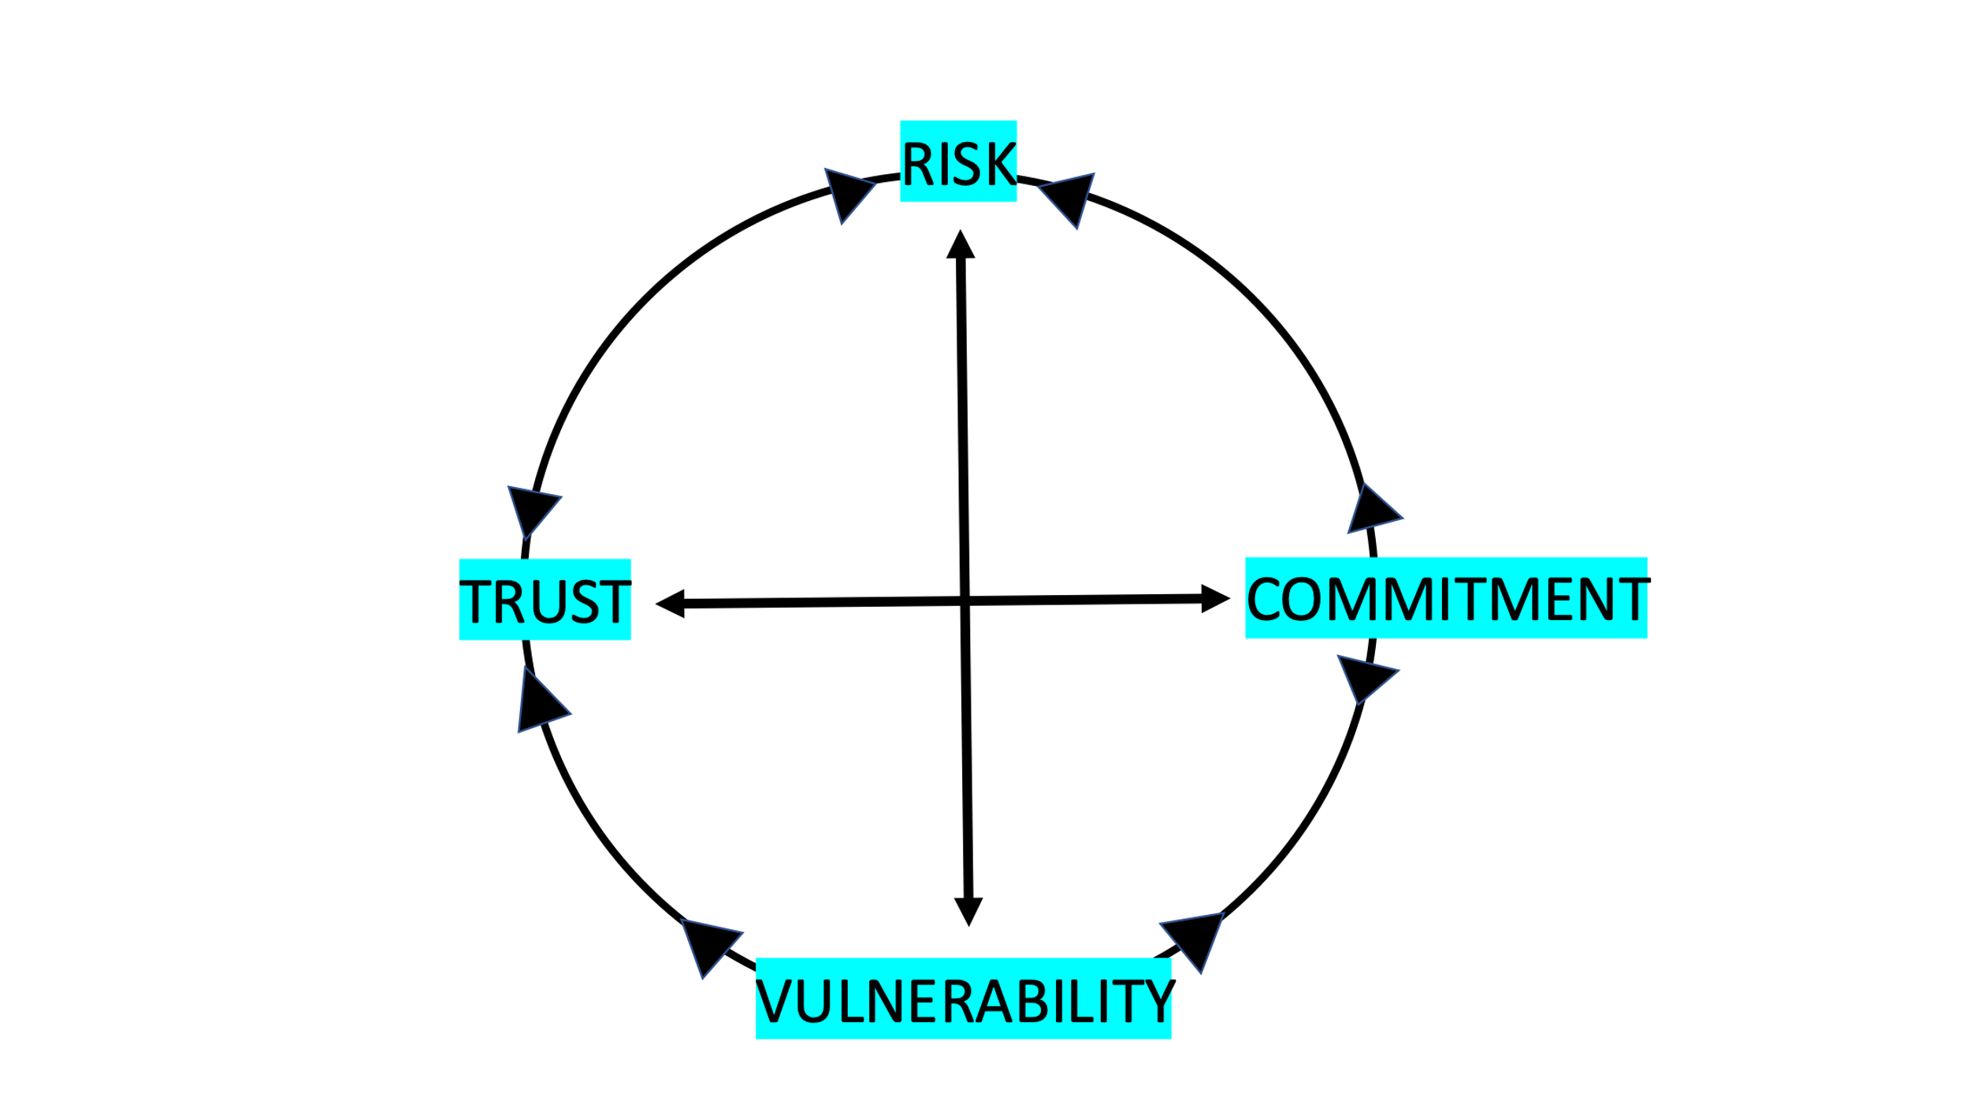

- If you have not yet done so, please spend 15-20 minutes to complete the Discipleship Planning Tool (grace.org/the journey) and the GPS Assessment Tool (grace.org/volunteer)

For Further Biblical Study:

Ephesians 4:1-6
4 As a prisoner for the Lord, then, I urge you to live a life worthy of the calling you have received. ² Be completely humble and gentle; be patient, bearing with one another in love. ³ Make every effort to keep the unity of the Spirit through the bond of peace. ⁴ There is one body and one Spirit, just as you were called to one hope when you were called; ⁵ one Lord, one faith, one baptism; ⁶ one God and Father of all, who is over all and through all and in all.

John 13:12-17
¹² When he had finished washing their feet, he put on his clothes and returned to his place. “Do you understand what I have done for you?” he asked them. ¹³ “You call me ‘Teacher’ and ‘Lord,’ and rightly so, for that is what I am. ¹⁴ Now that I, your Lord and Teacher, have washed your feet, you also should wash one another’s feet. ¹⁵ I have set you an example that you should do as I have done for you. ¹⁶ Very truly I tell you, no servant is greater than his master, nor is a messenger greater than the one who sent him. ¹⁷ Now that you know these things, you will be blessed if you do them.

Mark 10:45
⁴⁵ For even the Son of Man did not come to be served, but to serve, and to give his life as a ransom for many.”

How to Use These Study Guides:
- Consider sending out the Scripture passage to your group members ahead of time.
- Begin each meeting with a short time of checking in with one another.
- You may want to begin the discussion by reading the Scripture passage together out loud, or by summarizing the passage if everyone has read it ahead of time.
- Don’t feel like you need to discuss every question included in the Study Guide. Pick one or two to start with, and see how the conversation flows.
- If your group meets over Zoom:
  - You may need to do more overt facilitating over Zoom than you would in person. Feel free to call on people to invite them to share.
  - Try to be sensitive to attention spans over Zoom—keep the meetings shorter than they would be in person.
- Be sure to set aside time for sharing prayer requests and praying together.

Group Leader Support: Please reach out to your Campus Pastor or your Coach if you have any questions about leading your group or concerns about your group dynamic. If you have questions about or feedback on the Study Guides, please reach out to Pastor Tim or Grace Lee from the Group Life team.

