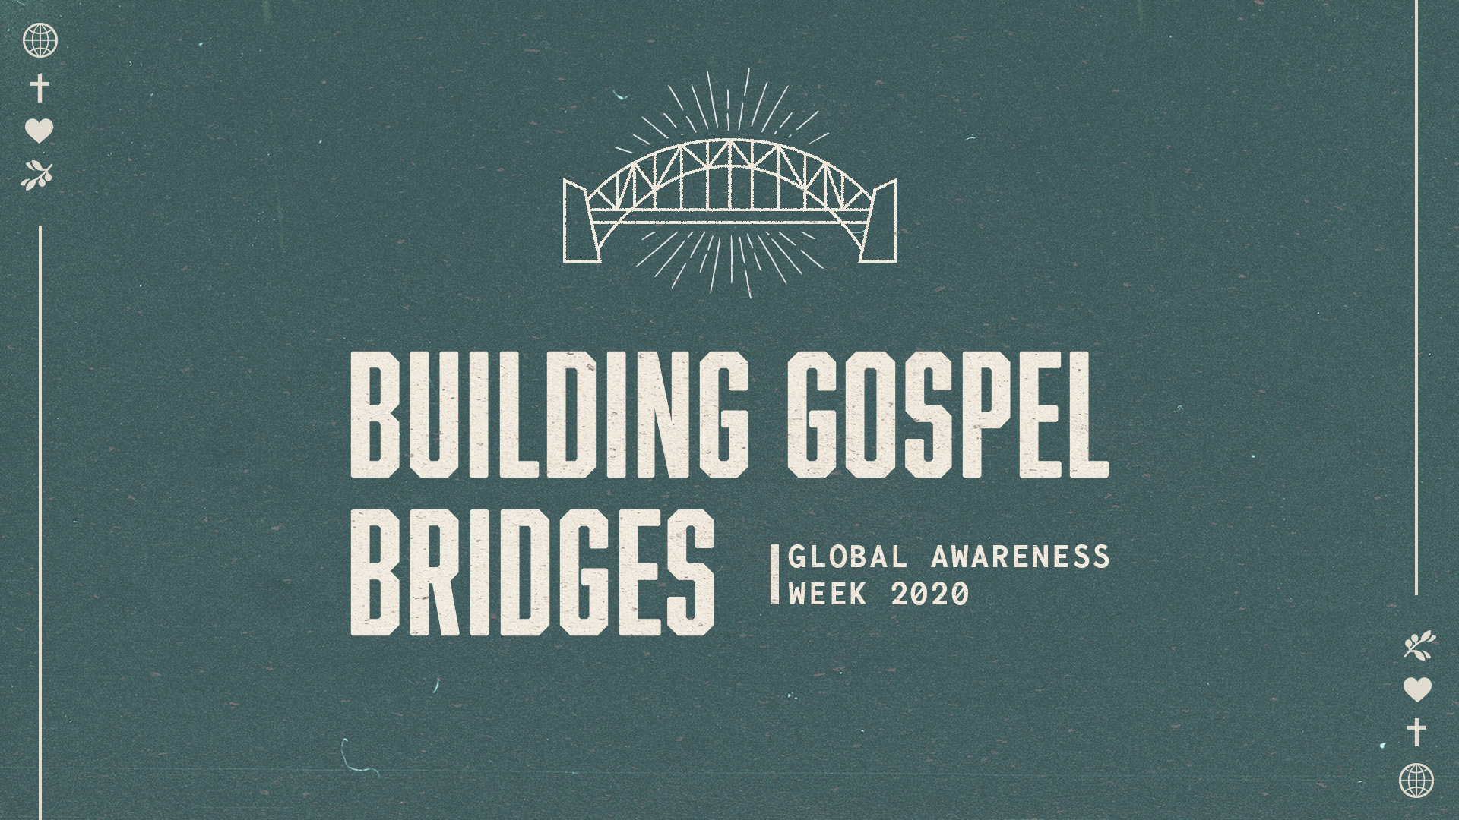

Sermon Study Guide
For the sermon preached on
11/15/2020:
“Building Gospel Bridges”
Isaiah 58:1-12

How to use the Study Guide During Virtual Online Group Meetings
Group life is even more critical during this incredible season. Over and over, group leaders are reporting that suddenly there is a new hunger to connect, share, pray, and meditate on Scripture together, and so we are making these guides available weekly and suggesting a new format during this season.

As you know, our Group Life’s vision is to “practice the way of Jesus.” And while Jesus never had to lead a Torah study over Zoom, he was strategic in his teaching ministry, and we want to be as well.

There are a number of differences between meeting in person and meeting online, ranging from the obvious to the subtle. One is, given our attention spans for online meetings, we want to encourage you to limit the length of your call between 45-60 minutes and we are calling this “Check-In Plus One.” Meaning, spend a few minutes checking in with your group and see if there are any new needs with them (or even amongst their neighbors). The “One” is to spend time in study. As our virtual season continues, our desire for meaningful content and interaction will grow. Given our new format, the study guides based on Sunday’s Sermon will be designed to be more application based (as opposed to unpacking the text with the Inductive Bible Study method). You might consider sharing the passage beforehand with your group in hopes that they might spend more time with the Scripture before the gathering.

As always, we are so grateful for you, your gifting, your servant leadership, and all that you do in practicing the way of Jesus in community.

Grace and peace,
Pastor Tim Ghali and Pastor Rachel Keeler on behalf of the Group Life Team

For the Leader: “Check-In Plus One”

Welcome everyone to the Zoom call and outline the goal of this call being 45 minutes. Spend 15-20 minutes checking in with one another, then move into a time of prayer, and then spend some time discussing the application of the Scripture passage.

A “Check-in” question might be, “How are you doing, and is there anything new that has arisen in your life or in your neighborhood that we can pray about?”

As we kick off Global Awareness Week, Nikki Toyama-Szeto, the Excutive Director of Christians for Social Action, is leading us in a reflection on our 2020 GAW theme, “Building Gospel Bridges.” The text for this sermon is Isaiah 58:1-12.

Isaiah 58:1-12

“Shout it aloud, do not hold back.
Raise your voice like a trumpet.
Declare to my people their rebellion
and to the descendants of Jacob their sins.
2 For day after day they seek me out;
they seem eager to know my ways,
as if they were a nation that does what is right
and has not forsaken the commands of its God.
They ask me for just decisions
and seem eager for God to come near them.
3 ‘Why have we fasted,’ they say,
‘and you have not seen it?
Why have we humbled ourselves,
and you have not noticed?’

“Yet on the day of your fasting, you do as you please
and exploit all your workers.
4 Your fasting ends in quarreling and strife,
and in striking each other with wicked fists.
You cannot fast as you do today
and expect your voice to be heard on high.
5 Is this the kind of fast I have chosen,
only a day for people to humble themselves?
Is it only for bowing one’s head like a reed
and for lying in sackcloth and ashes?
Is that what you call a fast,
a day acceptable to the Lord?

6 “Is not this the kind of fasting I have chosen:
to loose the chains of injustice
and untie the cords of the yoke,
to set the oppressed free
and break every yoke?
7 Is it not to share your food with the hungry
and to provide the poor wanderer with shelter—
when you see the naked, to clothe them,
and not to turn away from your own flesh and blood?
8 Then your light will break forth like the dawn,
and your healing will quickly appear;
then your righteousness[a] will go before you,
and the glory of the Lord will be your rear guard.
9 Then you will call, and the Lord will answer;
you will cry for help, and he will say: Here am I.

“If you do away with the yoke of oppression,
with the pointing finger and malicious talk,
10 and if you spend yourselves in behalf of the hungry
and satisfy the needs of the oppressed,
then your light will rise in the darkness,
and your night will become like the noonday.
11 The Lord will guide you always;
he will satisfy your needs in a sun-scorched land
and will strengthen your frame.
You will be like a well-watered garden,
like a spring whose waters never fail.
12 Your people will rebuild the ancient ruins
and will raise up the age-old foundations;
you will be called Repairer of Broken Walls,
Restorer of Streets with Dwellings.”

Q – Reflecting on Isaiah 58, Nikki spoke about how the Israelites seemed to be doing all the right things—seeking to know God, fasting, repenting—but failed to see “the connection between their relationship with God and their relationship with other people. They cared only about their personal and private relationship with God.” Looking at our own lives, “have we separated our relationship with God from our relationship with the people who make our clothes, our electronics?”
- In what ways do we sometimes allow our relationship with God to be a private matter, cut off from the other parts of our lives?
- What would it mean for you, at this particular time in your life, to see a deeper connection between your relationship with people and your relationship with God?

Q – The kind of fast that God chooses for us to enage in, according to Isaiah 58:6-8, is for us “to loose the chains of injustice and untie the cords of the yoke, to set the oppressed free and break every yoke[,] … to share [our] food with the hungry and to provide the poor wanderer with shelter.” Nikki pointed out that to enage in any of these kinds of activities, we have to be in relationship with the people whose chains we are trying to loose, the people we are trying to share our food with. You can’t do these things from a distance.
- How, concretely, can we work to develop relationships with children of God who are oppressed, hungry, homeless? Why is this important? What barriers do you think might ordinarily keep us from building these kinds of bridges?
- What is one concrete next step you can take in response to the challenge presented to us in Isaiah 58?

Q – At the end of the sermon, Nikki spoke about how “justice and evangelism go hand in hand, because today people don’t assume that God is good. The pursuit of justice demonstrates that our God is a loving, compassionate, just, and able God.”
- How have you experienced the connection between justice and evangelism? How might action against injustice help us to spread the Gospel?

Close by praying for one another, that each person in the group might find ways to work for justice and build Gospel bridges in their own concrete situations and circumstances…

